Chapter 4: System Implementation and Results

This document aims to provide a comprehensive description of the Expense Tracker System, focusing on its key components and functionalities. This system enables users to efficiently manage, track, and analyze their personal or financial expenses to enhance financial awareness and make informed decisions.

4.1 Development Environment
The Expense Tracker System is designed as a modern web application, ensuring easy access and usability across various devices. The development environment typically relies on a set of open-source technologies that provide flexibility and scalability, consisting of the following components:

Component | Technology Used
Operating System | Windows
Web Server | Apache HTTP Server
Backend Programming Language | PHP 8.
Database Management System | MySQL 8.
Frontend Technologies | HTML5, CSS3, JavaScript
Development Tools | VS Code, Modern Web Browser
These technologies were chosen for their ability to build robust and efficient web applications, offering a seamless user experience and extensive developer community support.

4.2 Key Module Implementation
The system's implementation was divided into key modules, each responsible for a specific aspect of the system's functionality, ensuring ease of maintenance and future development.

4.2.1 User Management and Authentication
This module is the cornerstone of the system, providing secure mechanisms for user registration and login. It is implemented using PHP and MySQL.

- Login Page: Allows existing users to enter their credentials to access their accounts. Data is verified against the database, and upon successful login, a user session is created, redirecting the user to the dashboard.
- New Account Creation Page: Enables new users to create an account by entering their basic information. Passwords are encrypted to ensure maximum security before storage.

4.2.2 Profile Information
The Profile Information Page provides an interface for users to view and modify their personal data and financial preferences. Users can update information such as name, email, and change passwords, with these changes being immediately reflected in the database to ensure continuous data accuracy.

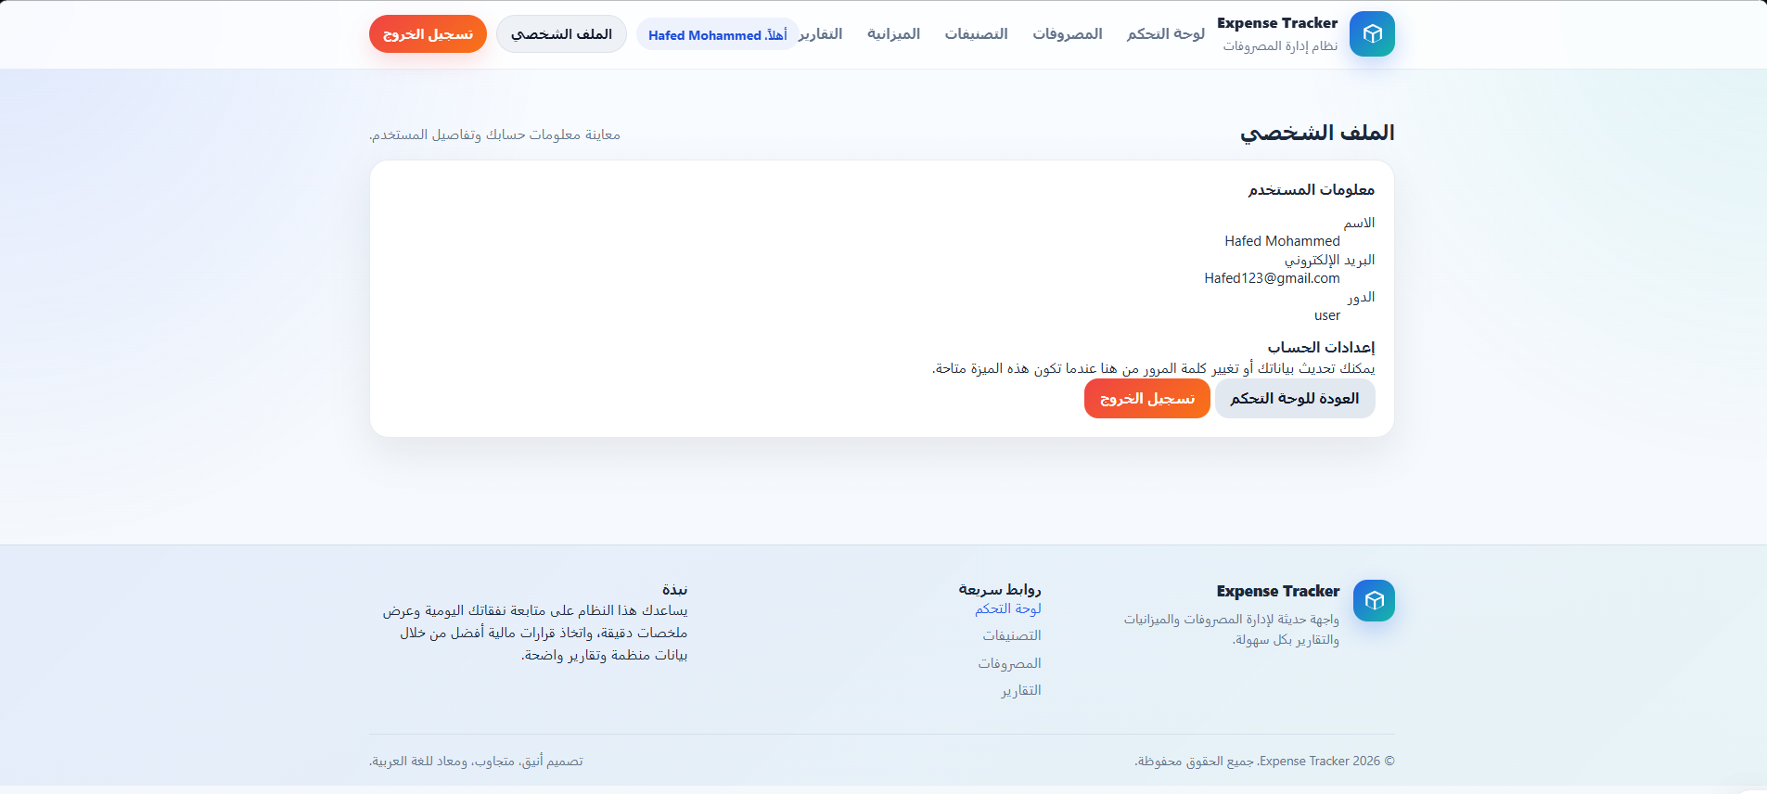

4.2.3 Dashboard and Budget Management
The Dashboard Page serves as the central hub of the system, offering a quick overview of the user's financial status through summaries of expenses and remaining budget. To enhance financial control, the Monthly Budget Page allows users to set spending limits for different categories, tracking progress and alerting the user when they are approaching or exceeding these limits.
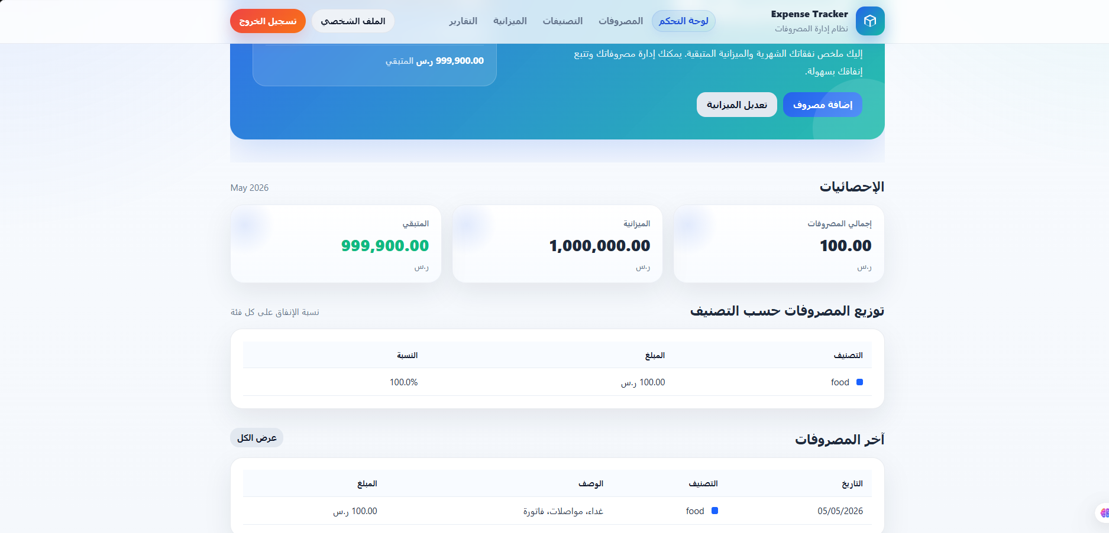

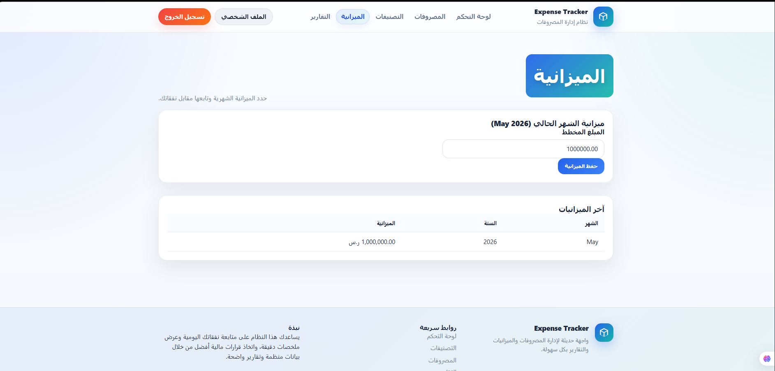

4.2.4 Categories and Expenses Management
The Categories Page enables user to organize their expenses by creating custom categories such as food, transportation, and entertainment. Through the Expenses Page, user can record each expenditure in detail, including amount, date, description, and associated category, with options to search and filter past transactions.
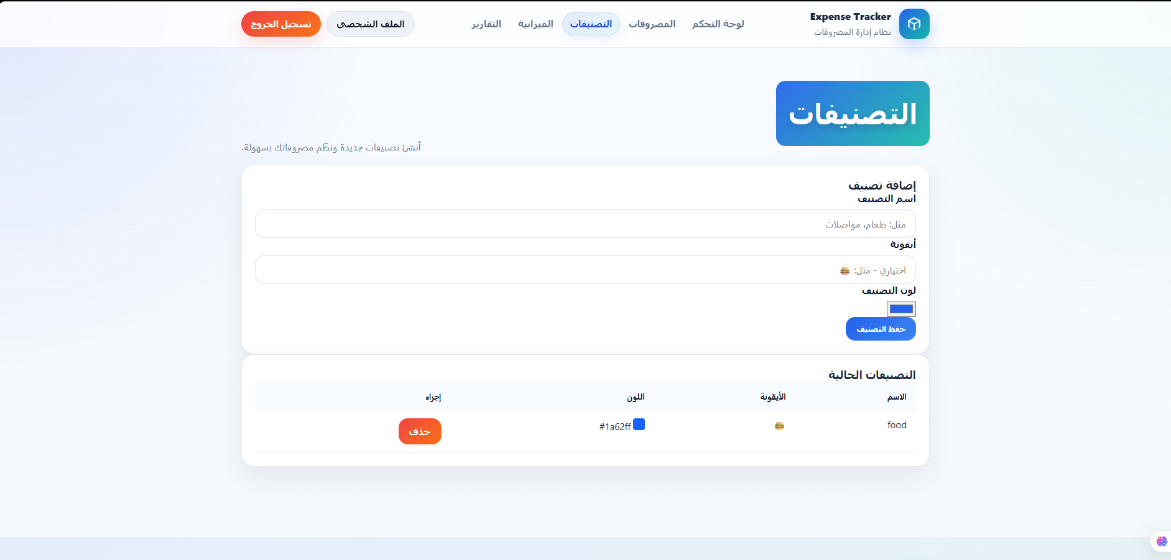

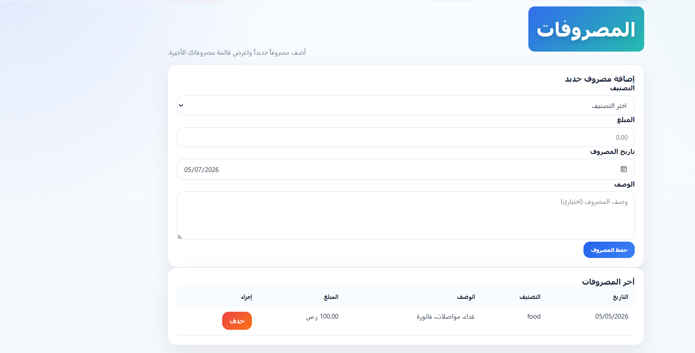

4.2.5 Financial Reports and Analytics
The Reports Page provides in-depth analysis of spending patterns over various time periods. Data is presented using interactive charts and tables illustrating expense distribution across different categories, helping users identify areas where they can reduce spending and improve their financial management.

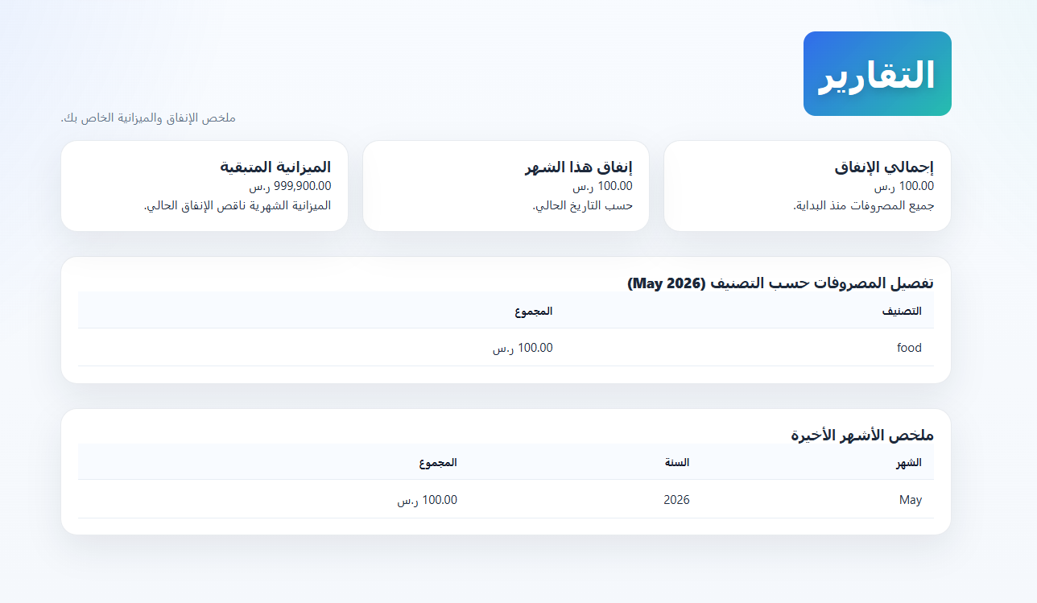

4.3 Results
The implementation of the Expense Tracker System has successfully achieved the project's defined objectives, resulting in a comprehensive web application characterized by:

- Intuitive User Interface: The interface is designed to be user-friendly, allowing users to navigate sections and input data seamlessly.
- Accurate Data Tracking: The system demonstrated high capability in accurately processing and categorizing expenses, providing reliable financial insights to users.
- Full Arabic Language Support: The system is designed to fully support the Arabic language, including text and Right-to-Left (RTL) direction, making it suitable for users in the Arab region.

4.4 Study Contributions
This project offers valuable contributions to the field of personal financial management, including providing an integrated system that links expense recording with budget planning, offering personalized financial analyses that help improve individuals' saving behavior, and delivering an Arabic-localized technical tool that supports digital transformation in personal financial management.

4.5 Future Work
Based on current results, the system can be further developed in the future by integrating artificial intelligence technologies for predicting future expenses, direct integration with bank accounts via Application Programming Interfaces (APIs), and developing a native mobile application for increased accessibility and productivity.

