HASSAN MUKHTAR HASSAN  Web Developer & Designer  xasanmuqtaar952@gmail.com  +252 61 4041111  Mogadishu, Somalia  github.com/EngHassan12  portfolio-three-theta-38vqaxxnmn.vercel.app | 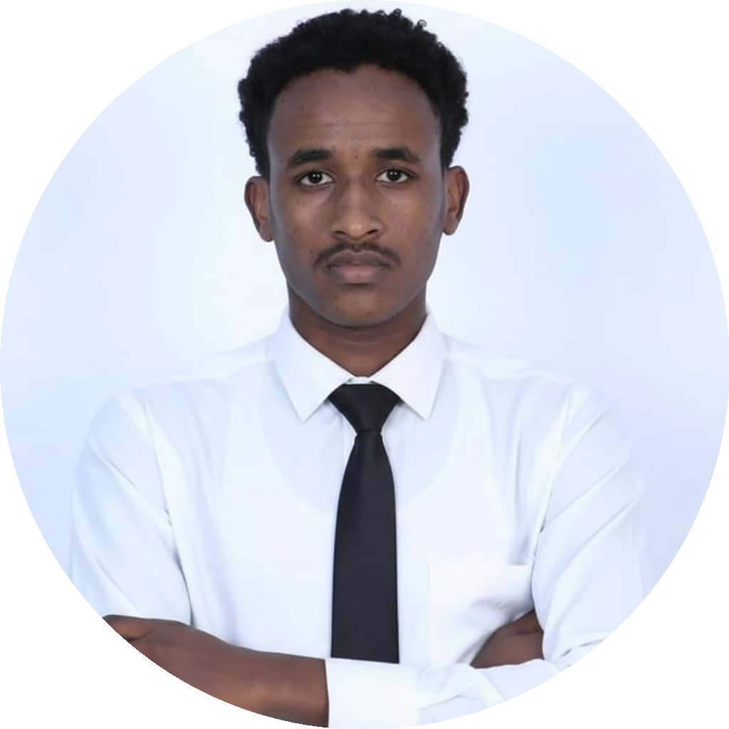

PROFILE
A multidisciplinary digital specialist blending design, development, and marketing. Helps businesses scale by creating seamless end-to-end digital experiences — from high-performance web applications to compelling visual identities and targeted marketing campaigns.
SKILLS & EXPERTISE
Web Development: HTML5, CSS3, JavaScript (ES6+), React.js, PHP, Java, MySQL, SQL Server, Responsive Design, Clean Code, Web Performance & Security
Graphic Design & UI/UX: Figma, Adobe Photoshop, Adobe Illustrator, Brand Identity & Logo Design, UI/UX Prototyping, Social Media Graphics, Print & Layout Design
Digital Marketing: Social Media Marketing (SMM), Content Strategy, Digital Campaign Management, Audience Targeting, Brand Strategy, Conversion Optimization
EXPERIENCE
Graphic Designer | QUUYOW
- Designed promotional materials and visual assets for the business's electronics/construction and services offerings.
Web Developer | QUUYOW
- Built and maintained the invoicing workflow and supporting tools for the business.
Digital Marketer | Maan Group
- Supported data and social media content work for a Somali professional development and leadership training organization.
SELECTED PROJECTS
E-Commerce & Custom Web Application | Web Development & UI/UX
- Designed and developed a full-stack, dynamic web application focused on speed, user experience, and secure data handling using React, PHP, MySQL, JavaScript, and CSS3.
- Built a fully responsive design with efficient database architecture and RESTful API integration, delivering a smooth user flow from landing page to checkout.
Comprehensive Brand Identity & Visual Design | Graphic Design & Branding
- Created a complete visual identity package for a modern startup, including logo design, typography, and color systems using Figma, Photoshop, and Illustrator.
- Delivered high-converting social media templates, corporate flyers, and professional digital product mockups.
Digital Marketing & Audience Growth Campaign | Digital Marketing & Strategy
- Executed a targeted social media marketing and content strategy that increased organic reach and engagement by over 150%.
- Drove targeted leads through high-converting ad copy and visual content.
EDUCATION
Bachelor's Degree, Computer Application | Jamhuriya University of Science and Technology

