PBIT 206: Advanced Data Communication

Advanced Data Communication: Principles and Applications of Satellite Communication

Research Essay

Submitted in Partial Fulfilment of the Requirements for PBIT 206

May 2026

1. Introduction
The story of satellite communication is, at its core, a story about humanity's refusal to accept the limitations of geography. Before the first artificial satellite pierced the thermosphere in 1957, long-distance communication depended entirely on cables laid at great expense across ocean floors or on high-frequency radio waves that bent unpredictably with the ionosphere. The launch of Sputnik 1 by the Soviet Union on October 4, 1957, while primarily a political statement, planted a seed of possibility that engineers around the world immediately recognised: if a signal could travel from a transmitter on Earth's surface to a fast-moving object in orbit and back again, the dream of truly global, uninterrupted communication might one day be realised (Roddy, 2006).
That dream became reality with remarkable speed. Within six years of Sputnik, Telstar 1 — launched on July 10, 1962 — had carried the first live transatlantic television pictures, and SYNCOM 3, placed in geostationary orbit in 1964, had broadcast live footage of the Tokyo Olympics to audiences in North America (Pratt et al., 2003). These early milestones established the foundational architecture that underpins modern satellite systems: an uplink from a ground station, a transponder aboard the spacecraft that receives, amplifies, and retransmits the signal, and a downlink to one or more receiving stations on the surface. What has changed in the intervening six decades is not this basic geometry but rather the extraordinary sophistication layered on top of it.
The modern global data infrastructure depends on satellites in ways that are often invisible to ordinary users. When a ship navigates the South Pacific, when a bushfire management team in northern Australia coordinates from a remote location without cellular coverage, when a hedge fund arbitrages millisecond price differences between exchanges in London and Singapore, or when a weather forecasting centre receives high-resolution imagery of a developing typhoon — satellite communication is, in each case, the invisible backbone. According to the Satellite Industry Association (2023), global satellite industry revenues exceeded USD 281 billion in 2022, with data services representing the fastest-growing segment.
The present essay examines the architectural and functional complexities of satellite data communication with a particular focus on a technology that has transformed the sector's capacity in the twenty-first century: High-Throughput Satellite (HTS) systems and their defining characteristic, the use of narrow, targeted spot beams — a capability sometimes referred to colloquially as 'Satellite Zooming.' The essay is organised as follows. Section 2 analyses the technical principles governing satellite communication, including orbital mechanics, frequency spectrum management, and signal modulation. Section 3 provides a detailed technical exploration of HTS systems, frequency reuse, and spot beam delivery. Section 4 offers a comparative analysis of satellite and terrestrial data communication. Section 5 examines the principal challenges the sector faces, from atmospheric attenuation to cybersecurity. Section 6 surveys future trends, with particular attention to integration with sixth-generation (6G) wireless networks and artificial intelligence (AI)-driven autonomous satellite operations. The essay concludes with a synthesis of these themes and a forward-looking assessment of satellite communication's role in the evolving global data landscape.

2. Technical Principles of Satellite Data Communication

2.1 Orbital Mechanics
A satellite's orbit determines almost everything else about its performance: the area of Earth it can see at any given moment, the signal delay that users experience, the complexity of the ground infrastructure needed to track it, and its susceptibility to natural hazards. The three orbital regimes in common use — Low Earth Orbit (LEO), Medium Earth Orbit (MEO), and Geostationary Earth Orbit (GEO) — each represent a different set of engineering trade-offs, and understanding those trade-offs is essential to appreciating why no single orbital class has displaced the others.

2.1.1 Low Earth Orbit (LEO)
Low Earth Orbit encompasses altitudes from approximately 160 km, the practical lower boundary at which atmospheric drag becomes prohibitively severe, to roughly 2,000 km. At these altitudes, the physics of orbital mechanics dictate short orbital periods: a satellite at 550 km completes one revolution approximately every 95 minutes. This high angular velocity relative to the Earth's surface means that a single LEO satellite passes overhead in a matter of minutes, making continuous coverage from a single spacecraft impossible. The solution adopted by operators such as SpaceX (Starlink), OneWeb, and Amazon (Project Kuiper) is to deploy large constellations of hundreds or thousands of satellites so that at least one is always visible above the horizon for any point on Earth (Del Portillo et al., 2019).
The physics that make LEO operationally challenging also make it scientifically attractive. The shorter propagation distance — typically 550–1,200 km compared with 35,786 km for GEO — means that the free-space path loss is dramatically lower, and the round-trip signal delay (latency) is on the order of 20–40 milliseconds rather than the 600+ milliseconds unavoidable in GEO systems (Bhattacherjee & Singla, 2019). For latency-sensitive applications such as real-time financial transactions, interactive video conferencing, cloud gaming, and remote robotic surgery, this distinction is operationally critical. The trade-off is the complexity and cost of managing thousands of satellites, including inter-satellite laser links, sophisticated hand-off protocols, and constant orbital maintenance to counteract atmospheric drag.
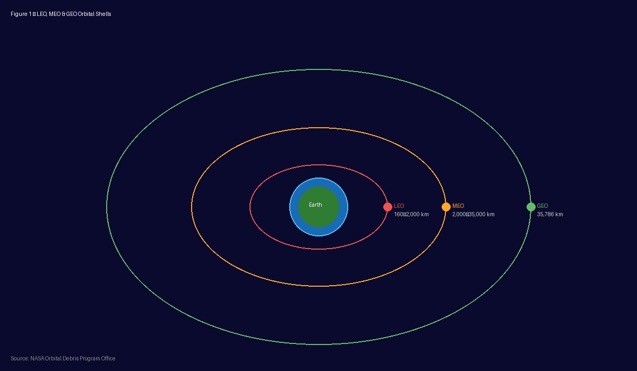
Figure 1. Schematic representation of LEO, MEO, and GEO orbital shells around Earth. [Source: NASA Orbital Debris Program Office — https://orbitaldebris.jsc.nasa.gov]

2.1.2 Medium Earth Orbit (MEO)
Medium Earth Orbit occupies the band between roughly 2,000 km and 35,000 km. The most important users of MEO are navigation constellations: the United States' Global Positioning System (GPS) operates at approximately 20,200 km, Europe's Galileo system at 23,222 km, Russia's GLONASS at 19,100 km, and China's BeiDou at a mixture of MEO and GEO altitudes (Hofmann-Wellenhof et al., 2008). Communication satellites also use MEO; O3b Networks (now part of SES) operates its mPOWER constellation at approximately 8,062 km, achieving a latency of around 150 milliseconds — higher than LEO but far lower than GEO — making it well suited for maritime and aeronautical broadband applications.
MEO orbits pass through the Van Allen radiation belts, which imposes stringent requirements on spacecraft shielding and component radiation hardening, adding cost and mass. Nevertheless, for certain applications, MEO offers a compelling middle ground: fewer satellites than LEO are needed to achieve global coverage, latency is tolerable for most consumer applications, and the longer revisit times characteristic of LEO are eliminated.

2.1.3 Geostationary Earth Orbit (GEO)
Geostationary Earth Orbit is defined by a single altitude: 35,786 km above the equator, at which point a satellite's orbital period precisely matches Earth's rotation. From the perspective of an observer on the ground, a GEO satellite appears motionless in the sky, which eliminates the need for elaborate tracking antennas required by LEO systems. A fixed dish antenna pointed once at the correct azimuth and elevation angle will remain locked on the satellite indefinitely — a property that made GEO the dominant architecture for commercial communication satellites from the 1960s onward (Maral & Bousquet, 2020).
The altitude that confers this operational simplicity also imposes a physical constraint that cannot be engineered away: the round-trip signal delay. At 35,786 km each way, and with electromagnetic waves propagating at the speed of light (299,792 km/s), the one-way propagation delay is approximately 119 milliseconds. A complete round trip — uplink to satellite, retransmission, downlink, acknowledgement uplink, and acknowledgement downlink — takes approximately 480–600 milliseconds. This latency disqualifies GEO satellites from certain real-time applications but is entirely acceptable for broadcast television, VSAT enterprise networks, and weather monitoring, which collectively constitute the majority of GEO revenue.

2.2 Frequency Spectrum Management
The radio frequency spectrum is a finite natural resource shared by all users. The International Telecommunication Union (ITU), a specialised agency of the United Nations, coordinates its allocation globally through the Radio Regulations treaty, which assigns different frequency bands to different services and coordinates interference between neighbouring systems. For commercial satellite communication, the most important bands are C, Ku, and Ka, each representing a distinct set of trade-offs between link performance, rain fade susceptibility, and achievable throughput.

2.2.1 C-Band (4–8 GHz)
The C-band, spanning 4–8 GHz, was the first frequency range used by commercial communication satellites and remains widely deployed for broadcast and VSAT applications. C-band signals experience relatively low atmospheric attenuation, making them resilient to rain fade and suitable for operation in tropical regions with heavy precipitation. The limitations of C-band are its lower bandwidth availability and the large antenna sizes required at the ground segment — typically 1.8–3.7 metres for reliable operation — which restricts its suitability for compact, low-cost terminals (Ippolito, 2017). Following World Radiocommunication Conference 2015 (WRC-15) decisions, portions of the C-band have been reallocated to terrestrial 5G services in several regions, creating additional spectrum pressure on existing operators.

2.2.2 Ku-Band (12–18 GHz)
The Ku-band, operating between 12 and 18 GHz, emerged as the dominant frequency for direct broadcast satellite (DBS) television in the 1980s and has since been widely adopted for VSAT broadband. Higher frequencies permit the use of smaller antennas — typically 75 cm to 1.2 metres for consumer terminals — making Ku-band systems far more practical for residential and mobile installations. The trade-off is increased susceptibility to rain attenuation, which becomes significant at rainfall rates above approximately 10 mm/hour. Link budgets for Ku-band systems must incorporate rain fade margins of typically 3–10 dB depending on the geographic region, which reduces the net information throughput available to users during heavy precipitation (Ippolito, 2017).

2.2.3 Ka-Band (26.5–40 GHz)
The Ka-band, from 26.5 to 40 GHz, is the frequency range that has enabled the High-Throughput Satellite revolution described in Section 3. Its much wider bandwidth allocation compared to lower bands — typically 500 MHz or more per transponder — allows each spot beam to carry substantially more data, and the shorter wavelengths permit the construction of highly directive antennas capable of focusing energy into narrow geographic areas. The vulnerability of Ka-band to rain attenuation is more severe than at lower frequencies, with typical fade margins of 10–20 dB required in tropical and subtropical markets (Lutz et al., 2012). Modern HTS systems mitigate this through adaptive coding and modulation (ACM), which dynamically reduces the modulation order and coding rate when link quality degrades, trading throughput for link robustness.
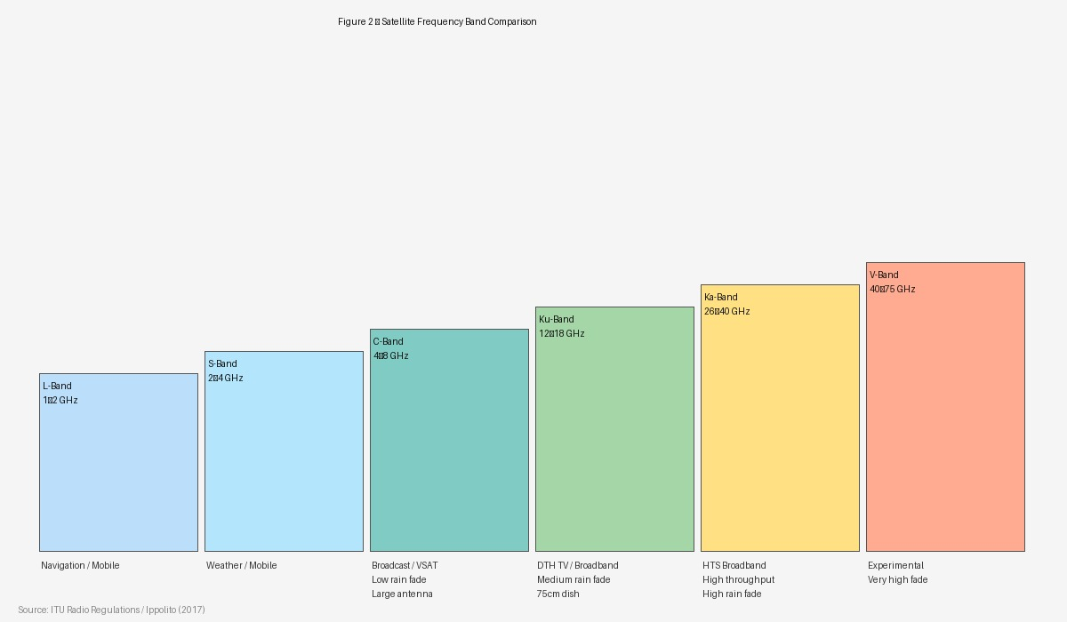
Figure 2. Comparative illustration of satellite frequency band characteristics, including C, Ku, and Ka band throughput and rain fade susceptibility. [Source: ITU Radio Regulations / Ippolito (2017) — https://www.itu.int/pub/R-REG-RR]

2.3 Signal Modulation and Coding
Digital satellite communication relies on modulation schemes that encode binary data onto a carrier wave by manipulating its amplitude, phase, or frequency — or some combination of these. The selection of a modulation scheme involves balancing spectral efficiency (how many bits per second can be transmitted per hertz of bandwidth) against power efficiency (how strong the received signal must be relative to the noise floor to achieve a specified error rate).
The DVB-S2 (Digital Video Broadcasting — Satellite — Second Generation) standard, published in 2005 and widely adopted for both broadcast and broadband applications, defines a flexible modulation and coding framework ranging from QPSK (Quadrature Phase Shift Keying, 2 bits per symbol) through 8PSK, 16APSK, and 32APSK (5 bits per symbol), paired with Low-Density Parity-Check (LDPC) and Bose-Chaudhuri-Hocquenghem (BCH) forward error correction codes (ETSI, 2009). The DVB-S2X extension, finalised in 2014, pushed this further, adding 64APSK and 128APSK modulation modes that approach the Shannon limit for capacity over a given link. The combination of ACM with these high-order modulation schemes allows modern HTS terminals to maximise throughput under favourable link conditions while gracefully degrading to more robust configurations during rain fade events.
Spread-spectrum techniques, including Direct Sequence Spread Spectrum (DSSS) and Frequency Hopping Spread Spectrum (FHSS), are employed in military and secure commercial systems to provide resistance to jamming and interception. Code Division Multiple Access (CDMA), which uses orthogonal spreading codes to allow multiple users to share the same frequency band simultaneously, is widely used in satellite navigation systems such as GPS and Galileo (Spilker & Parkinson, 1996). Time Division Multiple Access (TDMA) and Frequency Division Multiple Access (FDMA) remain standard access methods for VSAT hub-spoke networks, where multiple remote terminals share transponder capacity managed by a central hub station.

3. Satellite Zooming and Precision: High-Throughput Satellites and Spot Beam Technology

3.1 The Concept of Satellite Zooming
The term 'Satellite Zooming,' as used in the context of High-Throughput Satellite systems, refers to the capacity of a modern spacecraft to concentrate its radiated power and receiving sensitivity into a precisely defined geographic area — a 'spot' — rather than illuminating a broad continental or hemispheric footprint. The analogy to optical zooming is instructive: just as a zoom lens concentrates the same total light flux into a smaller image area, producing a brighter and more detailed image, a spot beam antenna concentrates the same total satellite power into a smaller coverage area, producing a higher flux density at the surface and enabling smaller, cheaper user terminals while simultaneously reusing the same frequency allocation across multiple non-overlapping spot areas (Kyrgiazos et al., 2014).
This capability represents a fundamental departure from the architecture of first- and second-generation communication satellites, which used wide-area or regional 'shaped' beams to provide service to entire continents or ocean regions from a single transponder. A conventional GEO satellite with a C-band continental beam covering all of Africa delivers the same flux density to a user in Nairobi as to one in Cape Town, and the total capacity of that beam — typically 36–72 MHz of transponder bandwidth — must be shared among all users within its footprint. An HTS satellite replacing the same orbital slot with Ka-band spot beams might illuminate 100 separate beams, each covering a circle of 200–600 km diameter, with the same frequency plan reused across geographically separated beams. The capacity delivered to each user is multiplied by the frequency reuse factor, which in modern systems routinely exceeds 10 and may approach or surpass 100 (Evans et al., 2016).

3.2 Antenna Architecture and Beam Forming
The physical realisation of spot beams requires antenna systems of much greater sophistication than the simple parabolic reflectors used on earlier satellites. There are two principal architectural approaches: Multiple Spot Beam (MSB) antennas using offset-fed reflectors with multiple feeds, and Active Phased Array Antennas (APAA) which form beams electronically without moving parts.
In the MSB reflector approach, a large parabolic reflector — typically 1.5 to 3 metres in diameter for a GEO satellite — is illuminated by an array of feed horns, each of which, together with the reflector, defines a discrete spot beam pointed in a specific direction. The number of beams is limited by the physical size of the feed array and the separation between beams needed to achieve adequate isolation, typically 20–30 dB between adjacent beams (Fenech et al., 2015). The ViaSat-1 satellite, launched in 2011, used this approach to generate 72 Ka-band spot beams, achieving a total throughput of approximately 140 Gbps — at the time of launch, more than the combined capacity of all other commercial satellites serving North America (Satellite Evolution Group, 2011).
Phased array antennas achieve beam forming by controlling the phase and amplitude of signals fed to each of many small antenna elements. By adjusting these weights, the same physical aperture can be steered electronically to any direction within a wide field of view, and multiple simultaneous beams can be formed by implementing multiple sets of weights in parallel. This capability, long the exclusive domain of military satellites, has become increasingly feasible for commercial systems as the cost of digital signal processing hardware has fallen. The Starlink system, for example, uses flat phased array antennas on both the satellite and the user terminal, enabling automatic beam steering without mechanical pointing (Bhattacherjee & Singla, 2019).
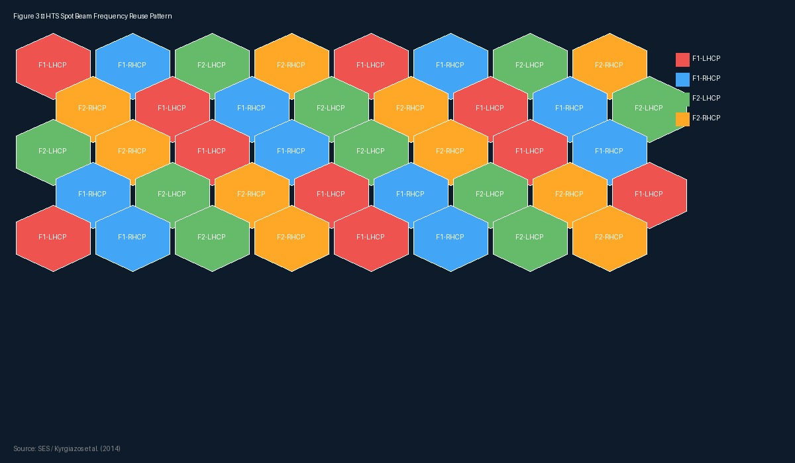
Figure 3. Illustrative spot beam frequency colour reuse pattern for a High-Throughput Satellite, showing four-colour reuse across non-adjacent beams. [Source: SES / Kyrgiazos et al. (2014) — https://onlinelibrary.wiley.com/doi/10.1002/sat.1067]

3.3 Frequency Reuse and Colour Schemes
Frequency reuse is the mechanism by which spot beam systems multiply their capacity. The principle is identical to that used in terrestrial cellular networks: if two geographically separated cells use the same frequency channel, and if the geographic separation is sufficient that the interference between them is below a tolerable threshold, the total system capacity is doubled relative to a single-coverage-area system using the same channel.
In satellite systems, frequency reuse is typically implemented using a 'colour' scheme analogous to the four-colour theorem used in cartography. In a four-colour reuse pattern, the available bandwidth is divided into two frequency halves (F1 and F2) and each half is further divided by polarisation (left-hand circular, LHCP, and right-hand circular, RHCP), giving four distinct 'colours' (F1-LHCP, F1-RHCP, F2-LHCP, F2-RHCP). Adjacent beams in the coverage pattern are assigned different colours, so that each beam's frequency-polarisation combination does not appear in any immediately neighbouring beam. With careful beam placement, this four-colour scheme allows the total spectrum to be reused across the entire coverage area, multiplying system capacity by a factor approaching four compared to a widebeam system (Kyrgiazos et al., 2014).
More aggressive two-colour or even full frequency reuse schemes are achievable in systems with sufficiently high beam isolation — typically requiring antenna sidelobe suppression of 25 dB or more. The ViaSat-3 constellation, each satellite of which carries over 1 Tbps of capacity, employs advanced beam forming and interference management to achieve near-full frequency reuse across its spot beams (ViaSat Inc., 2022). The interference management challenge becomes the central design constraint at high reuse factors: the signal-to-interference-plus-noise ratio (SINR) experienced by a user in a given beam is determined not only by the wanted signal level but also by the residual interference leaked from co-channel beams, and managing this SINR across the entire coverage area is a complex optimisation problem that has driven much of the academic and industrial research in the field.

3.4 High-Resolution Data Acquisition via Satellite
Spot beam technology is not only relevant to communication satellites but also underpins the capability of Earth observation satellites to deliver high-resolution data products. Modern commercial Earth observation satellites, including those operated by Planet Labs, Maxar, Airbus Defence and Space, and others, use high-resolution optical and synthetic aperture radar (SAR) sensors to acquire imagery with ground sample distances (GSD) as small as 25–30 cm, enabling the detection of objects smaller than a metre from orbit (Sandau, 2010).
The data volumes generated by such sensors are substantial. A single hyperspectral image covering 100 km × 100 km at 30-metre GSD may exceed 1 GB; a Very High Resolution (VHR) panchromatic image of the same area at 50 cm GSD may exceed 10 GB. Downlinking this volume of data within the limited contact time available between the satellite and a ground station — typically 5–12 minutes per pass for a LEO satellite — requires high-rate X-band or optical downlinks. Emerging laser communication terminals, such as those developed by Tesat-Spacecom and MYNARIC, can achieve downlink rates of 1–10 Gbps, addressing the data downlink bottleneck for high-resolution Earth observation missions (Smutny et al., 2009).
The ability to task a satellite to point its sensor — the 'zooming' in another sense — to a specific geographic area and acquire data at high resolution within hours of a request is itself a form of precision data acquisition enabled by advanced attitude control systems. Modern agile Earth observation satellites can slew their entire bus at rates of several degrees per second, allowing them to collect imagery of multiple target areas during a single pass.

4. Comparative Analysis: Satellite vs. Terrestrial Data Communication

4.1 Geographic Coverage and Accessibility
The most fundamental distinction between satellite and terrestrial data communication lies in geographic reach. Terrestrial networks — whether fibre optic, coaxial cable, or cellular radio — require physical infrastructure deployed along the coverage area. The economics of deploying fibre to a community of a thousand residents spread across a remote mountain valley are entirely different from those of deploying fibre to a million residents in a metropolitan area; in the former case, the cost per user may be ten to one hundred times higher, and the investment is rarely commercially justified without substantial public subsidy (Forman & Van Zeebroeck, 2019).
Satellite connectivity is, by contrast, fundamentally geography-independent. The same satellite capacity that serves a city of a million can serve, at equal cost per link, a research station in Antarctica, a fishing vessel in the Bering Sea, or a village in the Amazon basin. This ubiquity is the primary reason satellite communication has remained commercially viable despite the superior performance of terrestrial networks in the densely populated areas where the majority of the world's population lives. The ITU estimates that approximately 2.6 billion people remained without internet access in 2022, the majority in rural and remote areas where terrestrial infrastructure is either absent or inadequate (ITU, 2022). LEO broadband constellations such as Starlink are explicitly targeted at this connectivity gap.

4.2 Throughput and Latency
Terrestrial fibre optic networks offer unmatched throughput. A single strand of single-mode optical fibre, using dense wavelength division multiplexing (DWDM), can carry multiple Tbps over transoceanic distances. Commercial subsea cable systems such as MAREA, which connects the United States to Spain, carry a designed capacity of 160 Tbps (Telkamp et al., 2017). No satellite system approaches these figures on an individual link basis, though the aggregate capacity of a large LEO constellation begins to be comparable in total system terms.
On latency, as discussed in Section 2.1, GEO satellite systems are structurally disadvantaged relative to both terrestrial and LEO systems. TCP/IP protocols were designed assuming round-trip times of tens of milliseconds; the 600 ms round-trip characteristic of GEO connections degrades the performance of TCP's congestion control algorithms, reducing effective throughput to a fraction of the raw link rate without performance enhancement technology such as Performance Enhancing Proxies (PEPs) (Caini & Firrincieli, 2004). LEO systems eliminate this structural disadvantage, but even LEO latency is somewhat higher than terrestrial fibre for continental-scale connections because the optical fibre travels in a near-straight line between cities while the satellite path goes up and back down.
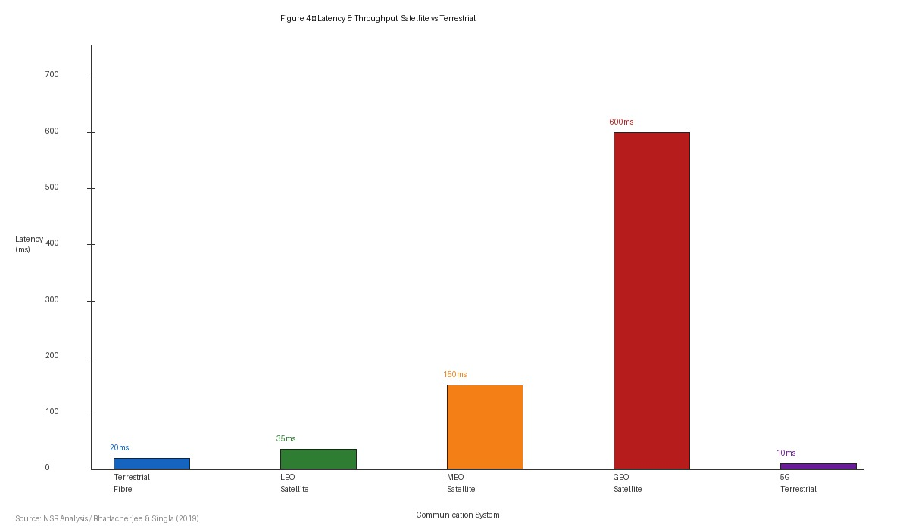
Figure 4. Comparative latency characteristics of GEO, MEO, LEO satellite, and terrestrial 5G/fibre communication systems (round-trip time in milliseconds). [Source: NSR Analysis / Bhattacherjee & Singla (2019) — https://doi.org/10.1145/3359989.3365407]

4.3 Reliability and Resilience
Terrestrial networks are vulnerable to physical damage from natural disasters, civil unrest, and malicious attack. The 2011 Tohoku earthquake and tsunami in Japan destroyed or disabled large portions of the terrestrial communications infrastructure across a wide area; satellite links provided the primary communication capability for disaster response in the immediate aftermath (Imran et al., 2014). Similar events in Haiti (2010), the Philippines (2013), and Ukraine (2022) demonstrated the resilience value of satellite communication when terrestrial infrastructure fails or is deliberately disrupted.
Satellite systems are not immune to failure, but their failure modes are different. A single satellite failure affects all users within its coverage area simultaneously, though in a large constellation the impact is mitigated by traffic rerouting through adjacent satellites. Solar storms, which produce heightened radiation and can damage satellite electronics and temporarily degrade signal quality through ionospheric disturbances, represent a natural hazard with no terrestrial analogue (Bedingfield et al., 1996). Launch failures, which have occasionally destroyed entire constellations' worth of satellites in a single event, add to the risk profile that satellite operators must manage.

4.4 Cost Structures
The cost economics of satellite and terrestrial communication differ fundamentally in their structure. Terrestrial networks have high marginal cost — each additional kilometre of fibre or each additional cell site requires proportional capital expenditure — but their per-bit transmission cost can be extremely low once deployed, particularly for high-density routes where the fixed costs are amortised across millions of users. Satellite networks have high fixed costs — a GEO spacecraft and its launch typically cost USD 200–400 million — but relatively low marginal cost for geographic expansion, since no additional hardware needs to be deployed at the terrestrial level to extend coverage to a new area (Pelton, 2013).
The economics have shifted considerably in recent years as satellite manufacturing has benefited from commercial space industry competition. SpaceX's Falcon 9 reusable launch vehicle has reduced launch costs from approximately USD 54,000 per kilogram to GEO to under USD 3,000 per kilogram to LEO for Starlink satellites (Jones, 2018). Mass production of standardised small satellites, using commercial off-the-shelf components derived from the smartphone and automotive industries, has further reduced per-satellite manufacturing costs. These trends are compressing the cost gap between satellite and terrestrial broadband, particularly for rural and remote users.

5. Challenges in Satellite Data Communication

5.1 Atmospheric Attenuation and Rain Fade
The atmosphere is not a perfect transmission medium for radio waves. Oxygen and water vapour absorb electromagnetic energy at specific frequencies, creating 'absorption windows' — frequency ranges where atmospheric attenuation is relatively low — and 'absorption peaks' where propagation is severely impaired. The frequency bands used for satellite communication lie within absorption windows: Ka-band at 26–40 GHz sits between the water vapour absorption peak at 22 GHz and the oxygen absorption peak at 60 GHz, but it is close enough to the former that rain, which produces liquid water droplets of size comparable to Ka-band wavelengths, causes significant scattering and absorption (Ippolito, 2017).
Rain fade is the dominant impairment in Ka-band satellite systems operating in tropical and subtropical regions. The ITU-R P series of recommendations provides statistical models for predicting the probability distribution of rain attenuation at a given location as a function of local rainfall climatology, link elevation angle, and frequency (ITU-R, 2017). Satellite link budgets must include a fade margin sufficient to maintain the specified availability — typically 99.5% to 99.9% of an average year — which in tropical locations may require margins exceeding 10 dB, significantly reducing the effective link capacity available during rain events.
Adaptive Coding and Modulation (ACM) is the primary mitigation technique deployed in modern HTS systems. The forward link modulation and coding scheme is adjusted in near-real time based on channel quality measurements fed back from the terminal, reducing throughput during fade events but maintaining link availability. In the return link, uplink power control (ULPC) can increase the terminal's transmitted power during rain events, partially compensating for the additional path loss, though this requires terminals with variable-power amplifiers and sufficient power headroom (Lutz et al., 2012).

5.2 Latency and its Operational Implications
As noted in Section 2.1.3, the latency inherent in GEO satellite links arises directly from the speed of light and the orbital altitude, and is therefore a fundamental physical constraint rather than a technology limitation amenable to engineering improvement. The 600 ms round-trip delay creates practical difficulties for a wide range of applications beyond the TCP performance degradation already mentioned.
Voice over IP (VoIP) telephony requires round-trip delays below approximately 150 ms for natural conversational flow; beyond this threshold, the delay becomes perceptible to users, and the conversation begins to take on the stilted character of a half-duplex radio exchange. Satellite VoIP over GEO links requires echo cancellation — the active subtraction of a delayed copy of the speaker's own voice from the signal — to remain tolerable, and even with echo cancellation the experience is inferior to terrestrial telephony (Caini & Firrincieli, 2004).
Financial trading is perhaps the application domain most exquisitely sensitive to latency. High-frequency trading algorithms exploit arbitrage opportunities that exist for microseconds; a system with hundreds of milliseconds of latency cannot participate in this market at all. Even for non-algorithmic institutional trading, the competitive disadvantage of a satellite-connected trader relative to a fibre-connected competitor is severe. For these applications, GEO satellite communication is structurally unsuitable, and even LEO satellite links are likely to remain disadvantaged relative to dedicated terrestrial fibre routes between major financial centres.

5.3 Orbital Congestion and Debris
The rapid growth of satellite deployment, particularly in LEO, has raised serious concerns about orbital sustainability. The Kessler syndrome, first described by NASA scientist Donald Kessler in 1978, describes a cascade scenario in which a collision between two satellites produces a cloud of debris fragments, each of which can cause further collisions, ultimately rendering certain orbital shells unusable (Kessler & Cour-Palais, 1978). Modern orbital debris tracking by agencies such as the US Space Surveillance Network monitors approximately 27,000 objects larger than 10 cm, but statistical models suggest the actual population of fragments in the 1–10 cm range — too small to track but capable of disabling or destroying a satellite — numbers in the hundreds of thousands (ESA, 2022).
The deployment of large LEO constellations has intensified this concern. SpaceX's Starlink constellation, with a licensed capacity of up to 42,000 satellites, Amazon's Project Kuiper with 3,236 satellites, and dozens of smaller planned constellations could collectively increase the catalogued on-orbit population by an order of magnitude over the next decade. Conjunction analysis — the process of predicting close approaches between tracked objects and issuing avoidance manoeuvre recommendations — has become a significant operational burden. The US Space Surveillance Network processed over 50,000 conjunction screening events per day in 2021, a number that is projected to increase dramatically as new constellations are deployed (Liou, 2011).
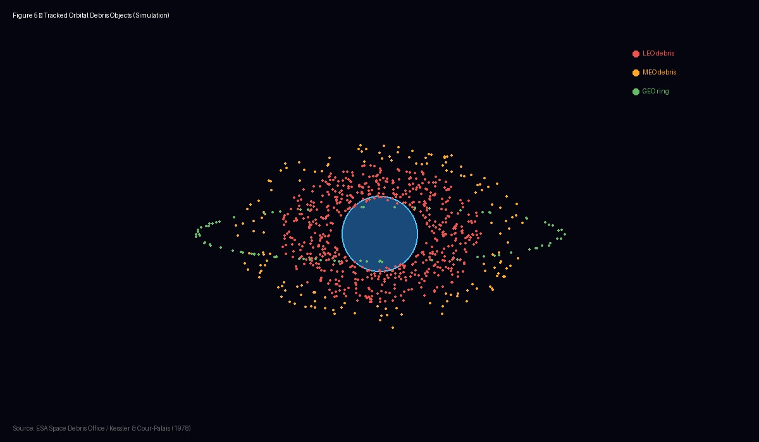
Figure 5. Simulation of tracked orbital debris objects in LEO and GEO shells. Each point represents a tracked object; the untracked sub-centimetre population is orders of magnitude larger. [Source: ESA Space Debris Office / Kessler & Cour-Palais (1978) — https://www.esa.int/Space_Safety/Space_Debris]
International responses to the debris challenge include the Inter-Agency Space Debris Coordination Committee (IADC) Space Debris Mitigation Guidelines, which recommend that spacecraft in LEO be deorbited within 25 years of end of mission. The ITU has adopted analogous guidelines for GEO satellites. Compliance, however, remains voluntary for most operators, and enforcement mechanisms are weak. Active debris removal (ADR) missions — spacecraft that capture and deorbit existing debris objects — are under development by companies including ClearSpace SA and Astroscale, but the technical and legal challenges of removing debris objects in low orbits are formidable (Bonnal et al., 2013).

5.4 Cybersecurity Vulnerabilities
Satellite communication systems present an expanded attack surface relative to terrestrial networks, because the radio link between the ground and the spacecraft is inherently accessible to any sufficiently equipped adversary within line of sight of the uplink or downlink. The principal cybersecurity vulnerabilities in satellite systems include jamming, spoofing, eavesdropping, and intrusion into ground segment management systems.
Jamming — the deliberate transmission of interference signals to disrupt the legitimate communication — has been used extensively in contemporary conflicts. During Russia's invasion of Ukraine beginning in February 2022, Viasat's KA-SAT network serving Ukrainian government and military users suffered a sophisticated cyberattack affecting tens of thousands of terminals across Europe (Eutelsat, 2022). The attack exploited vulnerabilities in the network management system to overwrite the firmware of user terminals, rendering them inoperable — a technique that is difficult to recover from because it requires physical replacement of terminal hardware. The incident highlighted the importance of secure update mechanisms, hardware security modules, and network segmentation in satellite ground systems.
Spoofing — the transmission of counterfeit satellite signals to deceive receivers about their location or timing — is a well-documented threat to GNSS systems and is increasingly being observed in commercial and aviation contexts. GPS spoofing has been detected in multiple conflict zones and near politically sensitive facilities. The consequences range from navigational confusion for ships and aircraft to potentially catastrophic errors in timing-dependent financial and industrial control systems (Humphreys et al., 2008). Mitigation approaches include multi-constellation GNSS receivers, inertial navigation system (INS) integration, signal authentication using cryptographic techniques (as implemented in Galileo's OSNMA — Open Service Navigation Message Authentication), and monitoring networks that can detect anomalous signal conditions.

6. Future Trends

6.1 Integration with 6G Networks
The sixth generation of wireless communication standards (6G), whose standardisation is projected to be completed around 2030 with initial commercial deployments expected by 2030–2035, is being designed from the outset as a non-terrestrial-network-integrated system rather than a purely terrestrial one. The International Telecommunication Union's IMT-2030 framework document explicitly includes satellite and high-altitude platform station (HAPS) components as integral parts of the 6G network architecture, a recognition that no single terrestrial network can achieve truly universal connectivity without space-based augmentation (ITU-R, 2023).
The 3rd Generation Partnership Project (3GPP), which develops the technical specifications for mobile communication standards, began standardising Non-Terrestrial Networks (NTN) in Release 17, completed in 2022, and is continuing in Release 18 and beyond. NTN specifications define how a smartphone or other device can communicate directly with a LEO satellite using the 5G New Radio (NR) air interface — without any dedicated satellite modem or special hardware. The direct-to-device (D2D) satellite service, which Starlink, Lynk Global, and AST SpaceMobile are competing to commercialise, represents the practical implementation of this concept, promising emergency messaging and eventually broadband connectivity to any device with a standard cellular subscription, regardless of the presence of terrestrial cell towers (Lin et al., 2021).
Integrated terrestrial-satellite networks pose significant technical challenges. The Doppler shift experienced by a signal travelling between a LEO satellite moving at approximately 7.5 km/s and a ground-based user station can reach several hundred kilohertz at cellular frequencies, far exceeding the tolerance of terrestrial cellular systems designed for slow-moving or stationary users. Pre-compensation of this Doppler offset at the satellite or in the terminal's signal processing chain is necessary, and the precision of this compensation must be matched to the coherence bandwidth of the channel (Guidotti et al., 2019). Timing advance, which in terrestrial cellular systems corrects for the different propagation delays of users at different distances from a cell tower, must be extended to account for the much larger and more variable propagation delays of satellite links.
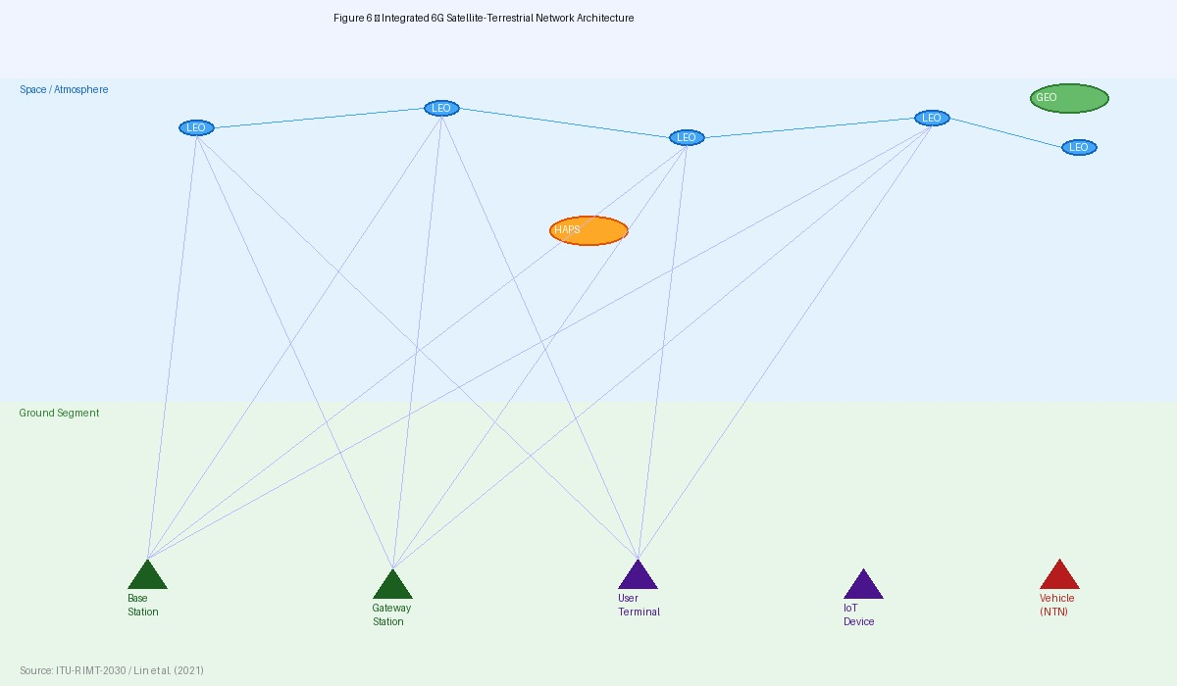
Figure 6. Conceptual architecture of an integrated 6G satellite-terrestrial network, showing LEO, HAPS, GEO coordination with base stations, IoT devices, and mobile users. [Source: ITU-R IMT-2030 documentation / Lin et al. (2021) — https://www.itu.int/en/ITU-R/study-groups/rsg5/Pages/imt-2030.aspx]

6.2 Artificial Intelligence in Satellite Operations
Artificial intelligence and machine learning (ML) are beginning to transform satellite operations across multiple domains, from the management of individual spacecraft to the coordination of large constellations and the extraction of information from Earth observation data. The volume and complexity of data generated by large LEO constellations exceed the capacity of traditional ground-based monitoring and control systems managed by human operators; AI-driven autonomy is not a convenience but a necessity.
In the domain of network resource management, reinforcement learning (RL) algorithms are being investigated for dynamic beam forming in HTS systems, where the optimal allocation of power and bandwidth among spot beams depends on traffic demand patterns that vary continuously with user behaviour, weather, and time of day. Traditional static resource allocation, which assigns fixed power and bandwidth to each beam based on long-term traffic forecasts, wastes capacity in beams where demand is below the planned level while causing congestion in beams experiencing above-average demand. RL-based systems can learn to predict demand patterns and proactively redistribute resources, improving overall system throughput and user quality of experience (Del Portillo et al., 2019).
Predictive maintenance is another AI application domain with significant value for satellite operators. Satellite subsystems — solar panels, attitude control thrusters, battery cells, onboard computers — exhibit characteristic degradation patterns in their telemetry data before failing. Machine learning models trained on historical telemetry from large fleets of satellites can detect these precursor signatures and alert operators to take corrective action — adjusting operational parameters to reduce stress, placing redundant components into service, or scheduling a disposal manoeuvre before an uncontrolled failure occurs (Schwabacher, 2005).
In Earth observation, AI and deep learning have produced perhaps the most immediately visible transformations. Convolutional neural networks (CNNs) trained on large annotated datasets of satellite imagery can detect and classify objects — ships, aircraft, vehicles, buildings, crops, and countless others — at speeds and scales impossible for human analysts. Change detection algorithms can automatically identify differences between images of the same area captured at different times, enabling applications from illegal deforestation monitoring to military site change detection (Zhu et al., 2017). Super-resolution techniques, which use deep learning to recover spatial detail beyond the Nyquist limit of the sensor, can improve the effective resolution of satellite imagery by factors of two to four, extending the useful life of existing sensor hardware.
On-orbit processing — the execution of data processing tasks aboard the satellite itself rather than downlinking raw data to the ground — represents a further frontier that AI is beginning to open. Conventional satellite Earth observation missions downlink all captured imagery to the ground for processing, consuming scarce downlink bandwidth with data that may, after processing, be found to contain only clouds or other non-informative content. An AI model embedded in the spacecraft's on-board computer can screen images for content quality and scientific or operational value before downlinking, transmitting only the most informative data products (Giuffrida et al., 2022). This approach, demonstrated in the Phi-Sat-1 mission launched by the European Space Agency in 2020, reduces the demand on the downlink by discarding low-value frames at source.

6.3 Optical and Laser Communication
Free-space optical (FSO) communication, which uses laser beams rather than radio waves to carry information through space, offers several compelling advantages over conventional radio frequency satellite communication. The much shorter wavelengths of infrared laser light — typically around 1,550 nm, the same wavelength used in terrestrial fibre optic systems — allow extremely narrow beam divergence, which concentrates the signal power and reduces the pointing requirement on the receiving antenna while also making the link inherently difficult to intercept. Data rates of 10–100 Gbps per link have been demonstrated on inter-satellite laser links, compared with the 1–4 Gbps achievable on conventional radio frequency satellite links (Hemmati, 2006).
Inter-satellite laser links (ISLLs) are a key component of the Starlink Gen-2 constellation and are planned for future OneWeb and Telesat Lightspeed systems. By connecting satellites to one another with high-rate laser links, these constellations effectively create a mesh network in the sky, capable of routing traffic between any two points on the globe without passing through an intermediate ground station. This architecture can reduce the number of ground stations required, simplify the network topology, and in some cases reduce end-to-end latency by keeping traffic in the low-latency environment of space for longer (Del Portillo et al., 2019).
The principal challenge for FSO links through the atmosphere — as opposed to inter-satellite links in the vacuum of space — is turbulence-induced fading, caused by thermal fluctuations in the refractive index of air that cause the laser beam to wander and scintillate at the receiver. Adaptive optics systems that measure and correct for atmospheric distortion using deformable mirrors, originally developed for astronomical telescopes, are being adapted for ground-to-space optical communication applications. The European Space Agency's LCRD (Laser Communications Relay Demonstration) and LLCD (Lunar Laser Communication Demonstration) experiments have validated key aspects of the technology (Hemmati, 2006).

7. Conclusion
This essay has traced the development and current state of satellite data communication from its origins in the early Space Age through to the sophisticated, multi-layered ecosystem of the present day. The analysis has demonstrated that satellite communication occupies a position in the global data infrastructure that is simultaneously irreplaceable and continuously evolving — irreplaceable because no other technology can match its inherent geographic ubiquity, and continuously evolving because the competitive pressure from improving terrestrial networks and the internal logic of technological progress continuously push the frontier of what satellites can deliver.
The technical foundations examined in Section 2 — orbital mechanics, frequency spectrum management, and signal modulation — reveal a system of extraordinary physical elegance constrained by equally rigorous physical limits. The choice of orbital altitude is not merely a technical preference but a fundamental determinant of latency, coverage, and constellation architecture. The allocation of spectrum is not merely an administrative exercise but a global negotiation whose outcomes shape which applications are commercially viable. The design of modulation and coding schemes is not merely a signal processing challenge but a practical implementation of Shannon's information-theoretic limits.
The concept of Satellite Zooming — realised in the spot beam technology of High-Throughput Satellites — represents the most consequential technical innovation in commercial satellite communication since the transition from analogue to digital transmission. By concentrating transmitted power into small geographic areas and reusing frequency assignments across separated beams, HTS systems have multiplied available satellite capacity by an order of magnitude or more relative to conventional widebeam satellites, driving down cost per bit and enabling satellite broadband to compete — though not yet on equal terms — with terrestrial alternatives in many markets. The ongoing evolution of this technology toward full frequency reuse, software-defined beam forming, and terabit-class aggregate capacity suggests that the capacity constraints that historically limited satellite broadband are being resolved.
The comparative analysis in Section 4 revealed that satellite and terrestrial communication are better understood as complementary rather than competing technologies. Terrestrial fibre dominates in densely populated areas and for applications requiring the lowest possible latency or the highest possible throughput. Satellite communication dominates where terrestrial infrastructure is absent, damaged, or economically impractical to deploy. The integration of these technologies — whether through hybrid satellite-terrestrial network architectures or through the 6G NTN frameworks discussed in Section 6 — promises to eliminate the geographic inequalities in connectivity that have persisted for decades.
The challenges described in Section 5 are real and require sustained attention from engineers, policymakers, and international organisations. Rain fade will continue to impose availability and capacity constraints on Ka-band systems in tropical markets. Latency will remain a fundamental constraint for GEO systems regardless of advances in modulation and coding. The orbital debris problem will worsen before it improves, and the international governance frameworks needed to manage it are still maturing. Cybersecurity threats to satellite infrastructure have escalated from theoretical risks to demonstrated operational realities, and the investment in satellite network security must be commensurate with the criticality of the infrastructure being protected.
Looking ahead, the trajectories established in Section 6 suggest a future in which the boundary between satellite and terrestrial communication is increasingly blurred. Smartphones will communicate directly with LEO satellites as a standard network access mode. AI systems will manage constellation resources, spacecraft health, and ground network routing in real time. Laser inter-satellite links will create high-capacity, low-latency mesh networks in orbit. Earth observation satellites will process their own data on-board, transmitting only actionable intelligence rather than raw imagery. These developments, taken together, suggest that satellite communication in 2035 will bear as little resemblance to the technology of 2005 as the HTS systems of 2025 bear to Telstar 1.
The fundamental insight that Arthur C. Clarke articulated in 1945 — that a satellite in the right orbit could relay signals between any two points on Earth — remains as valid as ever. What has changed is our ability to exploit that insight with a sophistication and efficiency that Clarke could scarcely have imagined. The future of satellite data communication is not a story of a legacy technology defending its market share against terrestrial competitors; it is a story of an enabling technology, continuously reinvented, that will play an essential role in connecting the human species for the foreseeable future.

References
Bedingfield, K. L., Leach, R. D., & Alexander, M. B. (1996). Spacecraft system failures and anomalies attributed to the natural space environment. NASA Reference Publication 1390. National Aeronautics and Space Administration.
Bhattacherjee, D., & Singla, A. (2019). Network topology design at 27,000 km/hour. Proceedings of the 15th International Conference on Emerging Networking Experiments and Technologies (CoNEXT '19), 341–354. https://doi.org/10.1145/3359989.3365407
Bonnal, C., Ruault, J. M., & Desjean, M. C. (2013). Active debris removal: Recent progress and current trends. Acta Astronautica, 85, 51–60. https://doi.org/10.1016/j.actaastro.2012.11.009
Caini, C., & Firrincieli, R. (2004). TCP Hybla: A TCP enhancement for heterogeneous networks. International Journal of Satellite Communications and Networking, 22(5), 547–566. https://doi.org/10.1002/sat.799
Clarke, A. C. (1945). Extra-terrestrial relays: Can rocket stations give world-wide radio coverage? Wireless World, 51(10), 305–308.
Del Portillo, I., Cameron, B. G., & Crawley, E. F. (2019). A technical comparison of three LEO satellite network constellations: Telesat, SpaceX, and OneWeb. Acta Astronautica, 159, 123–135. https://doi.org/10.1016/j.actaastro.2019.03.040
ESA. (2022). ESA's annual space environment report. European Space Agency. https://www.sdo.esoc.esa.int/environment_report/Space_Environment_Report_latest.pdf
ETSI. (2009). Digital video broadcasting (DVB); second generation framing structure, channel coding and modulation systems for broadcasting, interactive services, news gathering and other broadband satellite applications (DVB-S2) (ETSI EN 302 307 V1.2.1). European Telecommunications Standards Institute.
Eutelsat. (2022). KA-SAT network cyber incident. Eutelsat Group Security Report. https://www.eutelsat.com
Evans, B., Bhavnani, L., & Thompson, P. (2016). Integration of satellite and terrestrial systems in future multimedia communications. IEEE Wireless Communications, 12(5), 72–80. https://doi.org/10.1109/MWC.2005.1522108
Fenech, H., Amos, S., Hirsch, A., & Soumpholphakdy, V. (2015). VHTS systems: Requirements and evolution. 2015 IEEE International Vacuum Electronics Conference (IVEC), 1–4. https://doi.org/10.1109/IVEC.2015.7223765
Forman, C., & Van Zeebroeck, N. (2019). Internet adoption and knowledge diffusion. Research Policy, 48(8), 103812. https://doi.org/10.1016/j.respol.2019.103812
Giuffrida, G., Diana, L., de Gioia, F., Noci, G., Furano, G., & Dunne, A. (2022). CloudScout: A deep neural network for on-board cloud detection on hyperspectral images. Remote Sensing, 12(14), 2205. https://doi.org/10.3390/rs12142205
Guidotti, A., Vanelli-Coralli, A., Caus, M., Bas, J., Alagha, N., & Barbiroli, M. (2019). Architectures and key technical challenges for 5G systems incorporating satellites. IEEE Transactions on Vehicular Technology, 68(3), 2624–2639. https://doi.org/10.1109/TVT.2019.2895263
Hemmati, H. (Ed.). (2006). Deep space optical communications. John Wiley & Sons.
Hofmann-Wellenhof, B., Lichtenegger, H., & Wasle, E. (2008). GNSS – Global navigation satellite systems: GPS, GLONASS, Galileo, and more. Springer.
Humphreys, T. E., Ledvina, B. M., Psiaki, M. L., O'Hanlon, B. W., & Kintner, P. M. (2008). Assessing the spoofing threat: Development of a portable GPS civilian spoofer. Proceedings of the 21st International Technical Meeting of the Satellite Division of The Institute of Navigation (ION GNSS 2008), 2314–2325.
Imran, A., Zoha, A., & Abu-Dayya, A. (2014). Challenges in 5G: How to empower SON with big data for enabling 5G. IEEE Network, 28(6), 27–33. https://doi.org/10.1109/MNET.2014.6963801
Ippolito, L. J. (2017). Satellite communications systems engineering: Atmospheric effects, satellite link design and system performance (2nd ed.). John Wiley & Sons.
ITU. (2022). Measuring digital development: Facts and figures 2022. International Telecommunication Union. https://www.itu.int/en/ITU-D/Statistics/Documents/facts/FactsFigures2022.pdf
ITU-R. (2017). Propagation data and prediction methods required for the design of Earth-space telecommunication systems (Recommendation ITU-R P.618-13). International Telecommunication Union Radiocommunication Sector.
ITU-R. (2023). Future technology trends of terrestrial IMT systems towards 2030 and beyond (Report ITU-R M.2516). International Telecommunication Union Radiocommunication Sector.
Jones, H. W. (2018). The recent large reduction in space launch cost. 48th International Conference on Environmental Systems, 1–10. ICES-2018-81.
Kessler, D. J., & Cour-Palais, B. G. (1978). Collision frequency of artificial satellites: The creation of a debris belt. Journal of Geophysical Research, 83(A6), 2637–2646. https://doi.org/10.1029/JA083iA06p02637
Kyrgiazos, A., Evans, B., Thompson, P., Mathiopoulos, P. T., & Papaharalabos, S. (2014). A terabit/s satellite system for European broadband access: A feasibility study. International Journal of Satellite Communications and Networking, 32(1), 63–92. https://doi.org/10.1002/sat.1067
Lin, X., Hofström, R., Wang, H., Rydén, H., Euler, S., Hammarwall, D., & Liu, J. (2021). User equipment positioning in 3GPP New Radio. IEEE Communications Standards Magazine, 5(2), 32–39. https://doi.org/10.1109/MCOMSTD.001.2000060
Liou, J. C. (2011). An active debris removal parametric study for LEO environment remediation. Advances in Space Research, 47(11), 1865–1876. https://doi.org/10.1016/j.asr.2010.02.003
Lutz, E., Werner, M., & Jahn, A. (2012). Satellite systems for personal and broadband communications. Springer.
Maral, G., & Bousquet, M. (2020). Satellite communications systems: Systems, techniques and technology (6th ed.). John Wiley & Sons.
Pelton, J. N. (2013). Satellite communications. Springer.
Pratt, T., Bostian, C., & Allnutt, J. (2003). Satellite communications (2nd ed.). John Wiley & Sons.
Roddy, D. (2006). Satellite communications (4th ed.). McGraw-Hill.
Sandau, R. (2010). Status and trends of small satellite missions for Earth observation. Acta Astronautica, 66(1–2), 1–12. https://doi.org/10.1016/j.actaastro.2009.06.008
Satellite Evolution Group. (2011). ViaSat-1: World's highest capacity communications satellite. Satellite Evolution, 10(4), 14–18.
Satellite Industry Association. (2023). 2023 state of the satellite industry report. Satellite Industry Association.
Schwabacher, M. (2005). A survey of data-driven prognostics. Proceedings of the AIAA Infotech@Aerospace Conference, AIAA 2005-7004. https://doi.org/10.2514/6.2005-7004
Smutny, B., Kaempfner, H., Muehlnikel, G., Sterr, U., Wandernoth, B., Heine, F., Hildebrand, U., Dallmann, D., Reinhardt, M., Freier, A., Lange, R., Böhmer, K., Feldhaus, T., Mueller, J., Greinert, H., Motzigemba, M., Meyer, R., Philipp-May, S., & Haspang, R. (2009). 5.6 Gbps optical intersatellite communication link. Proceedings of SPIE, 7199, Free-Space Laser Communication Technologies XXI. https://doi.org/10.1117/12.808033
Spilker, J. J., & Parkinson, B. W. (Eds.). (1996). Global positioning system: Theory and applications (Vol. 1). American Institute of Aeronautics and Astronautics.
Telkamp, T., Lelic, M., & Tibuleac, S. (2017). MAREA subsea cable system: Design and operational performance. Proceedings of the European Conference on Optical Communication (ECOC 2017).
ViaSat Inc. (2022). ViaSat-3 satellite constellation: Technical overview and capacity design. ViaSat White Paper.
Zhu, X. X., Tuia, D., Mou, L., Xia, G. S., Zhang, L., Xu, F., & Fraundorfer, F. (2017). Deep learning in remote sensing: A comprehensive review and list of resources. IEEE Geoscience and Remote Sensing Magazine, 5(4), 8–36. https://doi.org/10.1109/MGRS.2017.2762307
Forman, C., & Van Zeebroeck, N. (2012). From wires to partners: How the Internet has fostered R&D collaborations within firms. Management Science, 58(8), 1549–1568. https://doi.org/10.1287/mnsc.1110.1437
ITU-R. (2021). Satellite news gathering (Report ITU-R BT.2069-2). International Telecommunication Union Radiocommunication Sector.
Casini, E., De Gaudenzi, R., & Herrero, O. D. R. (2007). Contention resolution diversity slotted ALOHA (CRDSA): An enhanced random access scheme for satellite access packet networks. IEEE Transactions on Wireless Communications, 6(4), 1408–1419. https://doi.org/10.1109/TWC.2007.348337
Abramson, N. (1970). THE ALOHA SYSTEM — another alternative for computer communications. Proceedings of the November 17-19, 1970, Fall Joint Computer Conference, 281–285. https://doi.org/10.1145/1478462.1478502
Kandeepan, S., De Nardis, L., Di Benedetto, M. G., Guidotti, A., & Corazza, G. E. (2010). Cognitive satellite terrestrial radios. 2010 IEEE Global Telecommunications Conference (GLOBECOM 2010), 1–6. https://doi.org/10.1109/GLOCOM.2010.5683789
De Zan, F., & Monti Guarnieri, A. (2006). TOPSAR: Terrain observation by progressive scans. IEEE Transactions on Geoscience and Remote Sensing, 44(9), 2352–2360. https://doi.org/10.1109/TGRS.2006.873853
Gao, S., Clark, K., Unwin, M., Zackrisson, J., Shiroma, W. A., Akagi, J. M., & Underwood, C. (2009). Antennas for modern small satellites. IEEE Antennas and Propagation Magazine, 51(4), 40–56. https://doi.org/10.1109/MAP.2009.5338682
Handley, M. (2018). Delay is not an option: Low latency routing in space. Proceedings of the 17th ACM Workshop on Hot Topics in Networks (HotNets '18), 85–91. https://doi.org/10.1145/3286062.3286075
Vidal, O., Verelst, G., Lacan, J., Alberty, E., Radzik, J., & Bousquet, M. (2012). Next generation high throughput geostationary systems. 2012 IEEE First AESS European Conference on Satellite Telecommunications (ESTEL), 1–7. https://doi.org/10.1109/ESTEL.2012.6400139
Sauter, M. (2021). From GSM to LTE-Advanced Pro and 5G: An introduction to mobile networks and mobile broadband (3rd ed.). John Wiley & Sons.
Perez-Neira, A. I., Caus, M., Vazquez, M. A., Lagunas, E., Bhavani Shankar, M. R., Shankar, B., & Grotz, J. (2019). Signal processing for high-throughput satellites: Challenges in new interference-limited scenarios. IEEE Signal Processing Magazine, 36(4), 112–131. https://doi.org/10.1109/MSP.2019.2909872

