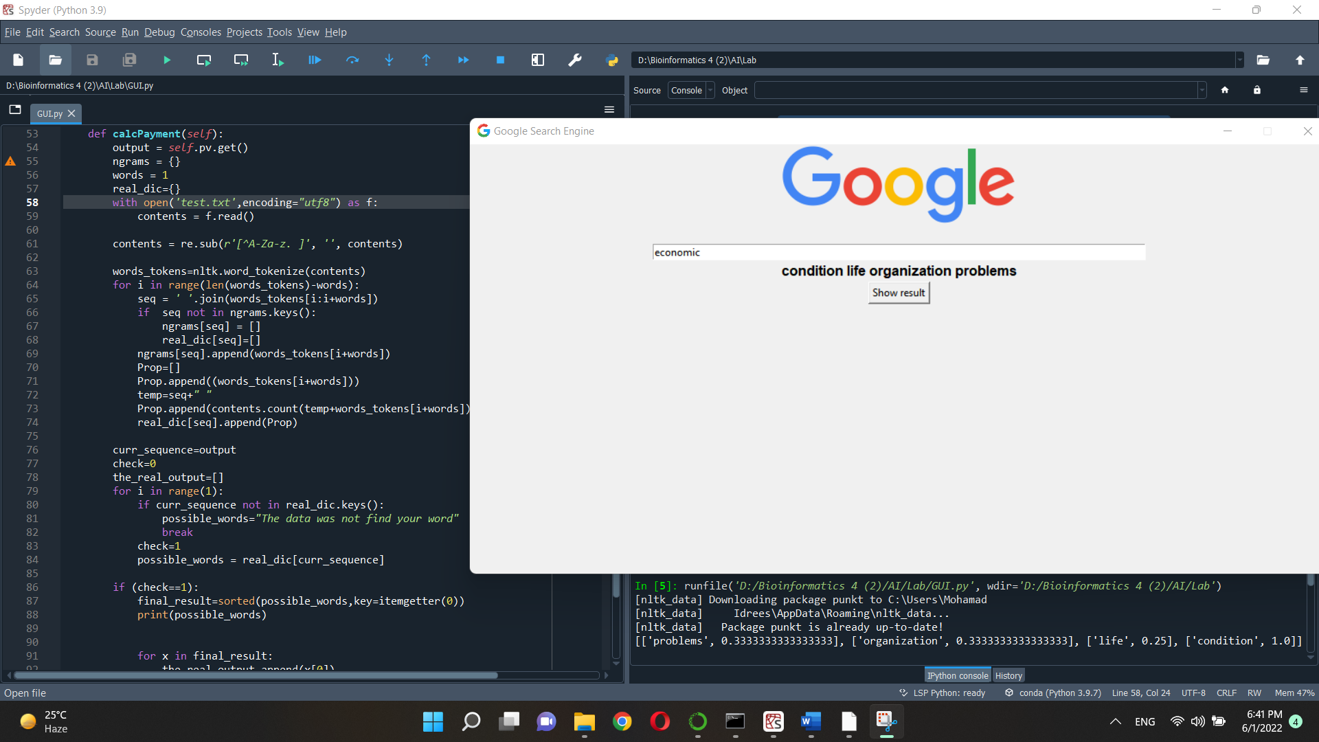

1)-Test the word:

economic

The result is in dictionary when the key is (economic) and value have the related word to economic

Each word has **probability** that this word come after economic word

[

['problems', 0.3333333333333333],

['organization', 0.3333333333333333],

['life', 0.25],

['condition', 1.0]

]

We can see that the word that have **higher probability** is condition and the second is life so the output print the condition word first then life then organization the problems.

2)

Test when we our Input word not in our Data:

