Retail Business

Dataset is:

Customers

Products

Category

Orders

Seven Scenarios were asked   
( mainly ingest -> a simple query -> save job)

Scenario 1:

Customers tab delimited

1. Reading

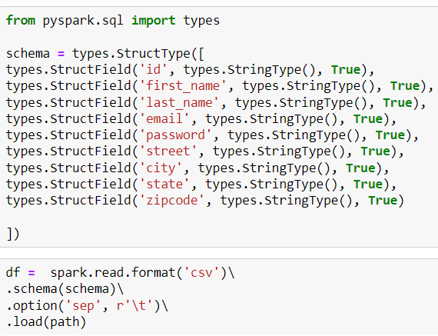

1. Filtering by state:



1. Concat:

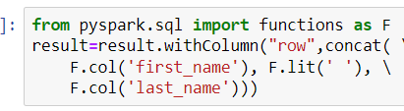

1. Saving:



Scenario 2:

Orders Parquet

The downloaded parquet files didn’t work.

Solution: parquetize order csv

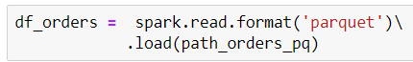



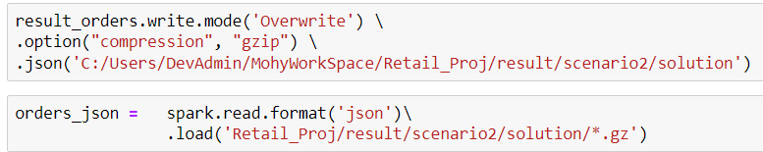

Scenario 3:

Customers tab delimited

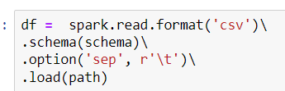



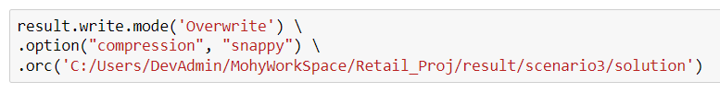

Scenario 4:

Categories

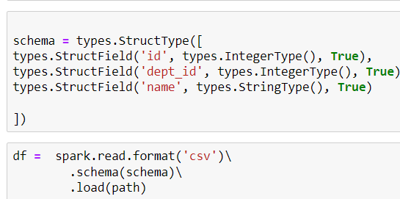

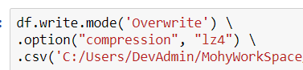

Scenario 5:



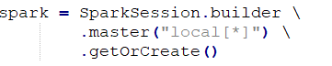

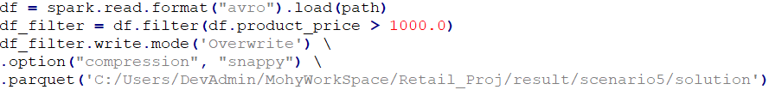

Scenario 6:



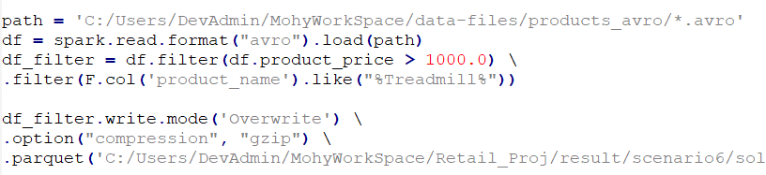

Scenario 7:

