ME 7120: Finite Element Method Applications

**Project III**

By

**Hao Li,**

**Obidigbo Chigozie**

**Mohammed Al Rifaie,**

**Prof:** Dr. Slater

**Submitted:** December 9nd, 2016

Table of Contents

Nomenclature i

Table of Figures ii

Project Description 1

Conclusion x

Appendix x

# Nomenclature

𝟂 = Natural Frequency

Ω =

𝛽 =

D = Displacement

DD = Velocity

DDD = Acceleration

P = Load

L = Length

A = Cross Sectional Area

E = Young’s Modulus of Elasticity

t = Time

F = Force

K = Stiffness Matrix

M = Mass Matrix

C = Damping Matrix

**Table of Figures**

**Project Description**

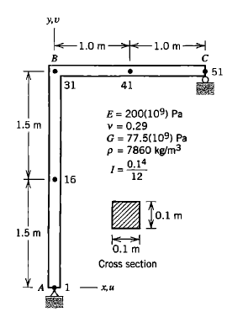For this project III, Finite Element Method was used to formulate and solve a time dependent structural problem. The stiffness matrix K and mass matrix M were obtained using WFEM. The objective is to formulate the damping matrix C using the stiffness matrix and mass matrix for the L-shaped structure of fig 11.17-1 from the text book “Concepts and Applications of Finite Element Analysis, 4th Edition, Wiley, 2001”, as shown in Figure 1.

Figure

Using WFEM gives a size of [306x306] for M and K because there are 6 DOFs at each node. For 2D problem, there are one DOF at node 1, 2 DOFs at node 51 and three DOFs at nodes (2-50) so that the size becomes [150x150]. The 3D stiffness and mass matrices are reduced to 2D and the boundary conditions are applied using the find_C.m function in Matlab. This function also generates the C matrix after solving eigenvalue and eigenvector problem. After which we use the integration method of Newmark beta to calculate for the transient response of the step loading of the system with a force F = ${10}^{5}$ N over a total time t = 0.01s, calculating the acceleration (DDD), velocity (DD) and displacement (D) of the 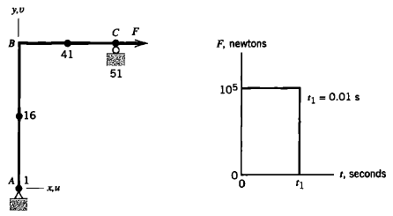system over this time period, as shown in Figure 2.

Figure

Finally, a comparison of the five Newmark beta methods are used to compare the responses generated using WFEM with those gotten from the text book.

**Damping Matrix C**

Continue…