**Results:**

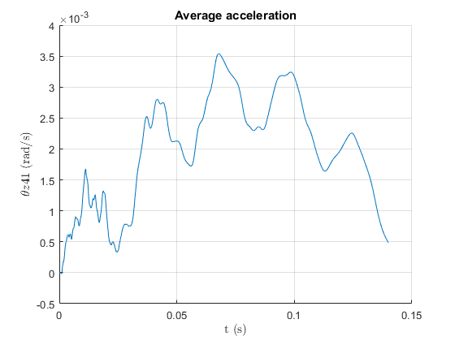The next 6 figures show the rotation θz at node 41 vs time(s) for 5 methods compared with text book, ζ=0.02.

Figure : Average acceleration, ζ=0.02

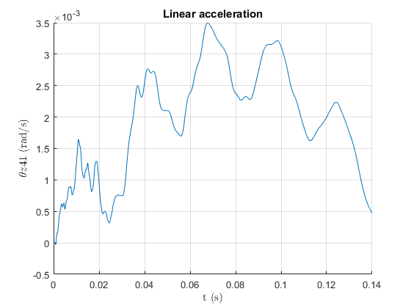

Figure : Linear acceleration, ζ=0.02

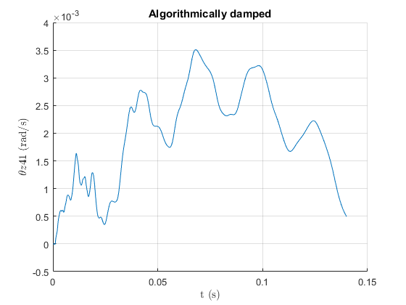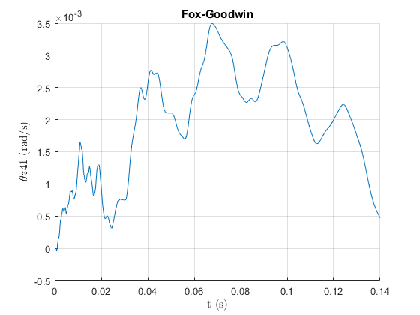

Figure :Algorithmically damped, ζ=0.02

Figure : Fox-Goodwin, ζ=0.02

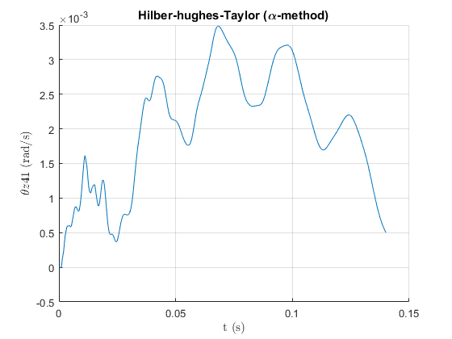

Figure : Hilber-hughes-Taylor (α-method), ζ=0.02

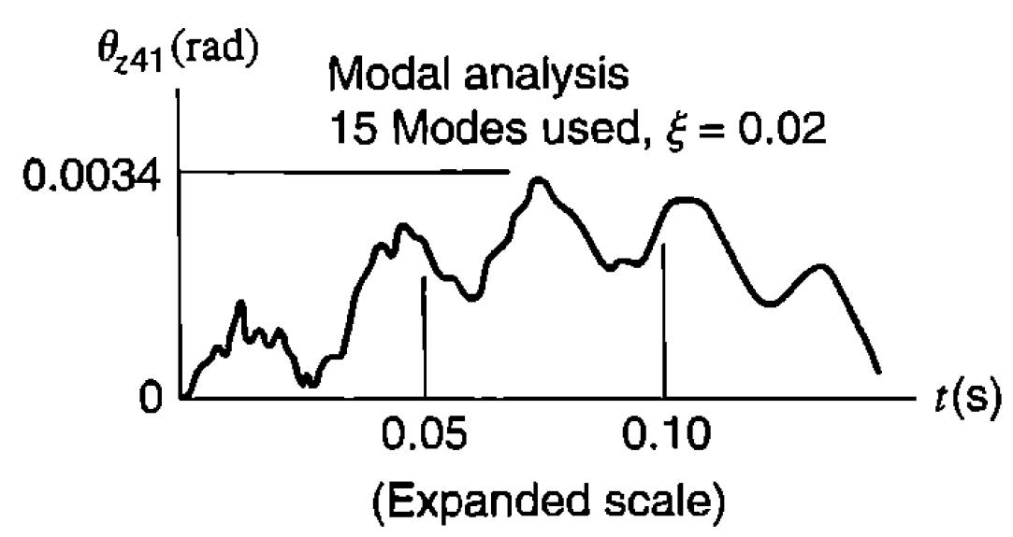

Figure : Text book figure, ζ=0.02

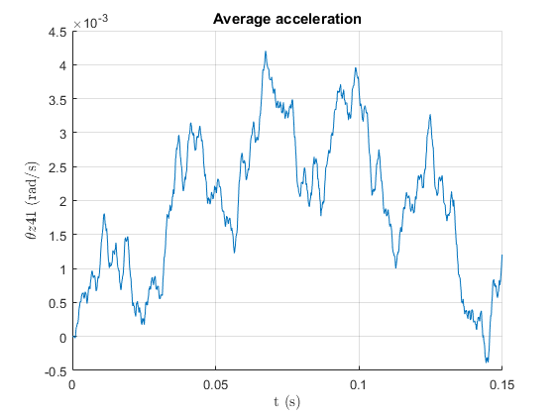The next 6 figures show the rotation θz at node 41 vs time(s) for 5 methods compared with text book when ζ=0.

Figure 9: Average acceleration, ζ=0

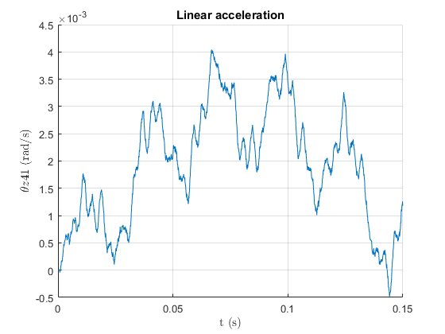

Figure 10: Linear acceleration, ζ=0

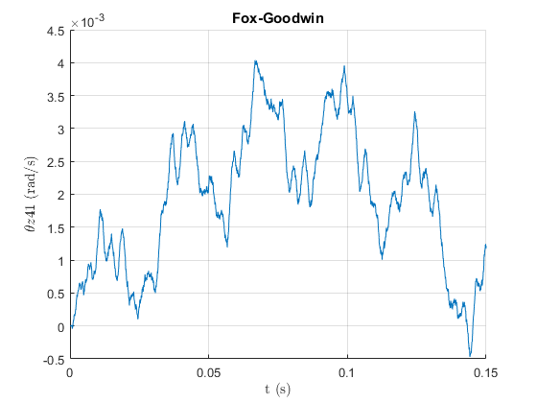

Figure 12: Algorithmically damped, ζ=0.02

Figure 11: Fox-Goodwin, ζ=0.02

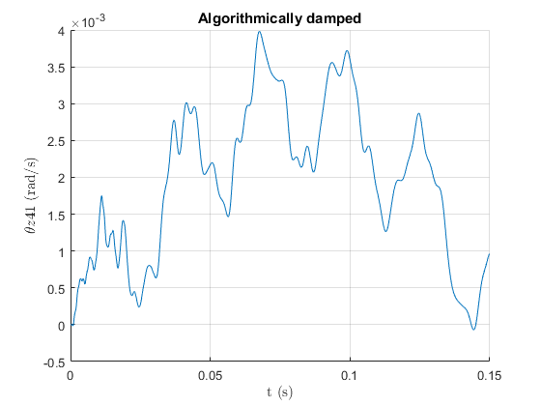

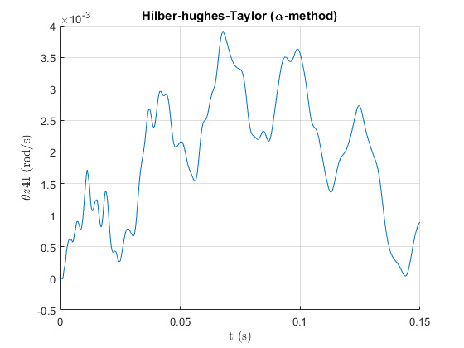

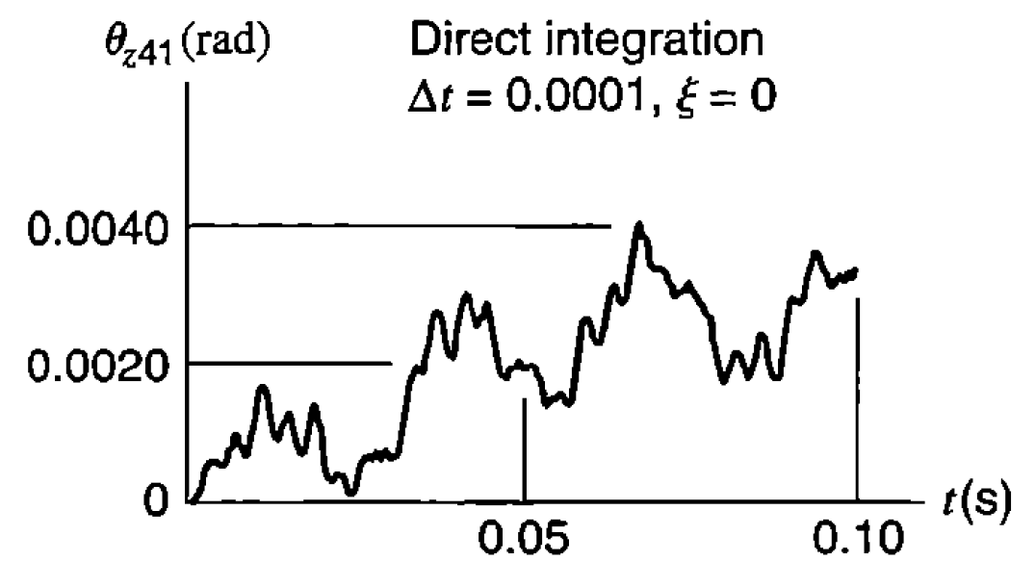

Figure 14: Text book figure, ζ=0.02

Figure 13: Hilber-hughes-Taylor (α-method), ζ=0.0