**Admir Makas**

**Reliability HW #3**

**Problem 1 and 2:** Create MCS Matlab script for the simply supported beam.

**Answer:** Code for the MCS is listed in Figure 1

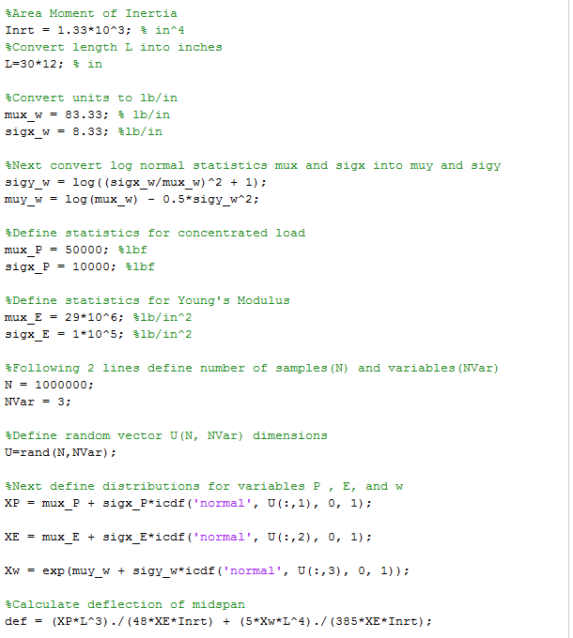

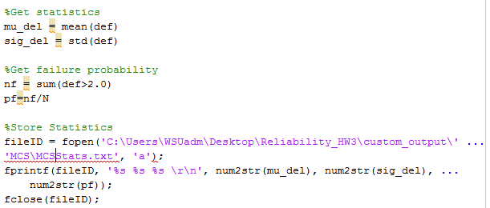

Figure 1

Code from Figure 1 was used to run MCS with N = 100, 10,000, 1,000,000 samples. For each number of samples N, 45 simulations were carried out to study convergence properties. These results are listed in Table 1 below.

|  |  |  |  |
| --- | --- | --- | --- |
| **N** | **Mean Disp. (in)** | **St Dev of Mean** |  |
| 100 | 1.737 | 0.0254 | 45 runs |
| 10000 | 1.731 | 0.0024 | 45 runs |
| 1000000 | 1.731 | 0.0002 | 45 runs |

Table 1

With increase of N samples the average beam displacement converges to 1.731 inches. The convergence behavior for the MCS technique is plotted in Figure 2

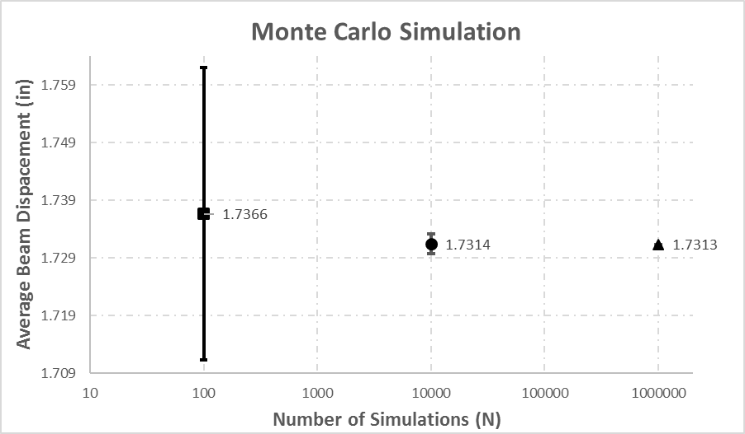

Figure 2

**Problem 3:** Run MCS with LHS.

**Answer:** Code for the MCS employing LHS is listed in Figure 3

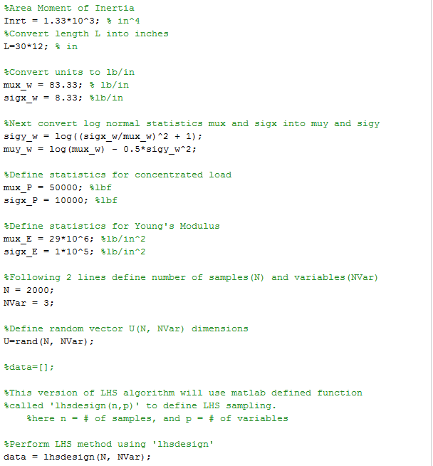

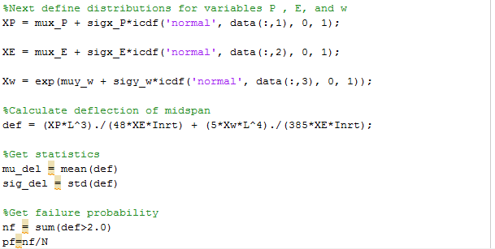

Figure 3

Using code in Figure 3, beam displacements were calculated with N = 100, 1000, 10000. For each number of samples N, 45 simulations were carried out to study convergence properties. These results are listed in Table 2 below. The answer converges to an average of 1.731 inches as soon as N=100.

|  |  |  |  |
| --- | --- | --- | --- |
| **N** | **Mean of Mean** | **St Dev of Mean** |  |
| 100 | 1.73134 | 0.00085 | 45 samples |
| 1000 | 1.73132 | 0.00009 | 45 samples |
| 10000 | 1.73132 | 0.00004 | 45 samples |

Table 2

From Table 2 it is clear that the LHS design simulation converged in about 100 samples. For the pure MCS design this level of accuracy was only achieved at N=1,000,000. Figure 4 shows the convergence plot for the LHS simulations.

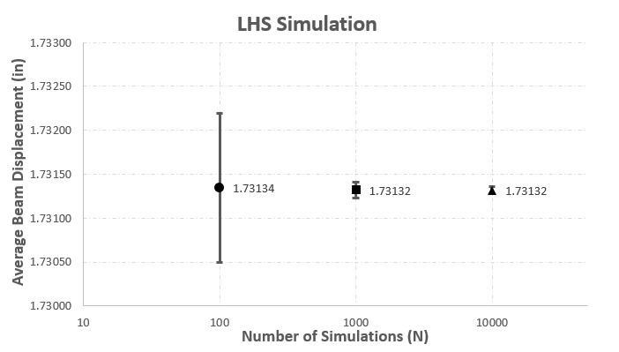

Figure 4

**Problem 4 and 5:** Create FEA model for the simply supported beam, use LHS design to estimate probability that δmax>2.0 inches.

**Answer:** FEA model was created in ABAQUS using beam elements. Figure 5 shows the model set-up with the boundary conditions and applied loads (P, w).

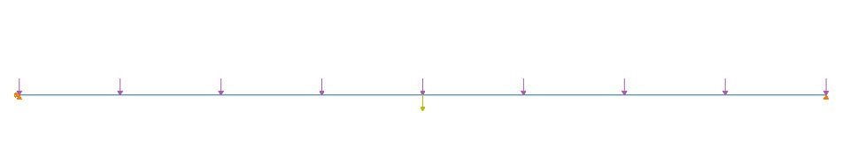

Figure 5

ABAQUS input file was generated using the beam definition from Figure 5. Following pages will show the simulation results and Matlab code used to perform the calculations.