**Control Assignment**

**ELC 3252**

|  |  |  |
| --- | --- | --- |
| **Name** | **Section** | **BN** |
| بيتر عاطف فتحي | 1 | 19 |
| بموا عريان عياد | 1 | 18 |
| مارك ياسر نبيل | 2 | 12 |

***Team Members***

**1. Write the dynamic equations of the system and use them to build the block diagram of the system (hand analysis).** 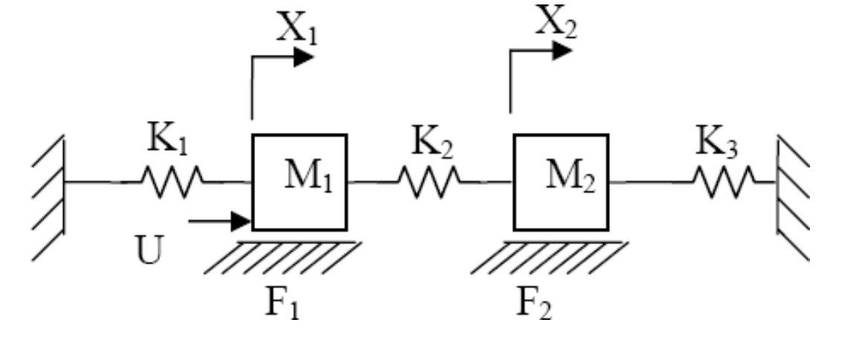

**Forces affecting M1:**

k1x1🡨

F1🡨

U 🡪

K2x1🡨

K2x2🡨

**Forces affecting M2:**

K2x1🡪

K2x2🡨

F1🡨

K3x2🡨

**Equations**

**Laplace**

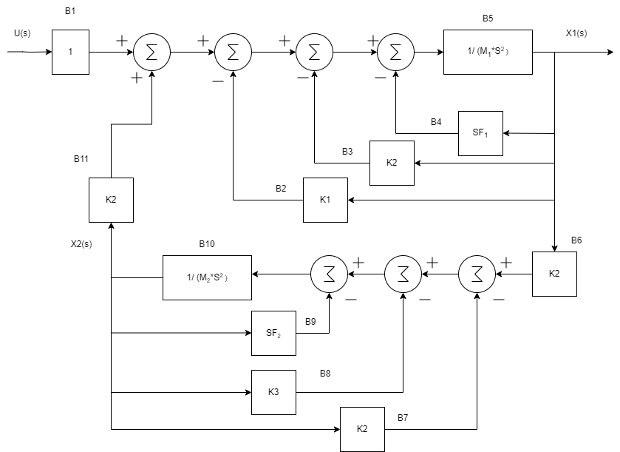

**2. MATLAB Code: in “main.m”**

**3. Stability Test for X1/U**

All poles exist in the left half plane, then the system is stable.

This can also be verified using Routh table:

**Given**

M1 = M2 = 100Kg.

K1 = K3 = 5 N/m and K2=50 N/m.

F1 = F2 = 100 Kg/sec.

Routh Table:

|  |  |  |  |
| --- | --- | --- | --- |
|  |  |  |  |
|  |  |  |  |
|  |  |  |  |
|  |  |  |  |
|  |  |  |  |

**4. Steady state values for X1 and X2 if u(t) = 1N**

Steady state response as plotted from MATLAB:

X1steady state = 0.105

X2steady state =0.0952

**Hand calculation on steady state values:**

u = 1 * u(t)

U(S) = 1/S

X1steady state =

=

X2steady state =

=

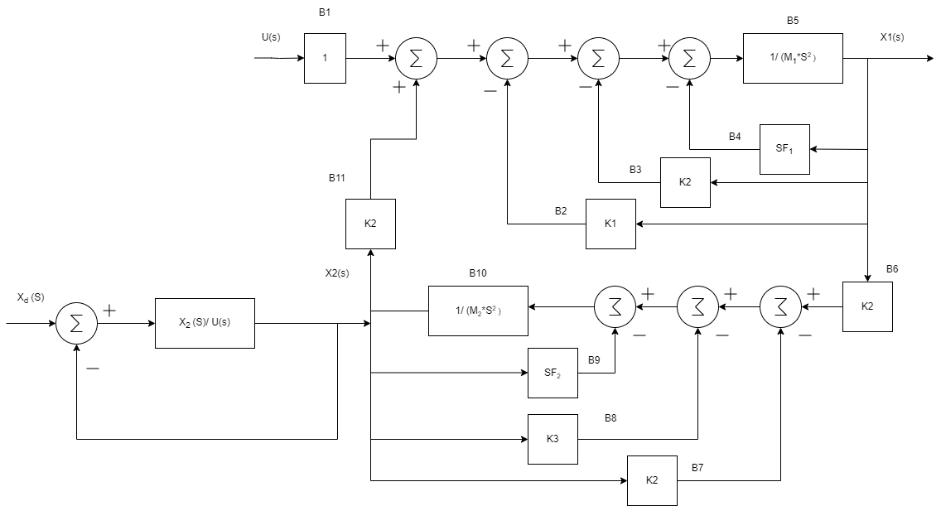**5. System modification**

This figure shows the modification to the system as described, where Xd is the input to the system, X2 is the output, and the transfer function is X2(s)/U(s).

**6. Simulate the system for a desired level (Xd) of 2 m. showing the response of X2.**

**7. For the response of X2 calculate the value of the rise time, peak time, max peak, and settling time. Also calculate the value of ess.**

X2) ss = 0.174

ess = 2 – 0.174 = 1.826

trise = 160 s

tsettling = 107 s

max peak = 0.174

tpeak > 160 s

overshoot = 0%

**8. As a solution to reduce the value of ess a proportional controller can be used. Study the effect of the value of proportional controller on both ess and transient response by simulating the system with the following values of P controller: 1, 10,100, and 1000. Calculate transient response parameters for each case. Comment on your results.**

|  |  |
| --- | --- |
|  | Kp = 1  X2) ss = 0.174  ess = 2 – 0.174 = 1.826  It is an over-damping system. Because the values of the damping ratio for the 4 poles are [ 1.0000, 0.6427, 0.6427, 1.0000]. |
|  | Kp = 10  X2) ss = 0.976  ess = 2 – 0.976 = 1.024  trise > 79.9 s  tsettling = 57.1 s  max peak >= 0.972  tpeak > 80s  overshoot = 0%  It’s a critical-damping system. Because the values of the damping ratio for the 4 poles are [1.0000, 0.6499, 0.6499, 1.0000]. |
|  | Kp = 100  X2) ss = 1.81  ess = 2 – 1.81= 0.19  trise = 5.46 s  tsettling = 15.5 s  max peak = 2.15  tpeak = 7.56 s  overshoot = 18.6%  The values of the damping ratio for the 4 poles are [0.4010, 0.4010, 1.0000, 1.0000].  So, the system is under damping. |
|  | Kp = 1000  X2) ss = infinity  ess = 2 – infinity= infinity  trise = infinity s  tsettling = infinity s  max peak <= -2.1e+27  tpeak > 200 s  overshoot = Nan  This happened because it’s unstable system.  There are poles in the RHP as the values of the damping ratio for the 4 poles are [-0.2920,  -0.2920, 0.8848, 0.8848]. |

**9. If the desired displacement of the second mass is to be 4 m, is it possible to obtain a steady state error less than 0.01 m using a proportional-only controller? Why?**

ess

For ess < 0.01 ==> Kp > 4189.5

But that **not possible** because that will lead to unstable system because there are two poles in the RHP “negative damping ratio.”

|  |  |
| --- | --- |
|  |  |

**10. Suggest a suitable controller to eliminate ess. Then, simulate the system using your proposed controller.**

We can use PI controller so

Kp = 100;

KI = 0.001;

C = tf([Kp, KI], [1,0]);

|  |  |
| --- | --- |
|  |  |

X2) ss = 4

ess = 4 - 4 = 0

trise = 6.16 s

max peak = 4.29

tpeak = 7.56 s

overshoot = 7.36%

And it’s a stable system “under-damping.”