**Control Assignment**

**ELC 3252**

|  |  |  |
| --- | --- | --- |
| **Name** | **Section** | **BN** |
| بيتر عاطف فتحي | 1 | 19 |
| بموا عريان عياد | 1 | 18 |
| مارك ياسر نبيل | 2 | 12 |

***Team Member***

Block Diagram: [*Link*](https://drive.google.com/file/d/1cFy5M5Vbqa_fztm7AiotJyVKdfv6QU6D/view?usp=sharing)

1. **Dynamic equations of the system**

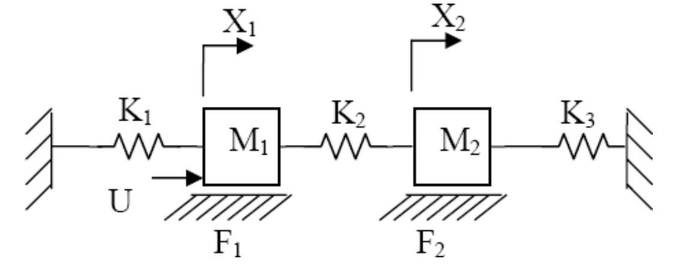

**Forces affecting M1:**

k1x1🡨

F1🡨

U 🡪

K2x1🡨

K2x2🡨

**Forces affecting M2:**

K2x1🡪

K2x2🡨

F1🡨

K3x2🡨

**Equations**

**Laplace**

**3. Stability Test**

**Given**

M1 = M2 = 100Kg.

K1 = K3 = 5 N/m and K2=50 N/m.

F1 = F2 = 100 Kg/sec.

|  |  |  |  |
| --- | --- | --- | --- |
|  |  |  |  |
|  |  |  |  |
|  |  |  |  |
|  |  |  |  |
|  |  |  |  |