Speech Signal Modulation

|  |  |  |
| --- | --- | --- |
| Name | Section | BN |
| Peter Atef | 1 | 19 |
| Beshoy Morad | 1 | 20 |

Q1)

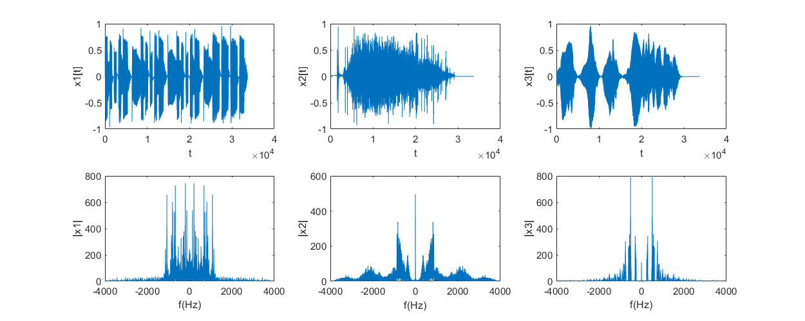

Figure 1 original signals in Time domain and magnitude spectrum

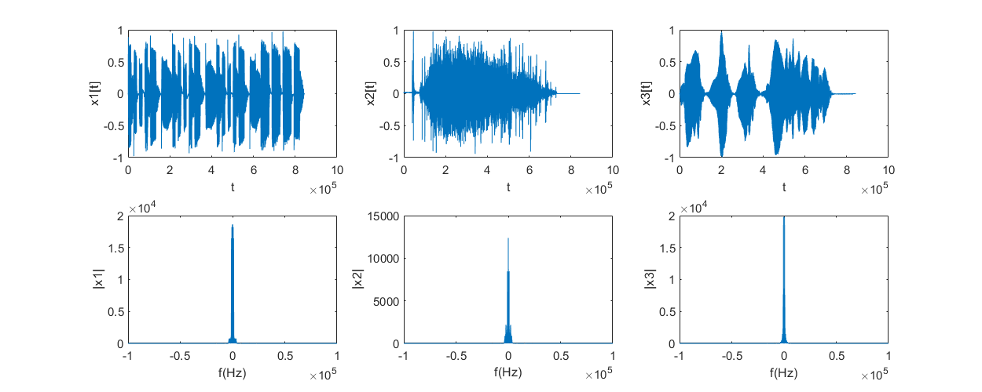

Figure 2 up sampled signals to have more room in frequency domain for manipulation

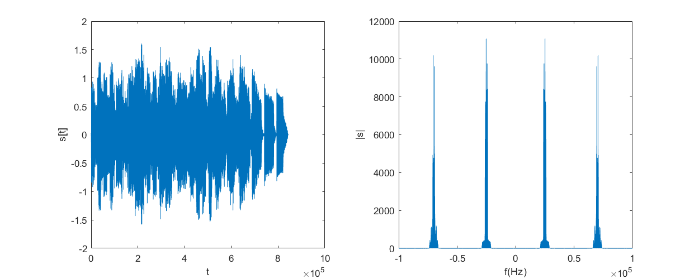

Figure 3 Modulated Signal in Time domain and magnitude spectrum

Q2)

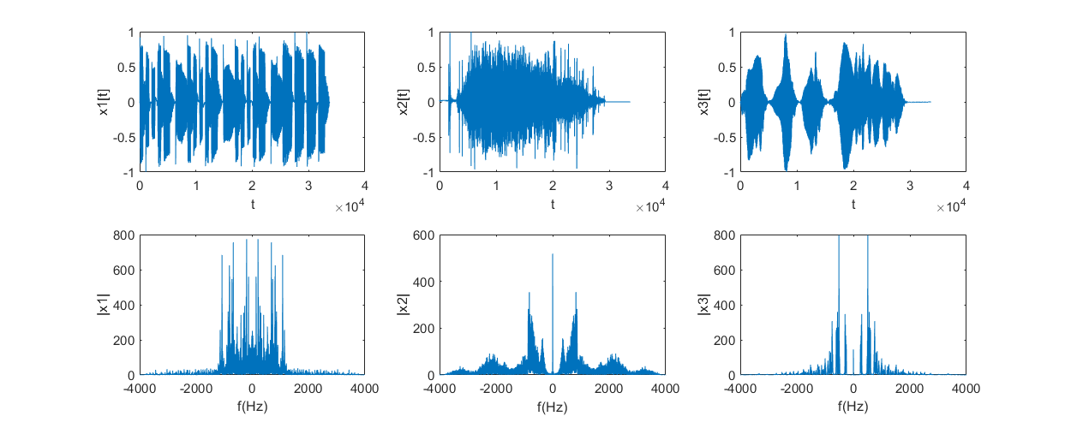

Figure 4 obtained signals after synchronous demodulation

We notice that there is no interference between the three signals after performing synchronous demodulation due to wise choice of carrier frequency. As we can see in Figure 3 the first signal doesn’t interfere with the other two signals and the other two signals don’t interfere as they perpendicular to each other one has phase 0 while the other is phase 90.

Q3)

Due to producing phase shifts to the local carrier used in the demodulator for example the first signal $X_{1}$ after demodulation will be $\frac{1}{2}X_{1}\left(t\right) cos\left(phaseShift\right)$ so if phase shift changes to anything but zero this will cause attenuation to the recovered signal $X_{1}$

While recovered $X_{2}$ will be $\frac{1}{2}\left[X_{2}\left(t\right)cos\left(phaseShift\right)-X_{3}sin\left(phaseShift\right)\right]$ and $X_{3}$ will be $\frac{1}{2}\left[X_{3}\left(t\right)cos\left(phaseShift\right)-X_{2}sin\left(phaseShift\right)\right]$

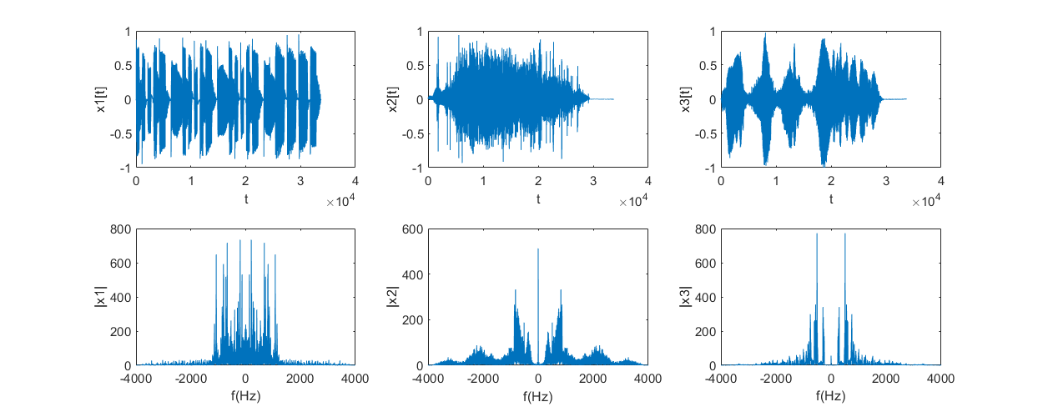

Figure 5 demodulated signals with phase shift 10

We notice in Figure 5 that the signals $X_{2}$ and $X_{3}$ begin to interfere (cochannel interference). Also, attenuation starts to happen to all signals.

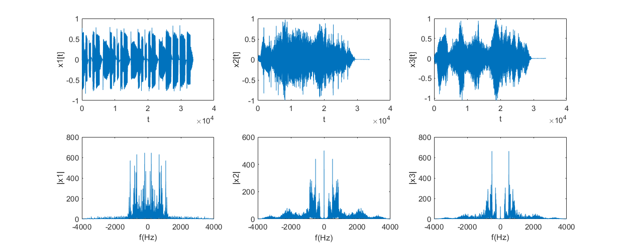

Figure 6 demodulated signals with phase shift 30

We begin to see in Figure 6 more attenuation in all signals and more cochannel interference between $X_{2}$ and $X_{3}$

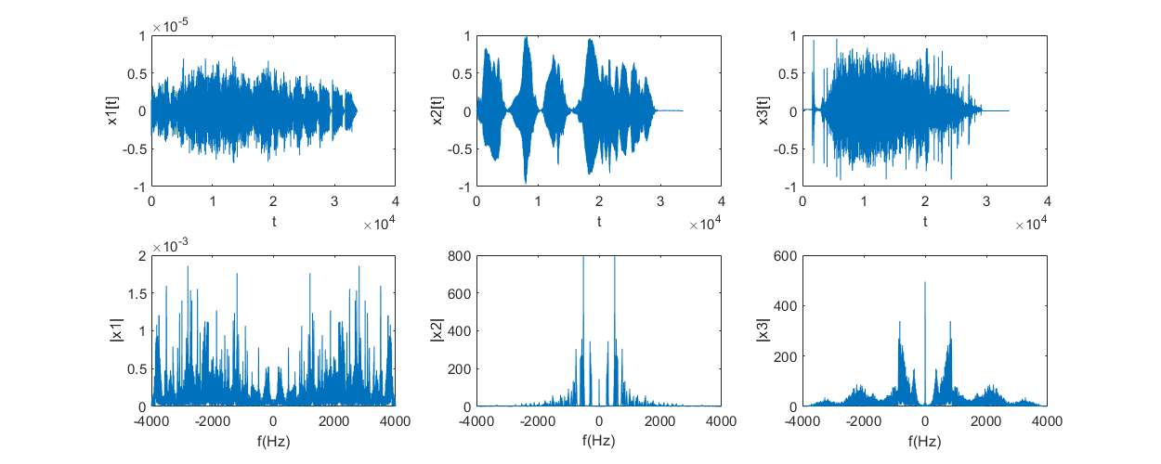

Figure 7 demodulated signals with phase shift 90

We notice in Figure 7 that the signal $X_{1}$ is now attenuated and has a very low amplitude (approx. zero) due to imperfection but it should be absolutely zero, we also notice that the signals $X_{2}$ and $X_{3}$ reached maximum interference as when we wanted to retrieve signal $X_{2}$ we got $X_{3}$ and **vice versa**

Q4)

Due to producing frequency shifts to the local carrier used in the demodulator:

$X_{1}$ after demodulation will be $\frac{1}{2}X_{1}\left(t\right) cos\left(frequencyShift*t\right)$

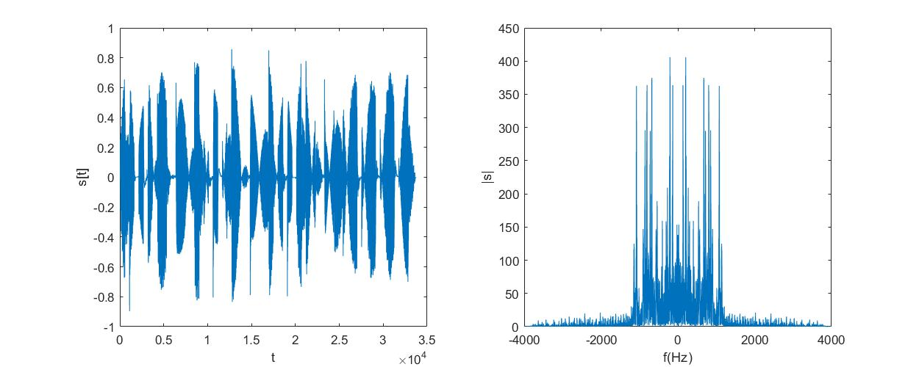

Figure 8 demodulated signals with frequency shift 2 Hz

We notice in Figure 7 that the signal $X_{1}$ is multiplied by a low frequency sinusoid, and this causes attenuation and distortion to the signal and the sound became slightly intermittent

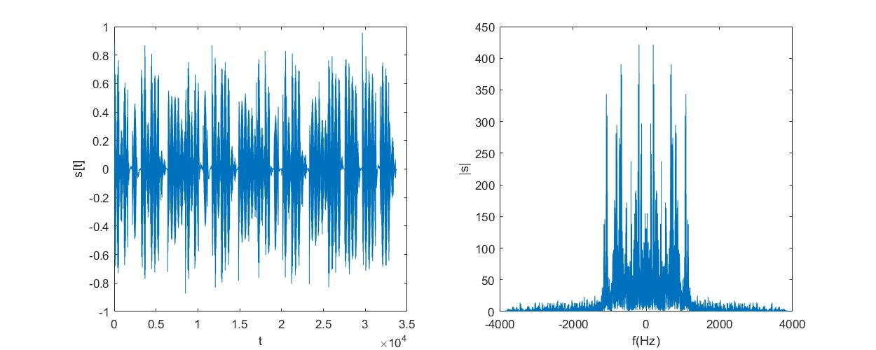

Figure 9 demodulated signals with frequency shift 10 Hz

From Figure 9 distortion increased and the sound became more intermittent

**Read the audio signal**

% assumptions made on the signals:

% 1- they have same sampling rate

% 2- they are less than 10 seconds

% 3- they are mono not stereo

speechSignalFileName = 'Comm_Signal';

[signal1, Fs1] = audioread([speechSignalFileName '_1.wav']);

[signal2, Fs2] = audioread([speechSignalFileName '_2.wav']);

[signal3, Fs3] = audioread([speechSignalFileName '_3.wav']);

**Edit the signals to be with equal length**

padding1 = 0;

padding2 = 0;

padding3 = 0;

maxSamples = max(max(length(signal2), length(signal3)), length(signal1));

if length(signal1) ~= maxSamples

padding1 = maxSamples - length(signal1);

signal1 = padarray(signal1, maxSamples - length(signal1), 0, "post");

end

if length(signal2) ~= maxSamples

padding2 = maxSamples - length(signal2);

signal2 = padarray(signal2, maxSamples - length(signal2), 0, "post");

end

if length(signal3) ~= maxSamples

padding3 = maxSamples - length(signal3);

signal3 = padarray(signal3, maxSamples - length(signal3), 0, "post");

end

displaySignals(signal1, signal2, signal3, Fs1, "After extending to same length");

**Up sampling the signals**

upSamplingRate = 25;

signal1 = resample(signal1, upSamplingRate, 1);

signal2 = resample(signal2, upSamplingRate, 1);

signal3 = resample(signal3, upSamplingRate, 1);

Fs1 = Fs1 * upSamplingRate;

Fs2 = Fs2 * upSamplingRate;

Fs3 = Fs3 * upSamplingRate;

displaySignals(signal1, signal2, signal3, Fs1, "After upsampling");

**Perform modulation**

% modulating signals

duration = length(signal1) ./ Fs1;

t = -(duration-1/Fs1)/2 : 1/Fs1 :(duration-1/Fs1)/2;

% current Fs is 200kHz assume worst case that our sound signals take a

% bandwidth of 20KHz

fcarrier1 = 25000;

fcarrier2 = 70000;

% generate the carriers

carrier1 = cos(2 * pi * fcarrier1 * t);

carrier2 = cos(2 * pi * fcarrier2 * t);

carrier3 = sin(2 * pi * fcarrier2 * t);

% generate the modulated signals

s1 = signal1' .* carrier1;

s2 = signal2' .* carrier2;

s3 = signal3' .* carrier3;

displaySignals(s1, s2, s3, Fs1, "Signals after modulating the carriers");

s = s1 + s2 + s3;

displaySignal(s, Fs1, "Modulated Signal");

**Perform demodulation with phase shifts**

% synchronous demodulation

demodulateWithPhaseShift(s, 0, Fs1, upSamplingRate, fcarrier1, fcarrier2, speechSignalFileName);

% demodulation with phase shift = 10 degrees

demodulateWithPhaseShift(s, 10, Fs1, upSamplingRate, fcarrier1, fcarrier2, speechSignalFileName);

% demodulation with phase shift = 30 degrees

demodulateWithPhaseShift(s, 30, Fs1, upSamplingRate, fcarrier1, fcarrier2, speechSignalFileName);

% demodulation with phase shift = 90 degrees

demodulateWithPhaseShift(s, 90, Fs1, upSamplingRate, fcarrier1, fcarrier2, speechSignalFileName);

**Perform demodulation with frequency shift**

% demodulation with frequency shift = 2 Hz

demodulateWithFreqShift(s, 2, Fs1, upSamplingRate, fcarrier1, speechSignalFileName)

% demodulation with frequency shift = 10 Hz

demodulateWithFreqShift(s, 10, Fs1, upSamplingRate, fcarrier1, speechSignalFileName)

**Functions**

function [x, y] = audioMagnitudeSpectrum(signal, Fs)

x = (-Fs/2 : Fs/length(signal) : Fs/2 - Fs/length(signal));

y = abs(fftshift(fft(signal)));

end

% Function used to plot one signal in the time domain

% and the magnitude spectrum

function displaySignal(signal, Fs, figureTitle)

figure('name', figureTitle);

set(gcf,'position', [100 100 1000 400]);

subplot(1,2,1);

plot(signal); ylabel("s[t]"); xlabel("t");

subplot(1,2,2);

[x, y] = audioMagnitudeSpectrum(signal, Fs);

plot(x, y); ylabel("|s|"); xlabel("f(Hz)");

end

% Function used to plot three signals in the time domain

% and the magnitude spectrum

function displaySignals(signal1, signal2, signal3, Fs, figureTitle)

figure('name', figureTitle);

set(gcf,'position', [100 100 1000 400]);

subplot(2,3,1);

plot(signal1);

ylabel("x1(t)"); xlabel("t");

subplot(2,3,2);

plot(signal2);

ylabel("x2(t)"); xlabel("t");

subplot(2,3,3);

plot(signal3);

ylabel("x3(t)"); xlabel("t");

subplot(2,3,4);

[x, y] = audioMagnitudeSpectrum(signal1, Fs);

plot(x, y); ylabel("|x1|"); xlabel("f(Hz)");

subplot(2,3,5);

[x, y] = audioMagnitudeSpectrum(signal2, Fs);

plot(x, y); ylabel("|x2|"); xlabel("f(Hz)");

subplot(2,3,6);

[x, y] = audioMagnitudeSpectrum(signal3, Fs);

plot(x, y); ylabel("|x3|"); xlabel("f(Hz)");

end

function demodulateWithPhaseShift(signal, phaseShiftDegrees, Fs, upSamplingRate, fcarrier1, fcarrier2, speechSignalFileName)

duration = length(signal) ./ Fs;

t = -(duration-1/Fs)/2 : 1/Fs :(duration-1/Fs)/2;

carrier1 = cos(2 * pi * fcarrier1 * t + (phaseShiftDegrees * pi / 180));

carrier2 = cos(2 * pi * fcarrier2 * t + (phaseShiftDegrees * pi / 180));

carrier3 = sin(2 * pi * fcarrier2 * t + (phaseShiftDegrees * pi / 180));

% demodulate

output1 = 2*(carrier1 .* signal);

output2 = 2*(carrier2 .* signal);

output3 = 2*(carrier3 .* signal);

% applying low pass filter

output1 = lowpass(output1, 20000, Fs);

output2 = lowpass(output2, 20000, Fs);

output3 = lowpass(output3, 20000, Fs);

% downsmapling the signals to the original sampling rate

output1 = resample(output1, 1, upSamplingRate);

output2 = resample(output2, 1, upSamplingRate);

output3 = resample(output3, 1, upSamplingRate);

%normaize

output2 = output2/(max(abs(output2)));

output3 = output3/(max(abs(output3)));

Fs = Fs / upSamplingRate;

displaySignals(output1, output2, output3, Fs, ['Demodulation output phase ' int2str(phaseShiftDegrees)]);

% save audio files

audiowrite([speechSignalFileName '_phase_1_' int2str(phaseShiftDegrees) '.wav'], output1, Fs);

audiowrite([speechSignalFileName '_phase_2_' int2str(phaseShiftDegrees) '.wav'], output2, Fs);

audiowrite([speechSignalFileName '_phase_3_' int2str(phaseShiftDegrees) '.wav'], output3, Fs);

end

function demodulateWithFreqShift(signal, freqShift, Fs, upSamplingRate, fcarrier1, speechSignalFileName)

duration = length(signal) ./ Fs;

t = -(duration-1/Fs)/2 : 1/Fs :(duration-1/Fs)/2;

carrier1 = cos(2 * pi * (fcarrier1 + freqShift) * t);

% demodulate

output1 = 2*(carrier1 .* signal);

% applying low pass filter

output1 = lowpass(output1, 20000, Fs);

% downsmapling the signals to the original sampling rate

output1 = resample(output1, 1, upSamplingRate);

Fs = Fs / upSamplingRate;

displaySignal(output1, Fs, ['Demodulation output frequency ' int2str(freqShift)]);

% save audio files

audiowrite([speechSignalFileName '_freq_1_' int2str(freqShift) '.wav'], output1, Fs);

end