Cairo University

Faculty of Engineering

Computer Department

Third Year

ELC-3253

|  |  |  |
| --- | --- | --- |
| Name | Section | B. N |
| Peter Atef Fathi | 1 | 19 |
| Beshoy Morad Attia | 1 | 20 |

Table of contents

|  |  |
| --- | --- |
| Title | Page |
| 1.Discritption | 3 |
| 2. Implementation of the uniform scalar quantizer function | 4 |
| 3. Implementation of uniform scaler de-quantizer function | 5 |
| 4. Testing the quantizer/de-quantizer functions on a deterministic input (ramp) | 6 |
| 5. Testing your input on a random input signal | 7 |
| 6. Testing the uniform quantizer on a non-uniform random input | 8 |
| 7. Quantization of the non-uniform signal using a non-uniform 𝝁 law quantizer | 9 |
| 8.Code | 10 |

1.Discritption:

//about the whole assignment

2. Implementation of the uniform scalar quantizer function

//how we thought about it

3. Implementation of uniform scaler de-quantizer function

//how we thought about it

4. Testing the quantizer/de-quantizer functions on a deterministic input (ramp)

*x=-6:0.01:6 n_bits= 3 xmax = 6*

*No.levels = 2^3 = 8*

*Delta = 2*6/8 = 1.5*

**For m = 0 (mid-rise)**

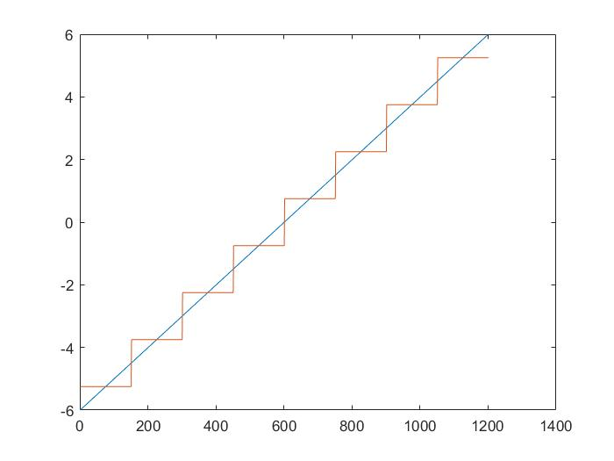

Comment:

1. It’s noticed that No. levels is 8 levels (2^3) as there is no level zero in mid-rise.
2. We note that the quantization error is big due to small number of bits.
3. It’s noticed that the levels are: ±0.75V, ±2.25V, ±3.75V, ±5.25V (max level)

**For m = 1 (mid-treat)**

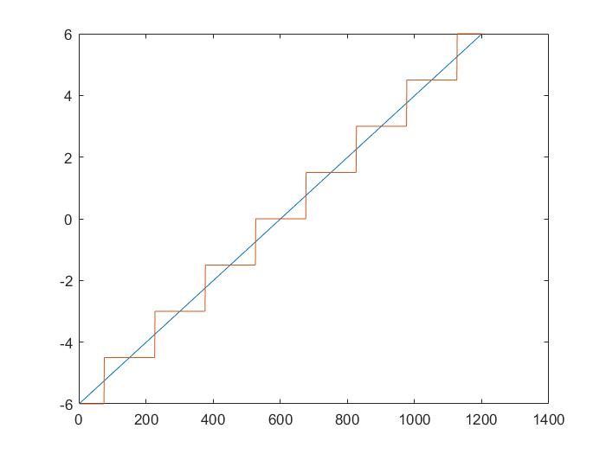

Comment:

1. It’s noticed that No. levels is 7 levels ((2^3)-1) as there is level zero in mid-treat.
2. It’s noticed that the levels are: 0, ±1.5V, ±3V, ±4.5V, ±6V (max level)
3. We note that the quantization error is big due to small number of bits.

5. Testing your input on a random input signal

6. Testing the uniform quantizer on a non-uniform random input

7. Quantization of the non-uniform signal using a non-uniform 𝝁 law quantizer

8.Code