Predict the time when an Earthquake might occur.

The exponential distribution is often concerned with the amount of time until some specific event occurs. For example, the amount of time until an earthquake occurs has an exponential distribution.

**Explaining Code in details:**

1. Importing needed libraries for exponential distribution

From "scipy.stats" we imported 'expon' for exponential distribution, "numpy" as 'np' for numerical operations and from "plot" we used 'plot_pdf', 'plot_cdf' for graphing functions.

2. Setting parameter for the Exponential distribution

Mean is the rate of earthquakes per year, which is used as the rate parameter lambda for exponential distribution.

3. Setting variables, calculating PDF and Printing Probability

The variable "time_period" is set to next year and then calculating x parameter which is lambda and use "expon.pdf" for the Probabilty Density Function for next year.

4. Graphing PDF and CDF

Output

1. Probability of occurrence Earthquake in the next year.



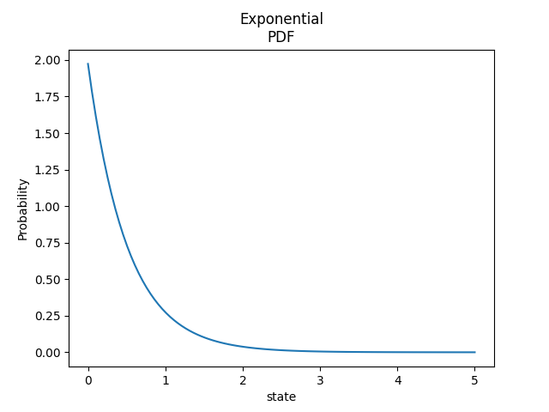2. PDF and CDF Graphes

