Gaussian random variable

Definition:

A continous random variable with probability density function (PDF) of the form P(x) = $\frac{1}{\begin{aligned}\sqrt{2πσ^{2}}\end{aligned}} e^{\frac{\begin{aligned}-{\left(x-μ\right)}^{2}\end{aligned}}{2σ^{2}}}$

Where ($μ, σ^{2}$) are parameters of the distribution

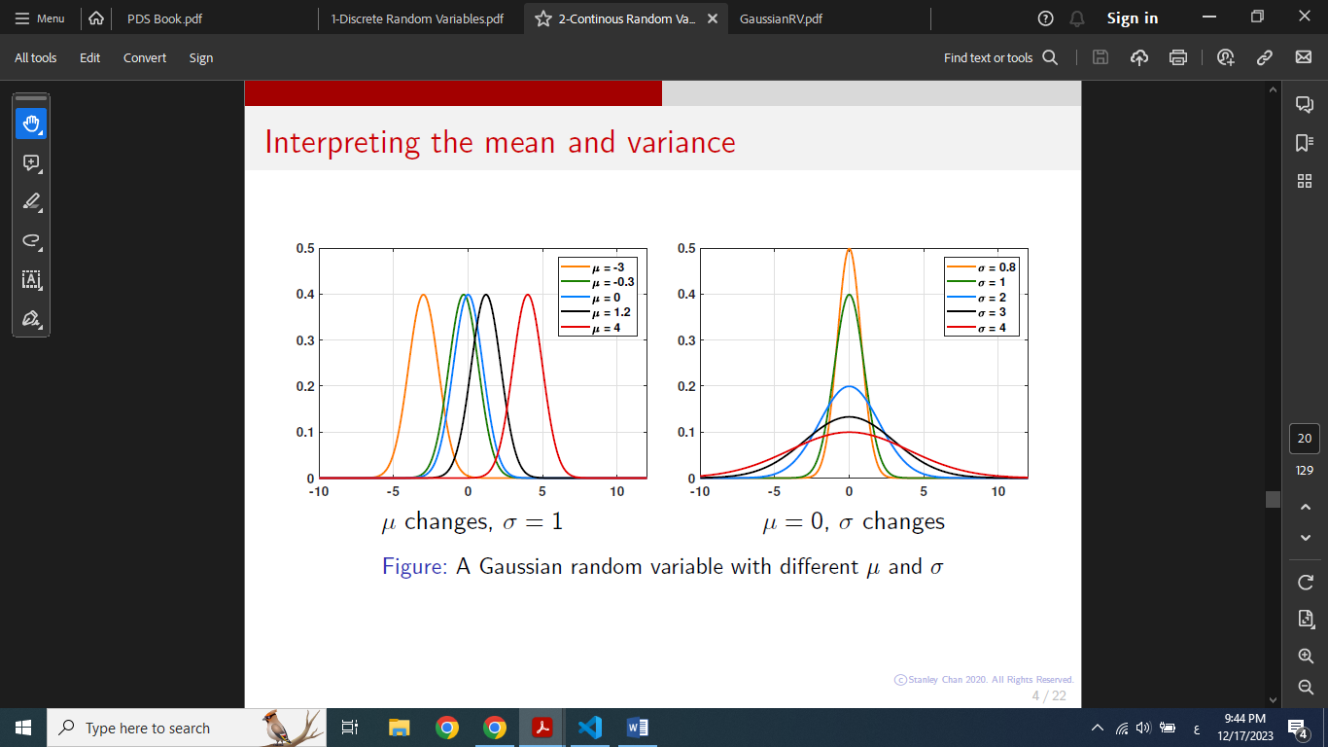

The Cumulative distribution function:

CDF is denoted with the capital Greek letter phi Φ is the intgral

Φ(x) = Fx(x) = $\frac{1}{√2π} \int_{-∞}^{x}{e^{\frac{\begin{aligned}-t^{2}\end{aligned}}{2}}}dt$

The Code explaination

1. Importing needed libraries

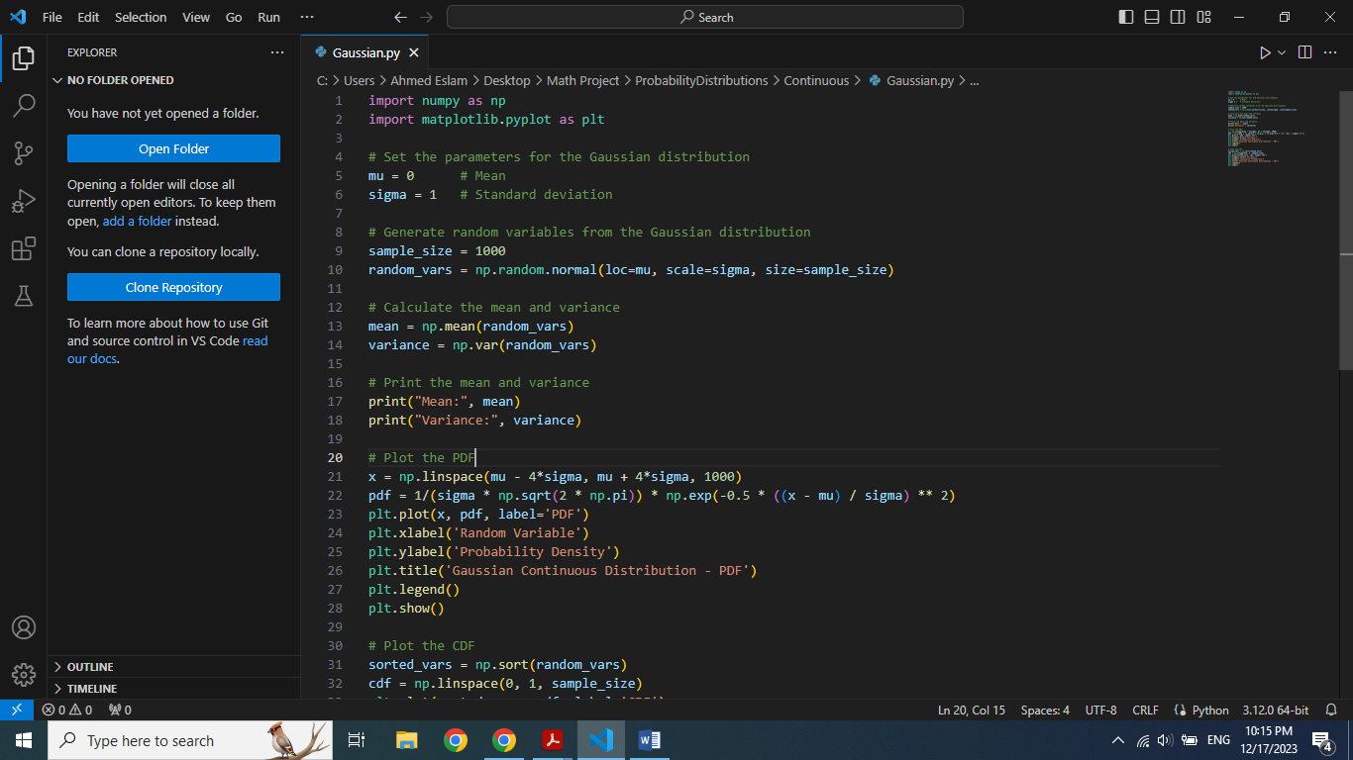

"numpy" as np for numerical operations, "matplotlib.pyplot" as plt for graphing the function

2. Setting parameters for Gaussian and generating random variables



The mean (mu) is the average value and standard deviation (sigma) is a measure of the spread of the distribution

"np.random.normal" generates a set of random number following a normal distribution.

3. Calculating and printing Mean and Variance



"np.mean","np.var" calculate mean and variance of the generated random variables from step 2

4. Plotting Probability Density Function (PDF)



"np.linespace" creates an array of evenly spaced values between two values

PDF is calculated and plotted by "plt.plot" and displayed by "plt.show()"

5. Plotting Cumulative Distribution Function

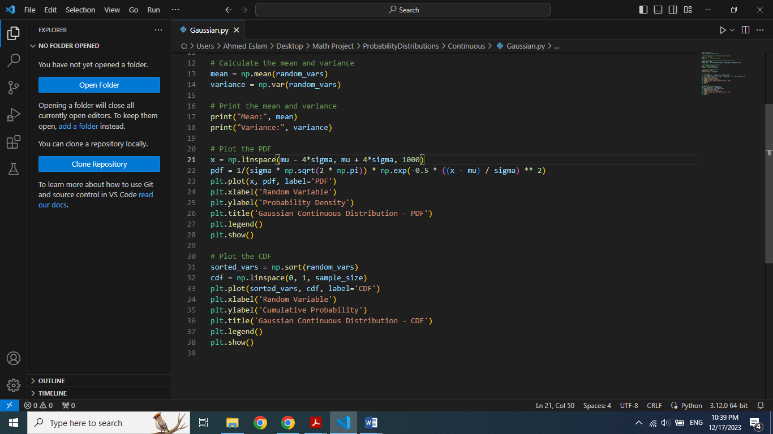

"np.sort" sort the generated random variable in ascending order

Output:

1. Mean and Variance

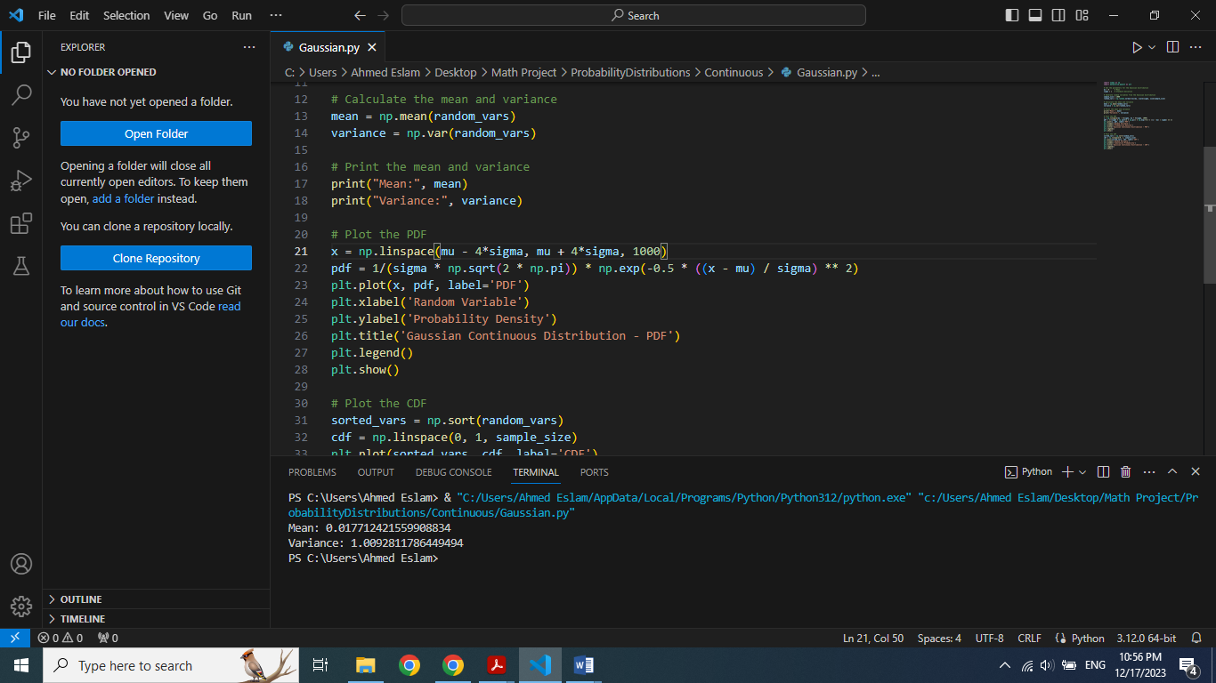

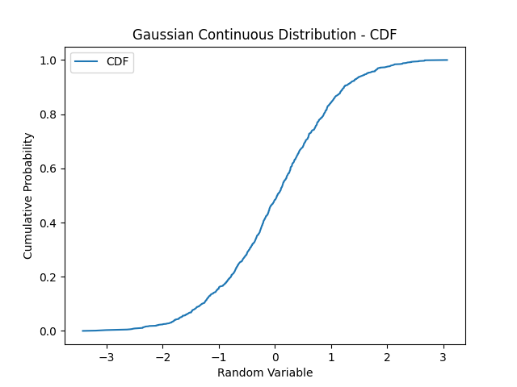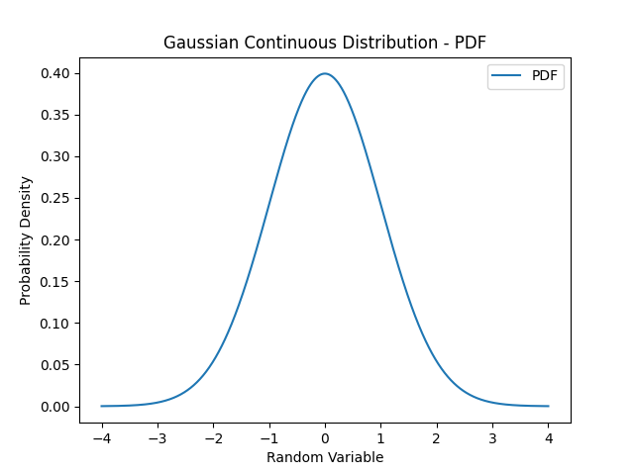2. PDF and CDF