# **Uniform Continous Distribution**

Definition:

The uniform distribution is a symmetric probability distribution where all outcomes have an equal probability of occurring. All values in the distribution have a constant probability, making them uniformly distributed.

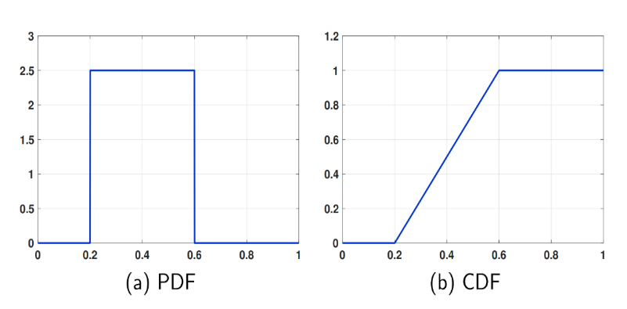

Probability Formula:

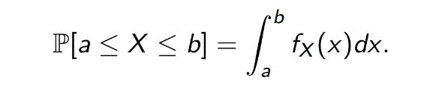

Where:

a : the begining of interval

b : the end of the interval

fx(x): is the probability density function”PDF”

Properties of Uniform distribution:

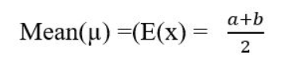

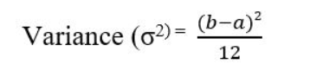

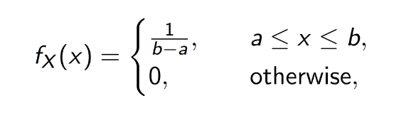**PDF:**

**CDF:**

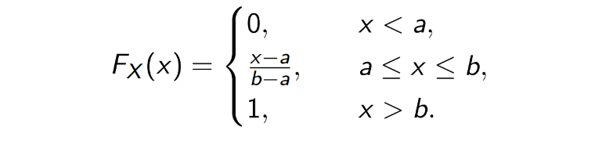

The code:

First we import the libraries we need for executing the code :

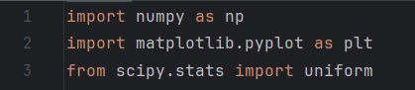

Line 1: **numpy** library helps in mathematical and logical operations on arrays

Line 2 : we use **matplotlib** library for used for plotting the pdf and cdf

Line 3 : the **scipy.stats** library used for statistical and probabilistic operations

To calculate and plot the uniform distribution we should set two parameters :

a is the lower bound

b is the upper bound

and then generate the random variable , the mean and the variance

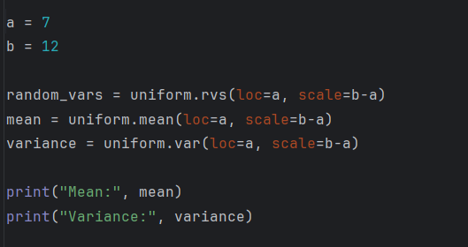

The uniform.rvs() , uniform.mean() and uniform.var() functions are associated with the **scipy.stats** library

The context of these functions contains (loc=a) which determines that the starting point is a and (scale=b-a) determines the width of the distribution

The output of printing Mean and Variance:

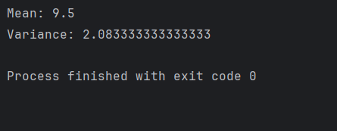

After calculating mean and variance and generating the random variables we will plot PDF and CDF using the following codes:

For PDF:

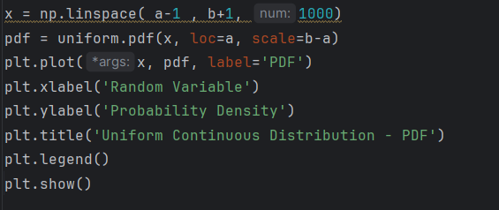

-The np.linespace( ) function generates an array name x contains 1000 evenly distributed values spaced between a-1 and b+1

-the uniform.pdf() function used to calculate the PDF of the distribution of array x

- plt.plot() plots the PDF using x array values as x-axis and pdf values as y-axis

- plt.xlabel() and plt.ylabel() sets the labels of x-axis and y-axis

-plt.title() displays the title of the plot

-plt.legend() displays the legend of the plot

-plt.show() displays the plot on the screen

For CDF:

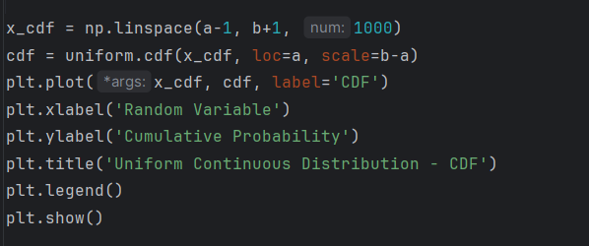

-The np.linespace( ) function generates an array name x_cdf contains 1000 evenly distributed values spaced between a-1 and b+1 and this array will be used as x-axis in plotting

-the uniform.pdf() function used to calculate the PDF of the distribution of array x_cdf

- plt.plot() plots the CDF using x_cdf array values as x-axis and cdf array values as y-axis

The next 5 lines function is the same as in PDF plotting

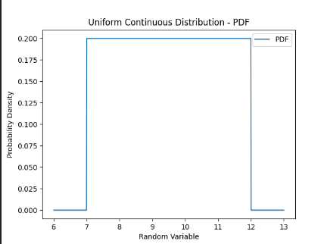The output of plotting :

