**First, we need to import needed libraries and define the plotting function:**

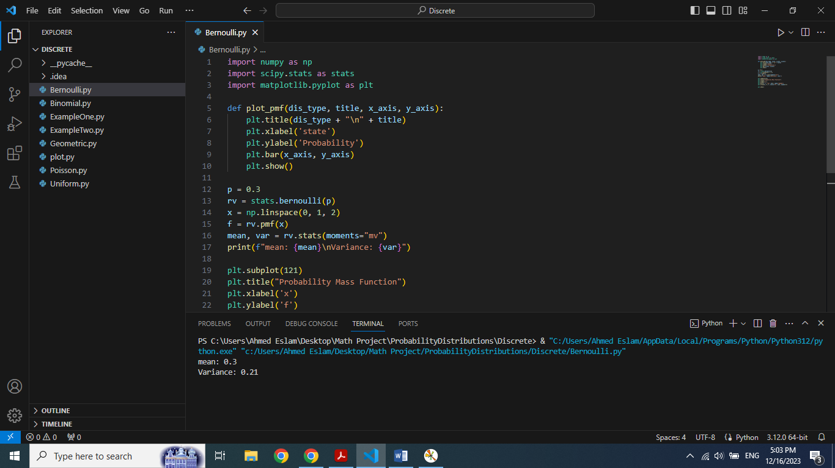

**Second, setting up the Bernoulli distribution:**

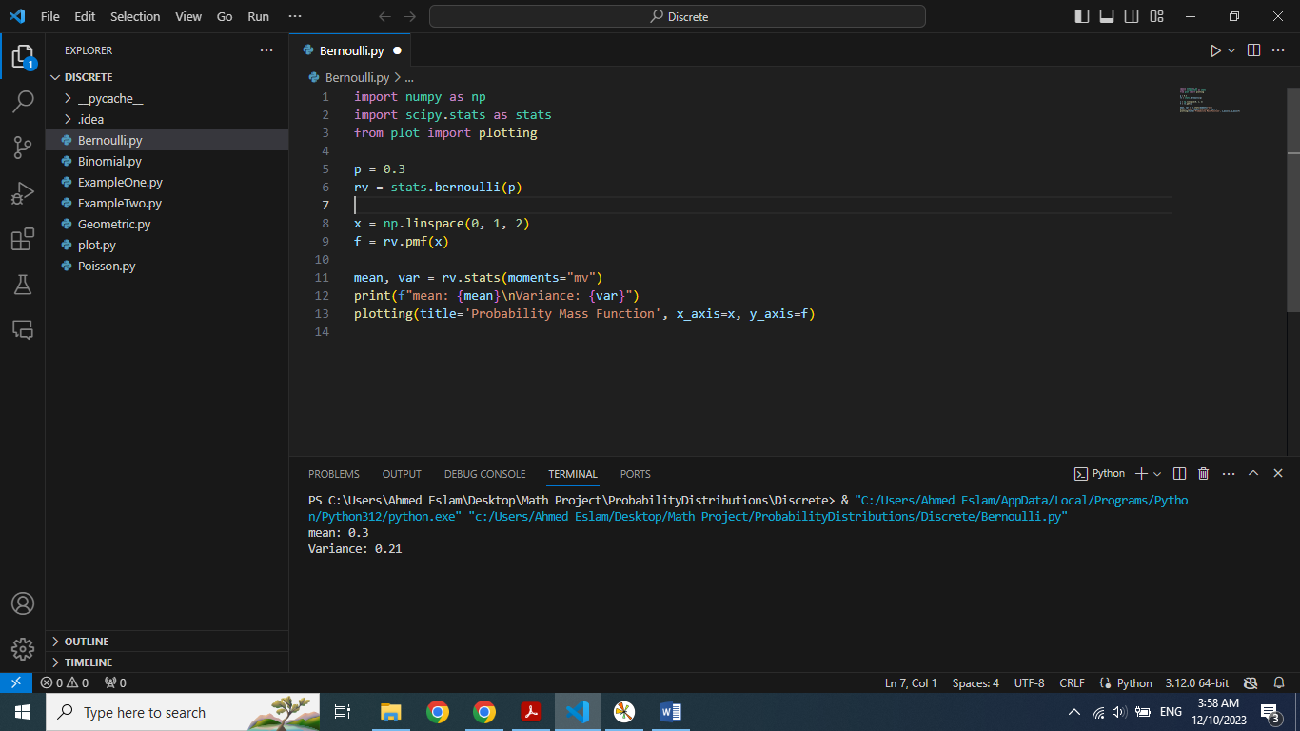

Where **'P'** is the probability of success of the Bernoulli distrbution

In addition, **'stats.bernoulli (p)'** creates a Bernoulli random variable distribution with specified probability **'P'**.

**Third, Defining values for X (Possible outcomes)**: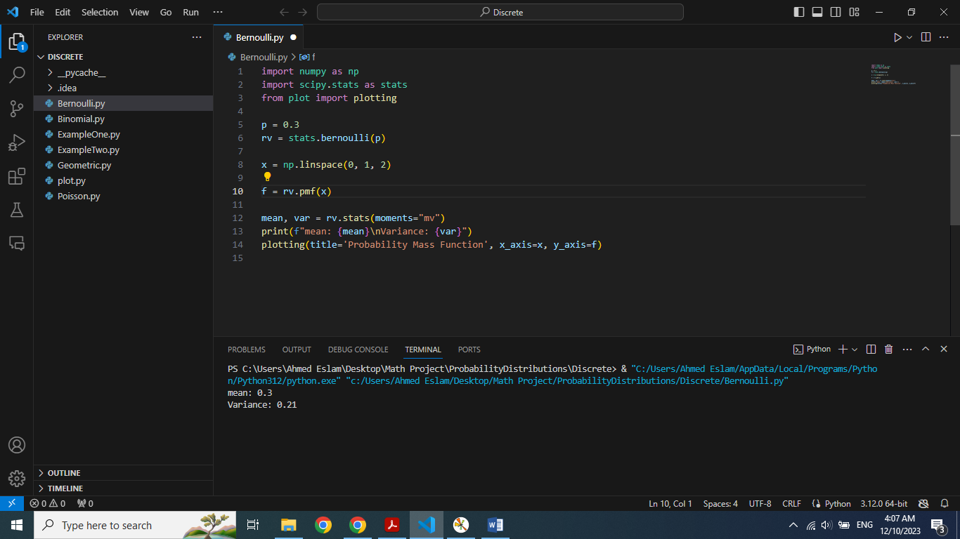

**'np.linespace (0, 1, 2)'** generates an array of two values between 0 and 1

In this case, **X** will be an array of [0 , 1].

**Fourth, calculating probability mass function (PFM), Mean and Variance:**

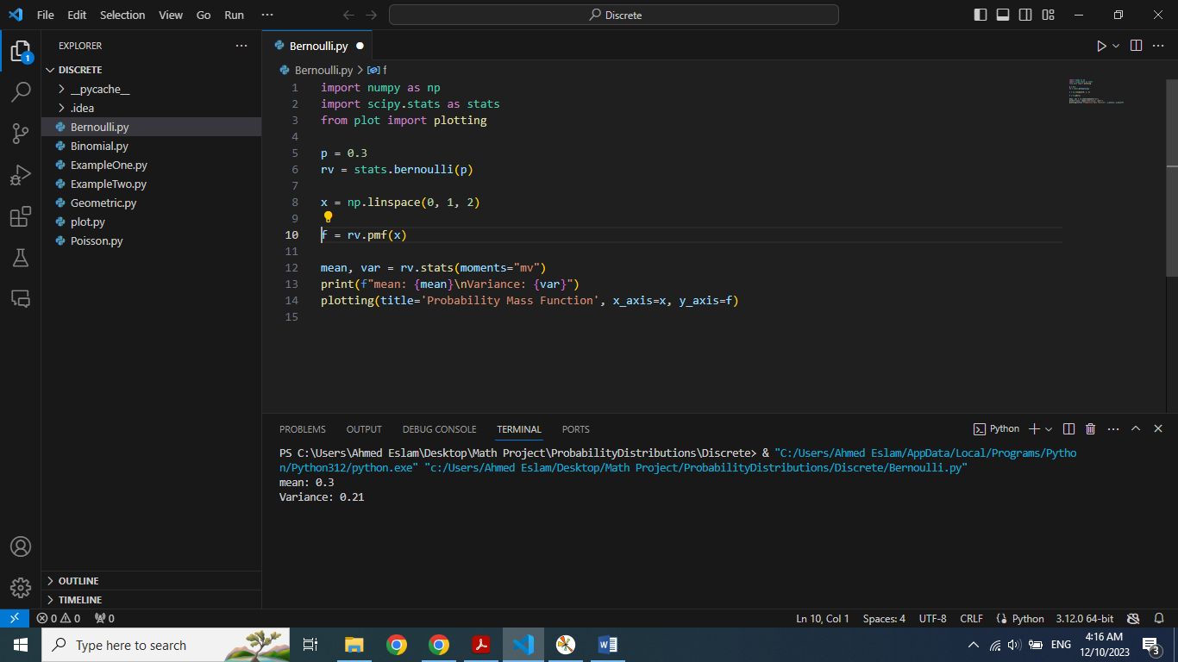

Here **'rv.pmf(x)'** calculates the probability mass function for the specified outcomes in **'X'**

Function **'rv.stats (moments="mv")'**calculates mean and var of Bernoulli

**Finally, printing mean and variance also, plotting the PMF:**

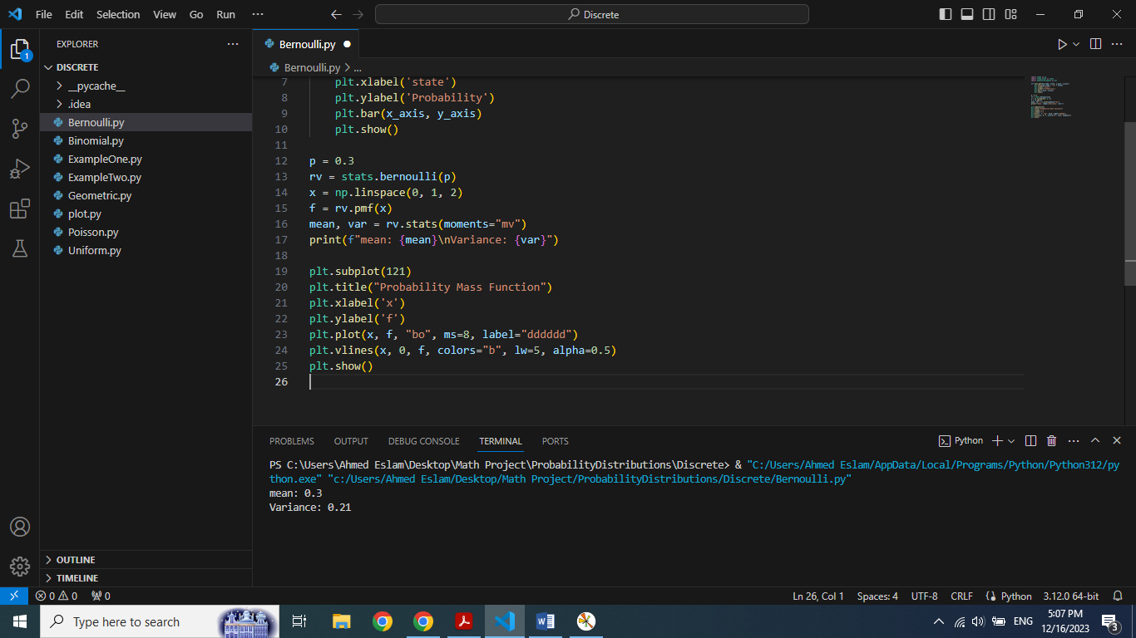

**Output:**

