Geometric random variable

Definition:

The Geometric random variable is a discrete random variable function that is used when one is modelling a series of experiments that have one of two possible outcomes – success or failure – 1 or 0.

Px (k) = (1 – P )k-1 P

Properties of Geometric random variable:

* E[x] =
* E[x2] =
* Var[x] =

**First: Importing needed libiraries:**

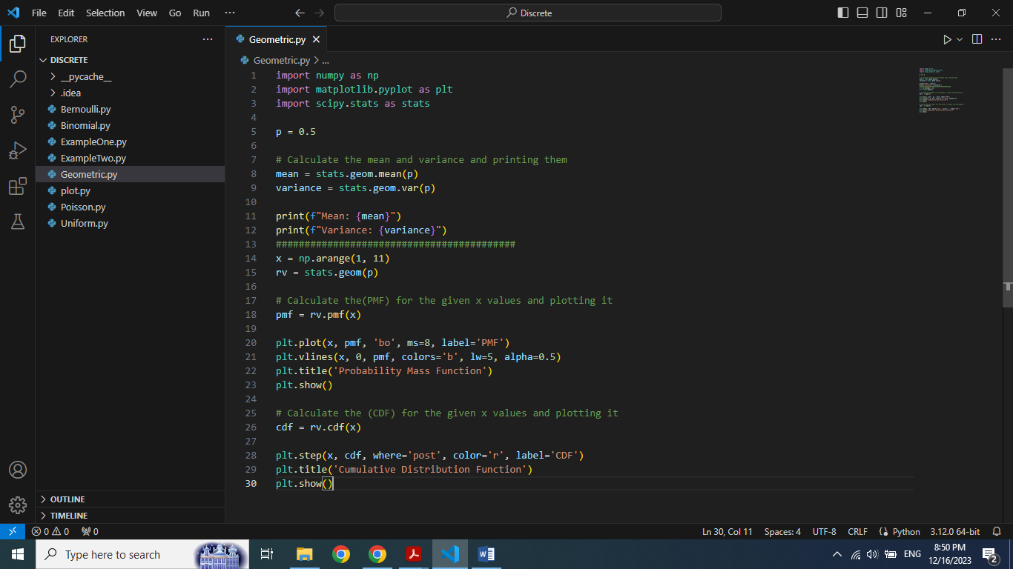

**"numpy"** as **np** for numerical operations, **"scipy,stats"** as **stats** for statistical functions, **"matplotlib.pyplot"** as **plt** for graphing the functions.

**Second: Defining the probability and calculating Mean and Variance**

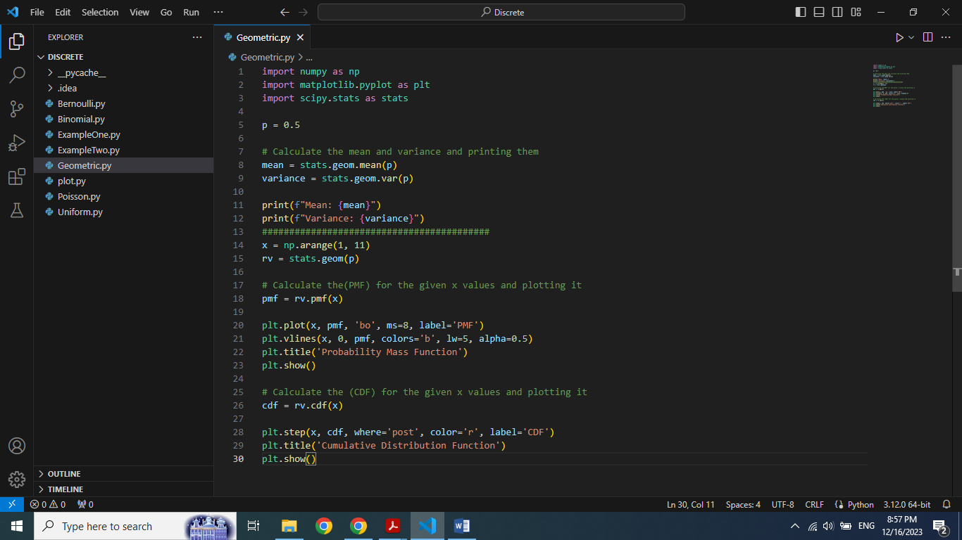

Here "p" has 0.5 value that represent probability of success in geometric distribution

Moreover, using "stats.geom.mean" and "stats.geom.var" from "scipy" libirary to calculate Mean and Variance for "p"

**Third: Creating values for x and Geometric Distribution**

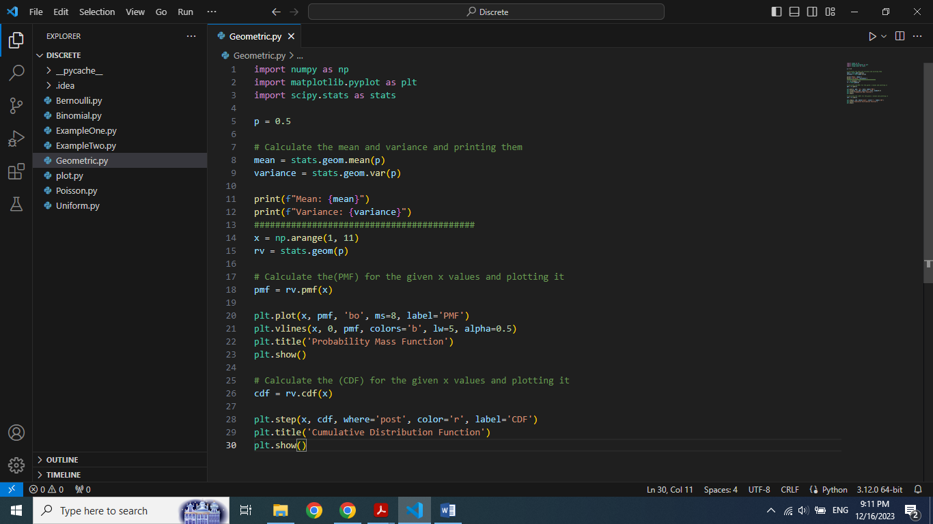

Here "x" is an array from 1 to 10 and "rv" is a Geometric Distribution for probability 'p'.

**Fourth: Calculating Probability mass function for "x" and plotting it**

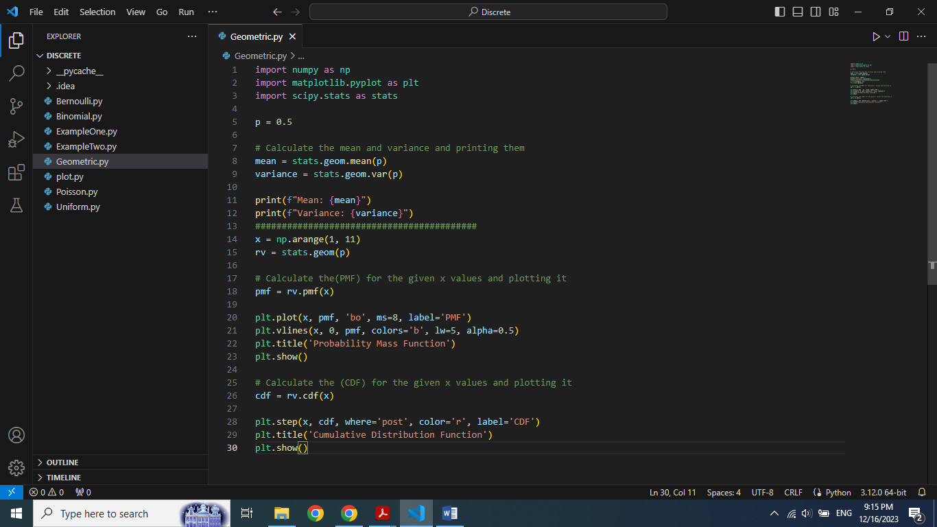

**Fifth: Calculating cummulative density function for "x" and plotting it**

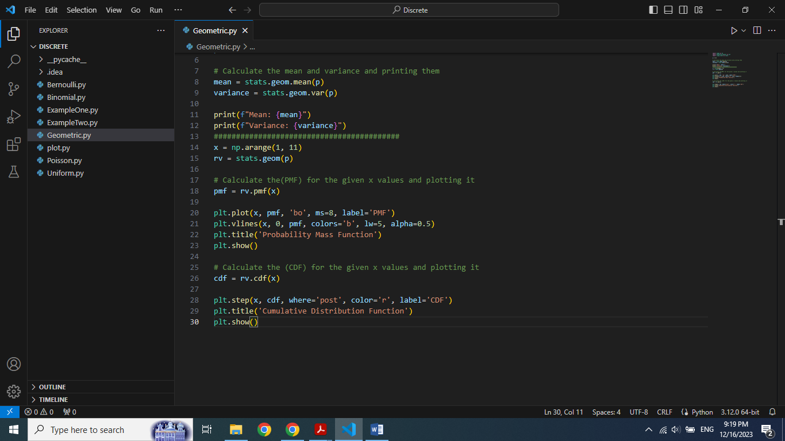

**Output:**

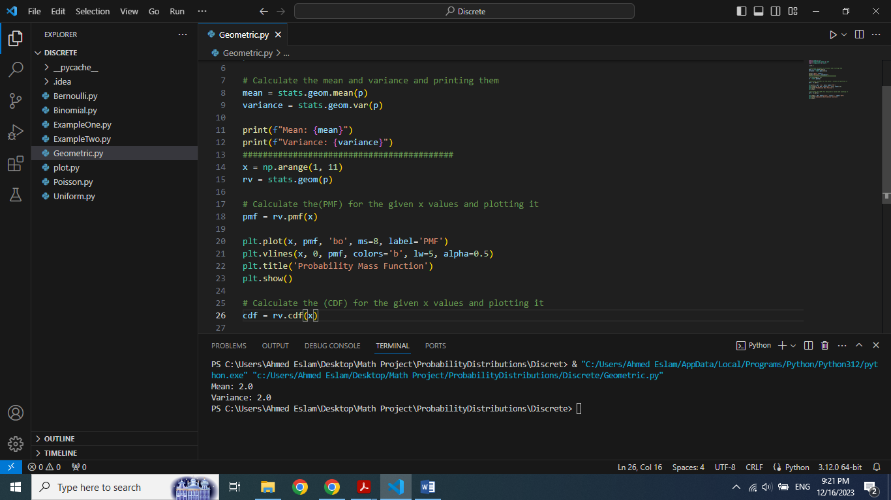

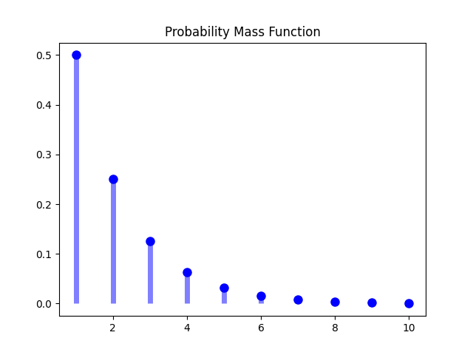 Mean and Variance

