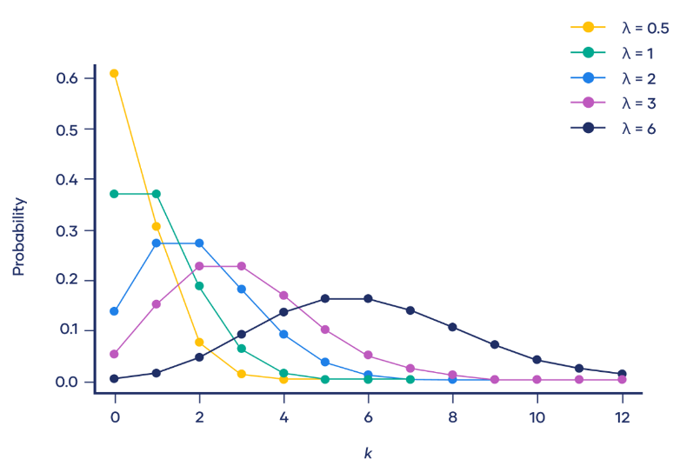**Poisson Distribution:**

1. **Definition**: Is a discrete probability distribution used to model the number of occurrences of a random event in a fixed interval of time or space.
2. **Formula**

Poisson distribution formula is:

P(X = k) = \dfrac{e^{-\lambda} \lambda^k}{k!}

Where:

* X is a random variable following a Poisson distribution
* k is the number of times an event occurs
* P (X = k) Is the probability that an event will occur k times
* e is Euler’s constant (approximately 2.718)
* \lambda is the average number of times an event occurs
* ! is the factorial function

1. **Properties of Poisson Distribution**

**X ~ Poisson ( 𝜆 )**

1. **Mean:** 𝐸(𝑥) = 𝜆
2. **𝐸 (${x }^{2}$)** = 𝜆 + $λ^{2}$
3. **variance**: 𝑉𝑎𝑟 (𝑥) = 𝜆

1. **Code**

**•** First, we start byimporting the required libraries.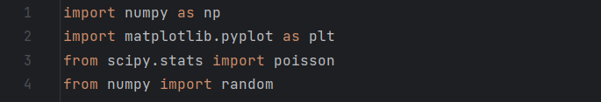

* Now, to calculate Poisson distribution we need 2 parameters which are 𝜆 & k. In our code, 𝜆 is 𝜇 or our expectation. We need to generate random variable for occurrence 2, we use Poisson’s function which is**“random.Poisson( )”** takes 𝜆 = 2 & 𝑘 = 10.

Then, the code produces a different set of random numbers each time it is executed.

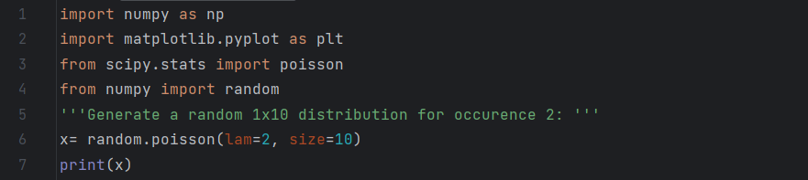

* Output:

* Here, we need an array of the **k** values. We use **“np.arange ( )”** function and gave it numbers from 0 to 16 and print it.

create an array with these values:

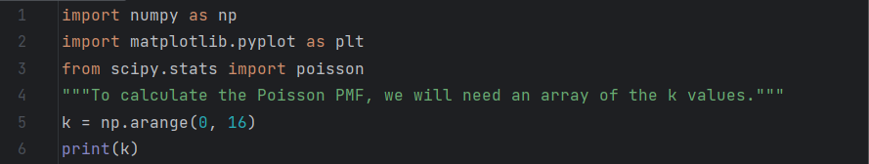

* Output:



* to calculate the Poisson PMF, we will use the **“poisson.pmf ( )”** method of the “**[Scipy.poisson](https://docs.scipy.org/doc/scipy/reference/generated/scipy.stats.poisson.html" \t "_blank)”** generator. It will need two parameters:
* k value (the **k** array that we created).
* μ value (which we will set to μ=6 as in our example).

**“np.round ( )”** **function** **:** to print 5 digits following the PMF's decimal.

We make **for loop** takes 2 parameters which are the value and the probability, then after substitute in Poisson’s equation, it will give me the probability of each value.

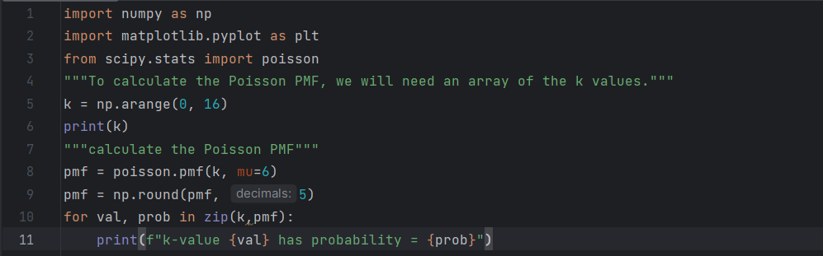

* Output:

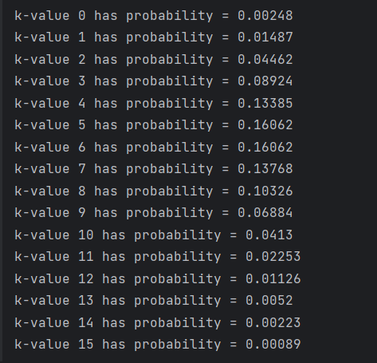

* We will need the **k** values array that we created earlier as well as the **PMF** values array in this step. Using **matplotlib** **library**. We need to plot PMF graph so, we use **“plt.bar( )”** function takes PMF value and k .Then, we add label to X-axis and Y-axis by using **“plt.xlabel ( )”** and **“plt.ylabel ( )”.**

• The same steps as PMF exactly except the function which is **“poisson.cdf ()”.**

**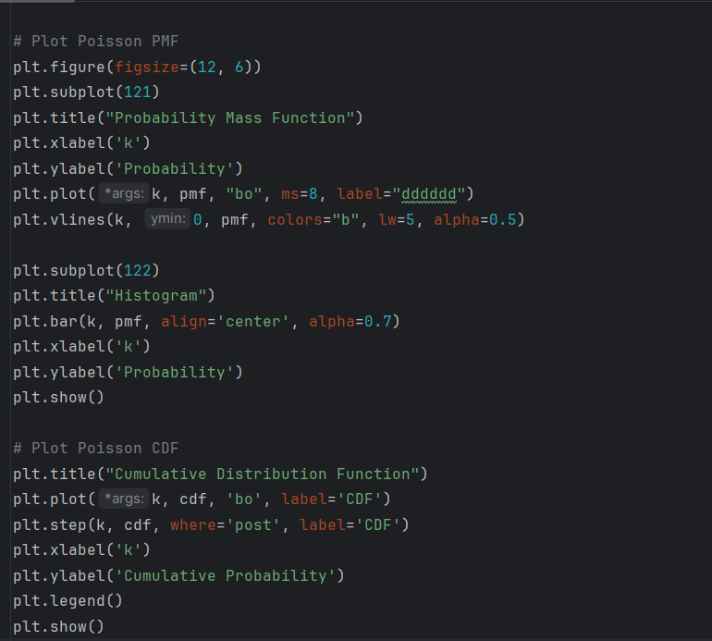**

* In this code, we need to calculate the first four moment.
* Our first moment is the expectation, we put it constant (μ=6) from the first code.
* Second moment is the variance which is equal to the expectation. Then $3^{rd}$ and $4^{th}$ moment.

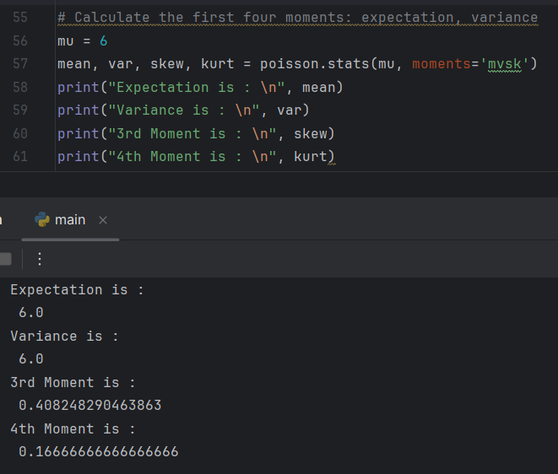

**Results**

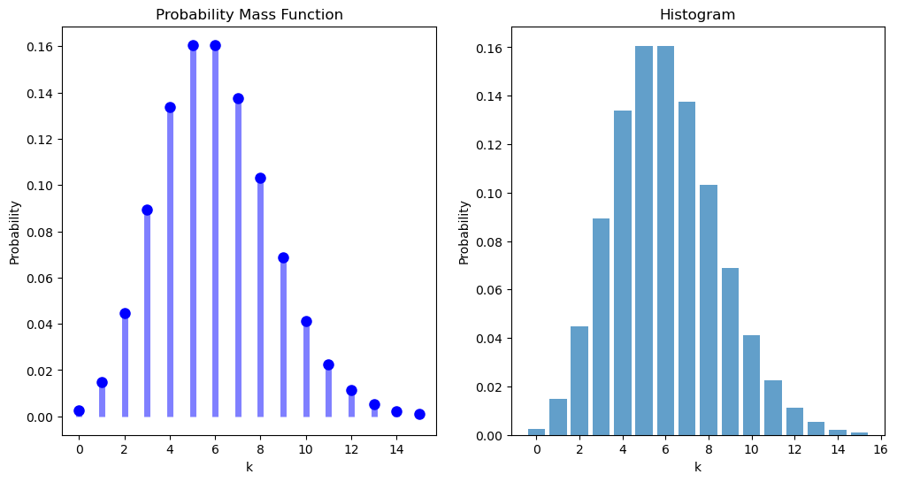By the above codes, finally we can be able to calculate the expectation and variance of PMF and CDF and plot the histogram of both.

(Poisson PMF)

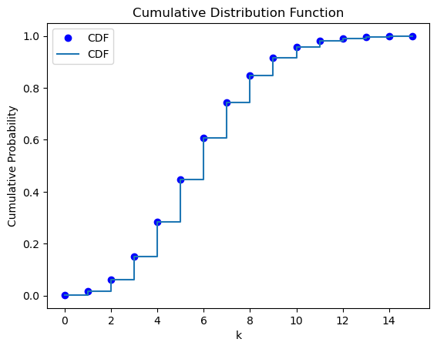

(Poisson CDF)