**1- Import necessary libraries:**



**2- Define the interval [a, b]:**

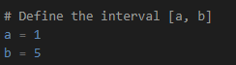

**3- Generate 1000 uniform random variables within the interval [a, b]:**



**4- Calculate the mean and variance of the generated data:**

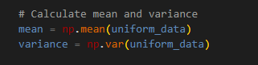

**5- Define the probability mass function (pmf) for a uniform distribution:**

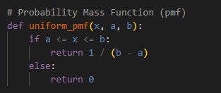

**6- Define the cumulative distribution function (cdf) for a uniform distribution:**

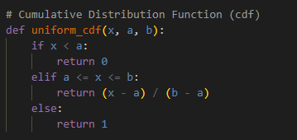

**7- Print the mean and variance:**

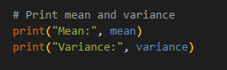

**<<sample output :**



**8- Plot the histogram of the generated data along with the PMF and CDF:**

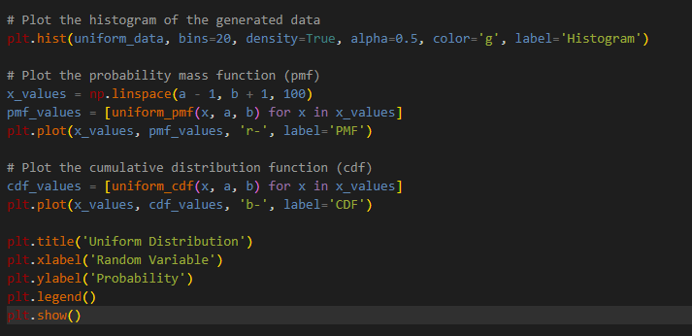

* The histogram is created using plt.hist with 20 bins, normalized to form a probability density, and plotted in green.
* The PMF and CDF are calculated and plotted using the uniform_pmf and uniform_cdf functions, respectively. The PMF is shown in red, and the CDF is shown in blue.
* Finally, the title, labels, and legend are added to the plot, and the plot is displayed using plt.show().

**<<sample output:**

