Platform Idea**:**

This project is a personal digital platform designed to help users organize and store their certificates, achievements, and future goals in one secure place.

Instead of keeping important files on multiple devices or risking their loss, users can upload them here, access them anytime from any device, and download them as PDFs.

It's like **Cloud Storage** but unlike traditional Clouds tools like **Google Drive**, this platform goes beyond just storing files. It's a smarter, more personalized system, including a dedicated section for future plans and courses to take and display it as a dashboard to track your progress.

Motivation :

Many people lose track of their certificates or forget their learning plans because they are scattered across devices or notes.

Such as : if I plan to take the IELTS exam or enroll in a training course next month, this platform helps me write down my priorities and organize my future plans easily.

So this platform solves that problem by offering a centralized and intelligent spacethat combines cloud storage with goal tracking, helping users stay organized, and always ready to achieve more.

أعلى النموذجأسفل النموذج

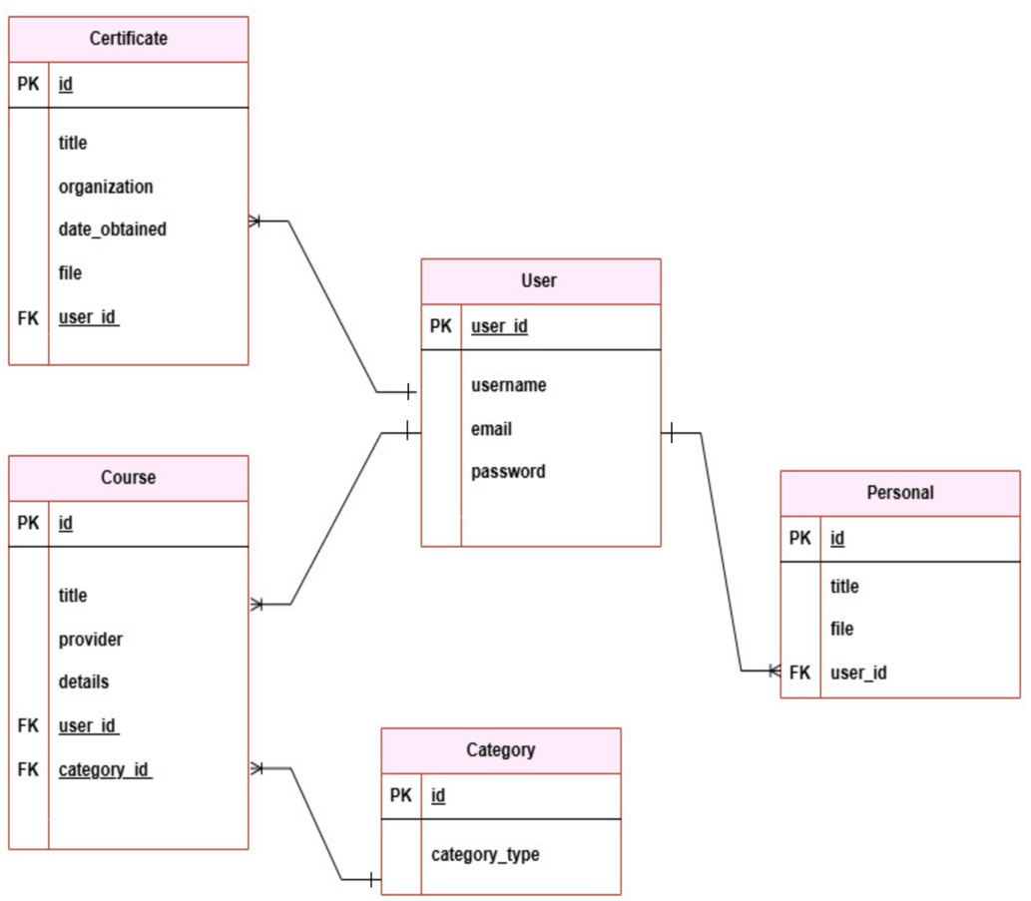**ERD**

**User Story**

As a user, I want to:

1. Create my own account and be able to log in securely.
2. Upload my certificates and add their details so I can access them later.
3. Download my certificates in PDF format to my personal device.
4. Add future courses that I plan to take in order to track my progress.
5. Edit the information of any certificate or course I have added.
6. Delete a certificate or course that I no longer need.
7. View all my achievements in an organized way, categorized by type (through a dashboard).
8. Search or filter to easily find a specific certificate or course.
9. Access my personal résumé in a dedicated section of the website.

**Backend Routes (Django)**

|  |  |  |  |
| --- | --- | --- | --- |
| Method | URL Pattern | Actions | CRUD |
| POST | /api/register/ | Creat a new account |  |
| POST | /api/login/ | Login for user account |  |
| GET | /api/certificates/ | View all certificates you have | READ |
| POST | /api/certificates/ | Add a new certificate | CREATE |
| PUT | /api/certificates/:id/ | Update specific certificate | UPDATE |
| DELETE | /api/certificates/:id/ | Delete specific certificate | DELETE |
| GET | /api/courses/ | View all future courses or plans | READ |
| POST | /api/courses/ | Add a new course or plan | CREATE |
| PUT | /api/courses/:id/ | Update specific course | UPDATE |
| DELETE | /api/courses/:id/ | Delete specific course | DELETE |
| GET | /api/personal/ | View all personal document | READ |
| POST | /api/ personal/ | Add a new personal document | CREATE |
| PUT | /api/ personal/:id/ | Update specific personal document | UPDATE |
| DELETE | /api/ personal/:id/ | Delete specific personal document | DELETE |

**Frontend Routes (React)**

|  |  |  |
| --- | --- | --- |
| Path | Page / Component | Description |
| /home | HomePage | Overview for home page |
| /about | AboutPage | Overview about who is I am |
| /login | LoginPage | User login form |
| /register | RegisterPage | Create a new account for user |
| /dashboard | Dashboard | Displays user future plans |
| /certificates | CertificateList | List of all certificates do u have |
| /certificates/new | AddCertificate | Add a new certificate |
| /certificates/:id /delete | DeleteCertificate | Delete specific certificate |
| /certificates/:id/edit | EditCertificate | Edit specific certificate |
| /courses | CourseList | List of all courses or future plans |
| /courses/new | AddCourse | Add a new course or future plans |
| /courses/:id /delete | DeleteCourse | Delete specific course |
| /courses/:id/edit | EditCourse | Edit specific course |
| /personal | PersonalDoc | List of all Personal documents such as : National ID, Electronic Passport, Graduation Certificate , Resume |
| /personal/new | AddPersonalDoc | Add a new Personal document |
| /personal/:id/edit | EditPersonalDoc | Edit specific Personal document |
| /personal/:id /delete | DeletePersonalDoc | Delete specific Personal document |