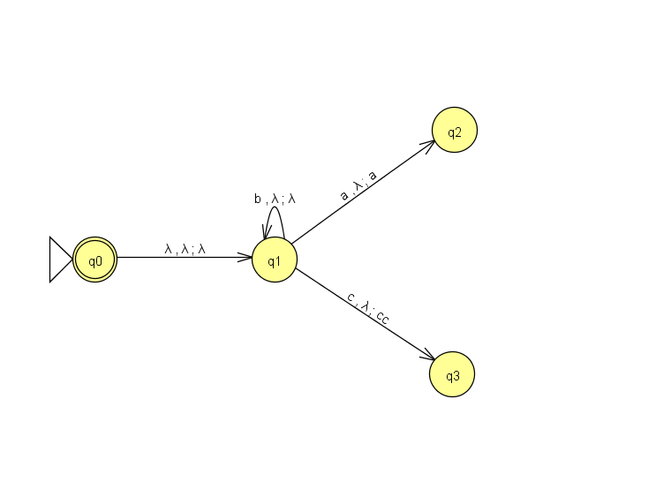

0a = 2 \* 0c so the initial is accepted

2 cases: first non-b is a, then use a on the stack, otherwise use c

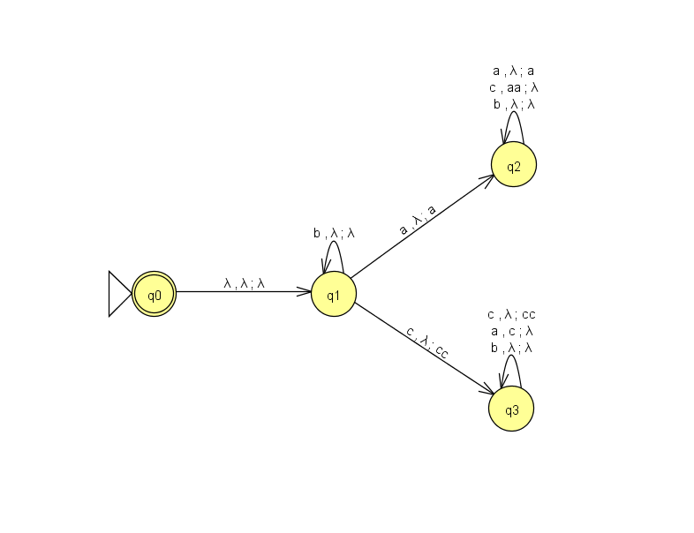

B doesn’t matter, so just loop itself.

If use a on the stack, 1 c will pop 2 a.

If use c on the stack, push on two c.

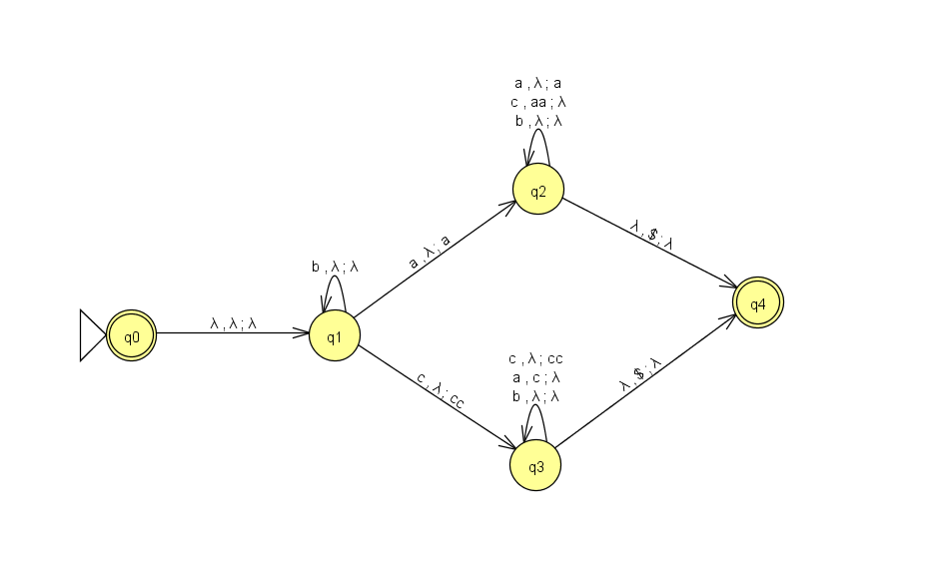

When the stack is no symbols left (only $), and no input is available anymore, pop the $ and accept the string.