Consider the 6-node network shown below, with the given link costs.

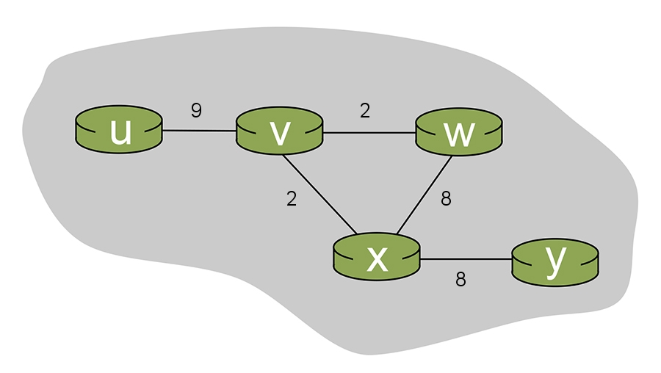

Answer the following questions.

* When the algorithm converges, what are the distance vectors in each of the routers. Note that this network is simple enough that you should be able to determine the final distance vectors by inspection (i.e., without having to actually execute the distance vector algorithm).
* What are the initial distance vectors, when each node only knows the one-hop link cost to its directly-attached neighbors?
* Now lets consider an execution of the distance vector algorithm. We will consider an iterative model in which all routers send distance vectors to their neighbors at the same time and at each iteration. (Recall, however, that in practice a router only sends it DV to its neighbor if its own DV has changed as a result of having received a DV from a neighbor; we will ignore that here, and assume for simplicity that all nodes exchange their DV with their neighbors at each iteration)

Suppose that after the ith iteration, the distance vector in each of the nodes is: du(u,v,x,w,y) =(0,\*,\*,\*,\*) dv(u,v,x,w,y) =(\*,0,\*,\*,\*) dw(u,v,x,w,y) =(\*,\*,0,\*,\*) dx(u,v,x,w,y) =(\*,\*,\*,0,\*) dy(u,v,x,w,y) =(\*,\*,\*,\*,0)   
where each \* above refers to some value. Calculate the new DV at each router after each iteration, assuming that at each iteration a router receives a DV (computed in the previous iteration) from each of its neighbors and then uses these DVs to compute its own new DV at the current iteration. For each iteration, show the DVs of each router at that iteration.

Consider the 6-node network shown below, with the given link costs.

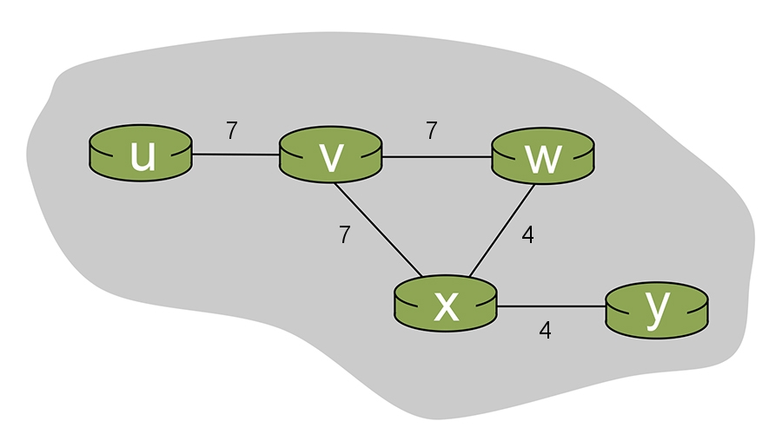

Answer the following questions.

* When the algorithm converges, what are the distance vectors in each of the routers. Note that this network is simple enough that you should be able to determine the final distance vectors by inspection (i.e., without having to actually execute the distance vector algorithm).
* What are the initial distance vectors, when each node only knows the one-hop link cost to its directly-attached neighbors?
* Now lets consider an execution of the distance vector algorithm. We will consider an iterative model in which all routers send distance vectors to their neighbors at the same time and at each iteration. (Recall, however, that in practice a router only sends it DV to its neighbor if its own DV has changed as a result of having received a DV from a neighbor; we will ignore that here, and assume for simplicity that all nodes exchange their DV with their neighbors at each iteration)

Suppose that after the ith iteration, the distance vector in each of the nodes is: du(u,v,x,w,y) =(0,\*,\*,\*,\*) dv(u,v,x,w,y) =(\*,0,\*,\*,\*) dw(u,v,x,w,y) =(\*,\*,0,\*,\*) dx(u,v,x,w,y) =(\*,\*,\*,0,\*) dy(u,v,x,w,y) =(\*,\*,\*,\*,0)   
where each \* above refers to some value. Calculate the new DV at each router after each iteration, assuming that at each iteration a router receives a DV (computed in the previous iteration) from each of its neighbors and then uses these DVs to compute its own new DV at the current iteration. For each iteration, show the DVs of each router at that iteration.

Consider the 6-node network shown below, with the given link costs.

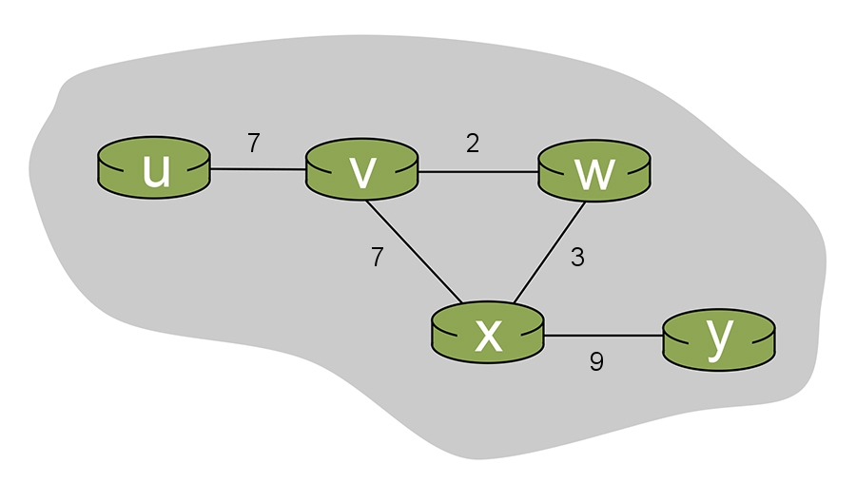

Answer the following questions.

* When the algorithm converges, what are the distance vectors in each of the routers. Note that this network is simple enough that you should be able to determine the final distance vectors by inspection (i.e., without having to actually execute the distance vector algorithm).
* What are the initial distance vectors, when each node only knows the one-hop link cost to its directly-attached neighbors?
* Now lets consider an execution of the distance vector algorithm. We will consider an iterative model in which all routers send distance vectors to their neighbors at the same time and at each iteration. (Recall, however, that in practice a router only sends it DV to its neighbor if its own DV has changed as a result of having received a DV from a neighbor; we will ignore that here, and assume for simplicity that all nodes exchange their DV with their neighbors at each iteration)

Suppose that after the ith iteration, the distance vector in each of the nodes is: du(u,v,x,w,y) =(0,\*,\*,\*,\*) dv(u,v,x,w,y) =(\*,0,\*,\*,\*) dw(u,v,x,w,y) =(\*,\*,0,\*,\*) dx(u,v,x,w,y) =(\*,\*,\*,0,\*) dy(u,v,x,w,y) =(\*,\*,\*,\*,0)   
where each \* above refers to some value. Calculate the new DV at each router after each iteration, assuming that at each iteration a router receives a DV (computed in the previous iteration) from each of its neighbors and then uses these DVs to compute its own new DV at the current iteration. For each iteration, show the DVs of each router at that iteration.