Consider the 6-node network shown below, with the given link costs.

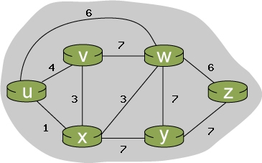

Using Dijkstra's algorithm, find the least cost path from source node **u** to all other destinations. Show your work in tabular format, as in the powerpoint slides.

Consider the 6-node network shown below, with the given link costs.

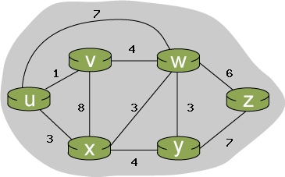

Using Dijkstra's algorithm, find the least cost path from source node **u** to all other destinations. Show your work in tabular format

Consider the 6-node network shown below, with the given link costs.

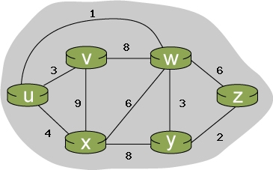

Using Dijkstra's algorithm, find the least cost path from source node **u** to all other destinations. Show your work in tabular format,