Consider the figure below. The IP and MAC addresses are shown for nodes A, B, C and D, as well as for the router's interfaces. **Assume each shaded area as a different subnet** **for all these exercises.**

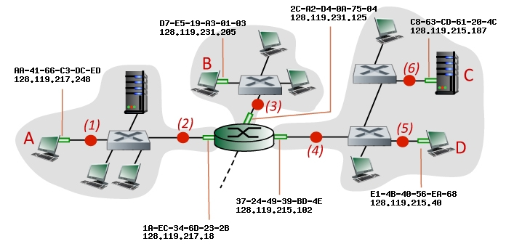

Consider an IP datagram being sent from node **A** to node **C**. Give the source and destination Ethernet addresses, as well as the source and destination addresses of the IP datagram encapsulated within the Ethernet frame at points *(1)*, *(2),(4)*, and *(6)* in the figure above.

Consider the figure below. The IP and MAC addresses are shown for nodes A, B, C and D, as well as for the router's interfaces.

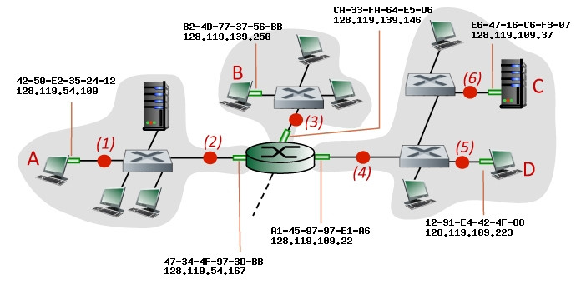

Consider an IP datagram being sent from node **A** to node **C**. Give the source and destination Ethernet addresses, as well as the source and destination addresses of the IP datagram encapsulated within the Ethernet frame at points *(1)*, *(2),(4)*, and *(6)* in the figure above.

Consider the figure below. The IP and MAC addresses are shown for nodes A, B, C and D, as well as for the router's interfaces.

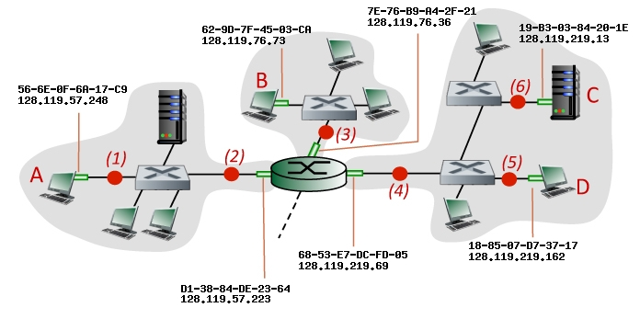

Consider an IP datagram being sent from node **D** to node **B**. Give the source and destination Ethernet addresses, as well as the source and destination addresses of the IP datagram encapsulated within the Ethernet frame at points *(5)*, *(4),* and *(3)* in the figure above.

Consider the figure below. The IP and MAC addresses are shown for nodes A, B, C and D, as well as for the router's interfaces.



Consider an IP datagram being sent from node **D** to node **B**. Give the source and destination Ethernet addresses, as well as the source and destination addresses of the IP datagram encapsulated within the Ethernet frame at points *(5)*, *(4),* and *(3)* in the figure above.

Consider the figure below. The IP and MAC addresses are shown for nodes A, B, C and D, as well as for the router's interfaces.

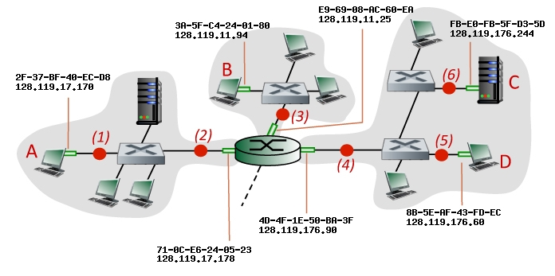

Consider an IP datagram being sent from node **A** to node **D**. Give the source and destination Ethernet addresses, as well as the source and destination addresses of the IP datagram encapsulated within the Ethernet frame at points *(1)*, *(2),(4)*, and *(5)* in the figure above.