1. UDP
2. Discover: 0.001s Offer: 0.000173s Request: 0.002010s ACK: 0.003015s
3. 
4. DHCP message type
5.  To identify different requests
6. Both destinations are always 255.255.255.255(as a medium)
7. 
8. 
9.  No relay agent
10. 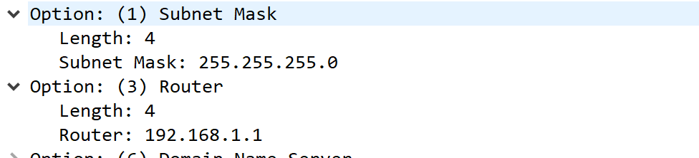 Router tells the default gateway, subnet mask tells the subnet mask
11. 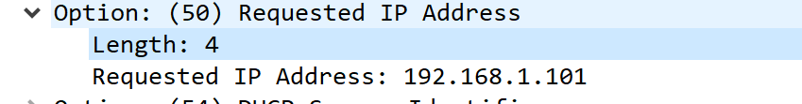
12. 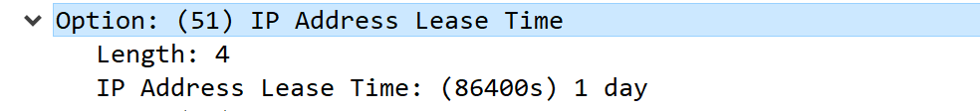 During the lease time this address won’t be given to another computer
13. It tells the DHCP server that the ip address is no longer being used. And the server says something like “successfully released” as a receipt. If it’s lost, it has to wait for the whole lease time.
14. 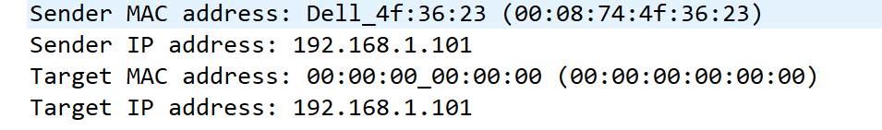 To make sure the ip to be issued is valid