1. 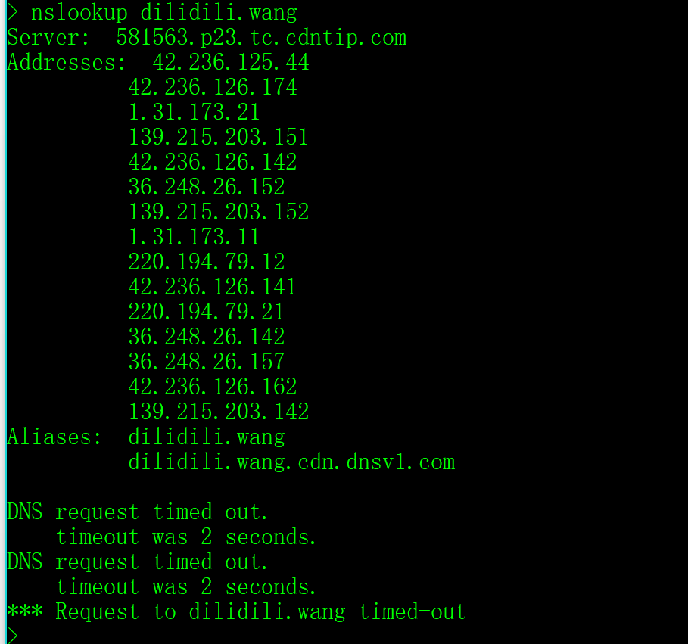
2. 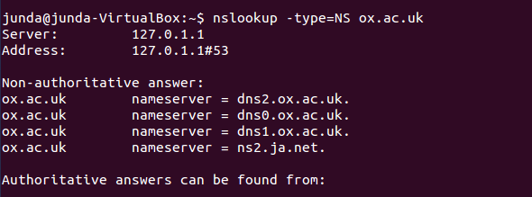
3. 
4. 
5. 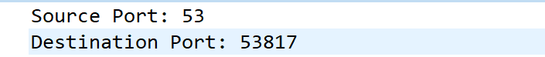
6.  They are the same
7. 
8. 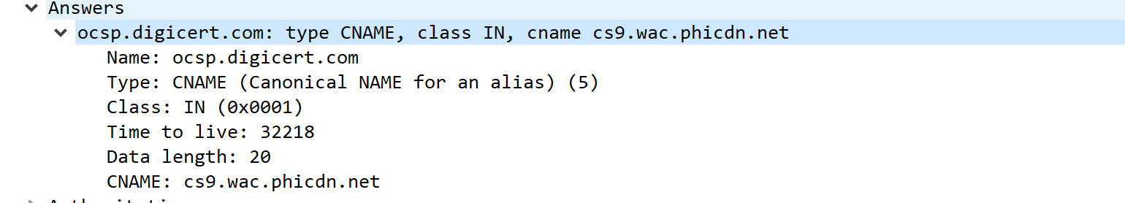
9. The same as the first answer from DNS
10. No
11. 
12.  Default DNS server
13. 
14. 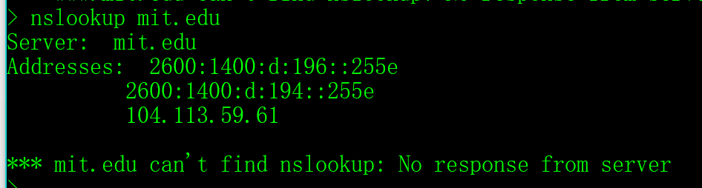
15. 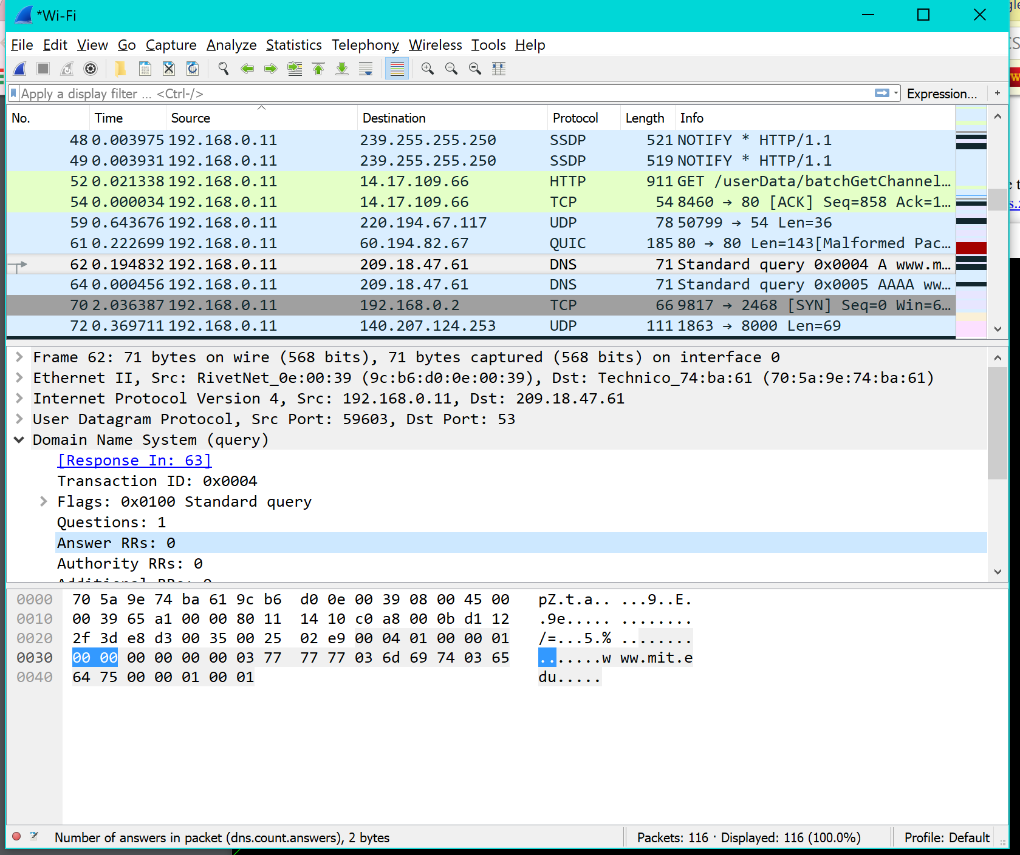
16.  same DNS
17. Type NS No answers
18. 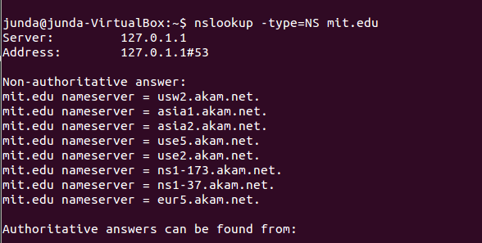
19. 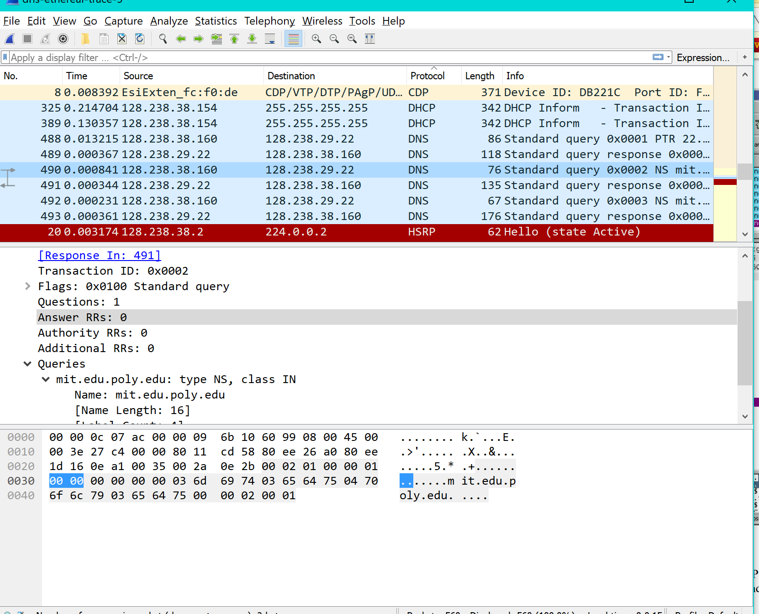
20.  it is bitsy.mit.edu
21. 
22. 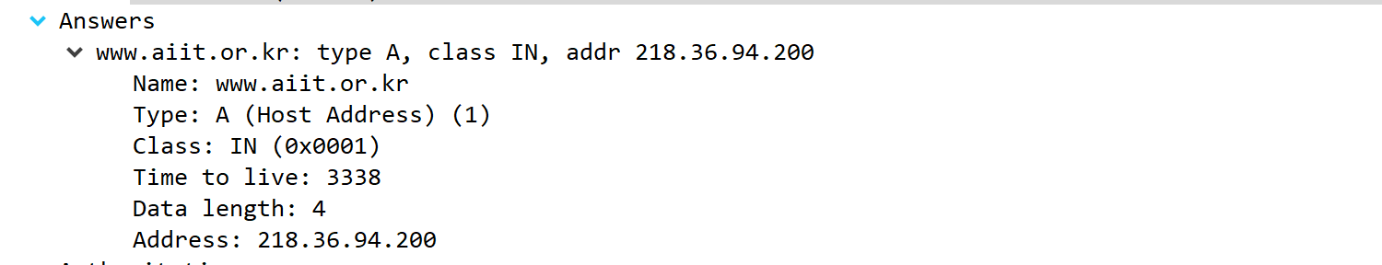
23. 