A-1. Mine: http 1.1 Server: http 1.1



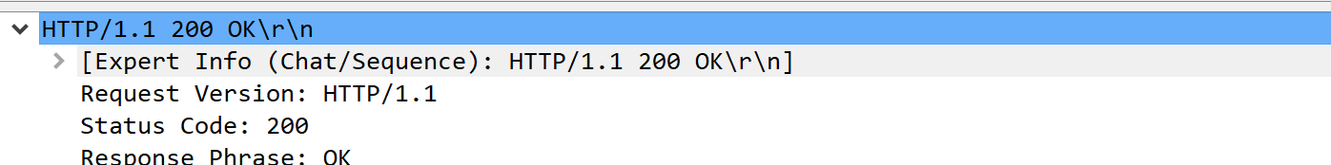

A-2. 

A-3. Mine:  Server: 

A-4. 

A-5. 

A-6. 

A-7. 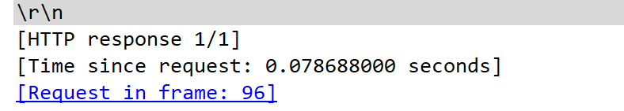

B-1. No

B-2. 

B-3. 

B-4. 304 Not Modified 

C-1. 1 GET request

C-2. 

C-3. 200

C-4. Not sure

D-1. 4 GET messages. To 128.119.245.12 and 128.119.240.90

D-2. Their execution time is different

E-1. 401 unauthorized

E-2. 