1. My host dst host 
2. Because it is not an application layer protocal
3. 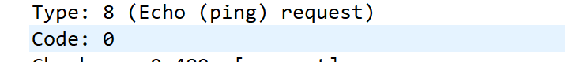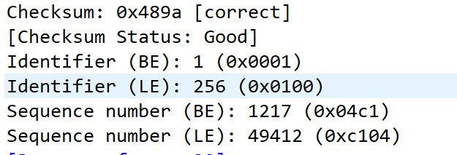 2 byte
4. Type 0, code 0, 2byte
5. 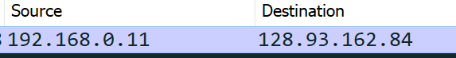
6. No, it would be 0x11
7. Yes. They are under the same protocol
8. It includes the first 8 bytes of the original one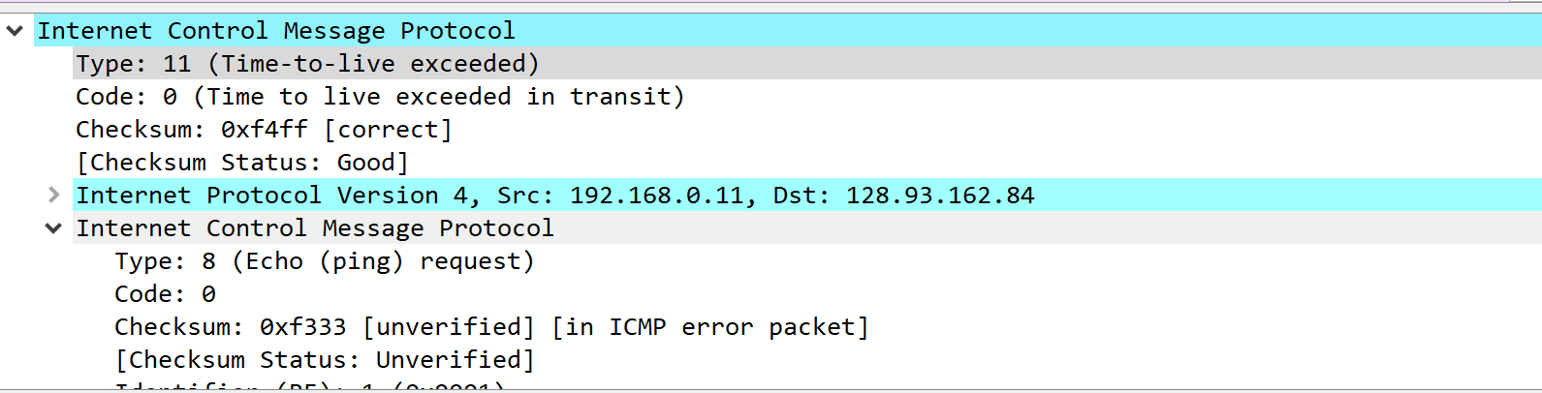
9. 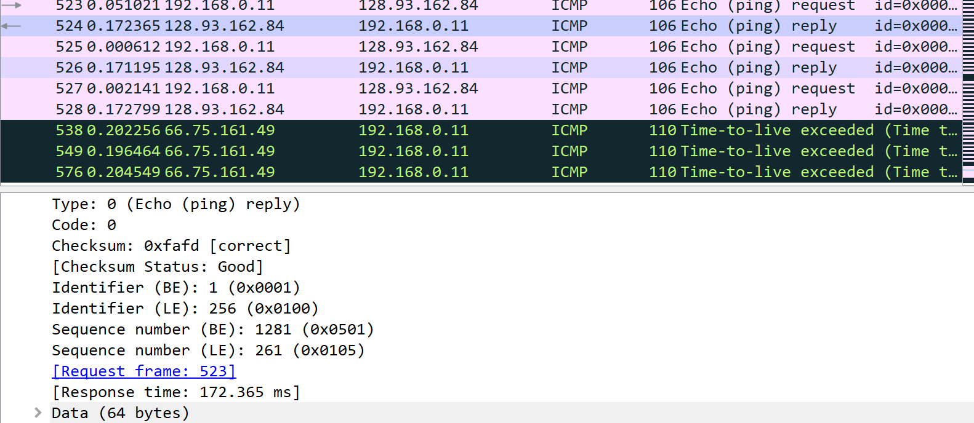They are reply other than TTL exceeded.
10. 

It should be the jump from US to France that cause the huge delay