1. 
2. ICMP
3. 20 bytes. 56-20 = 36 bytes
4.  Not fragmented
5. Identification and Header checksum
6. Source and Destination cannot be changed
7. It loops between 0xffff and 0x0000 increasingly
8. 
9. Time to live remain unchanged because it use the same router. Identification will change because it is unique for each one.
10. 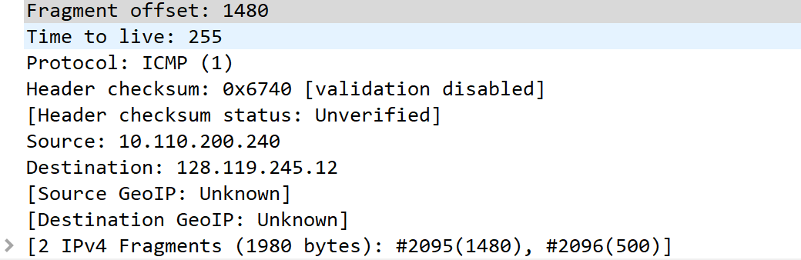 It has 2 ipv4 fragments
11. Flags, Fragment offset: 0 1480 long
12. Offset is not 0, there are more because it’s not 1480 yet.
13. Offset, checksum, flag
14. 1480
15. Offset, checksum