# Networking

Connect more than one devices through the physical medium to share resources is called networking.

* **Topologies**

Topology is the method where we define how each computer connect to each other.

OR

Topology map of your network

## Bus Topology

* + 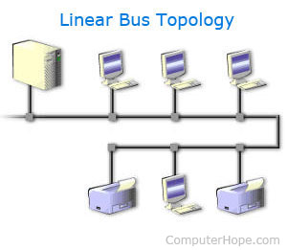

#### Advantages of Bus Topology

**•** Easy to connect a computer or peripheral to a linear bus.

**•** Requires less cable length than a [star topology](http://www.omnisecu.com/basic-networking/network-topologies-star-topology.php).

#### Disadvantages of Bus Topology

**•** Entire network shuts down if there is a break in the main cable.

**•** Terminators are required at both ends of the backbone cable.

**•** Difficult to identify the problem if the entire network shuts down.

**•** Not meant to be used as a stand-alone solution.

## Ring Topology

* + 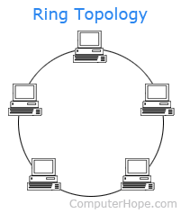

## **Advantages of ring topology**

* All data flows in one direction, reducing the chance of packet collisions.
* A network server is not needed to control network connectivity between each workstation.
* Data can transfer between workstations at high speeds.
* Additional workstations can be added without impacting performance of the network.

## **Disadvantages of ring topology**

* All data being transferred over the network must pass through each workstation on the network, which can make it slower than a [star topology](https://www.computerhope.com/jargon/s/startopo.htm).
* The entire network will be impacted if one workstation shuts down.
* The hardware needed to connect each workstation to the network is more expensive than Ethernet cards and hubs/switches.
  + Star Topology
  + 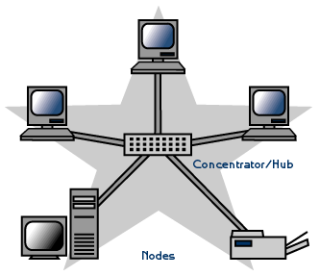

## Advantages of a Star Topology

* Easy to install and wire.
* No disruptions to the network when connecting or removing devices.
* Easy to detect faults and to remove parts.

### Disadvantages of a Star Topology

* Requires more cable length than a linear topology.
* If the hub, switch, or concentrator fails, nodes attached are disabled.
* More expensive than linear bus topologies because of the cost of the hubs, etc.

## Mesh (hybrid) Topology

* + 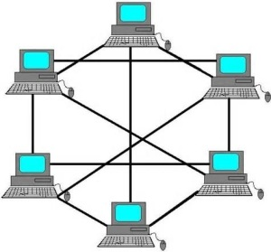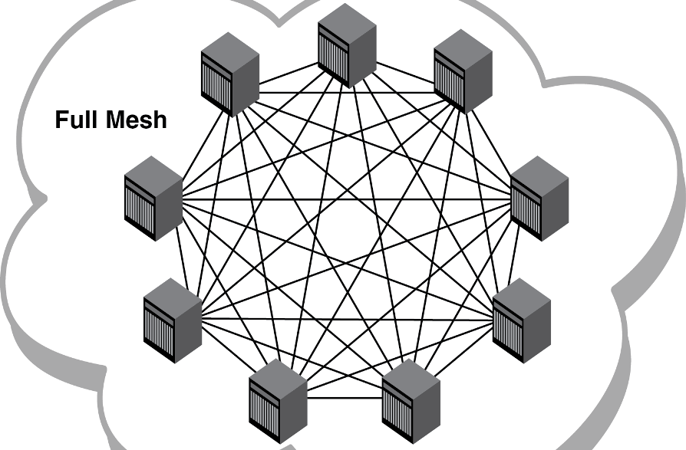
* Protocols
* OSI Layers