Linux Book commands

# Chapter4

1) **uptime**

19:26 up 29 days, 1:39, 2 users, load averages: 1.32 1.36 1.34

2) **uname -svr**

uname is the command to show the operating system name. –s (print the

operating system name), -r (print the operating system release), and –v (print

the operating system version) are options that you can use for the uname

command. In the particular example, we want to use all three so we put n –

srv to simplify. If we want to display the results as if we used all the options,

we can use the -a option.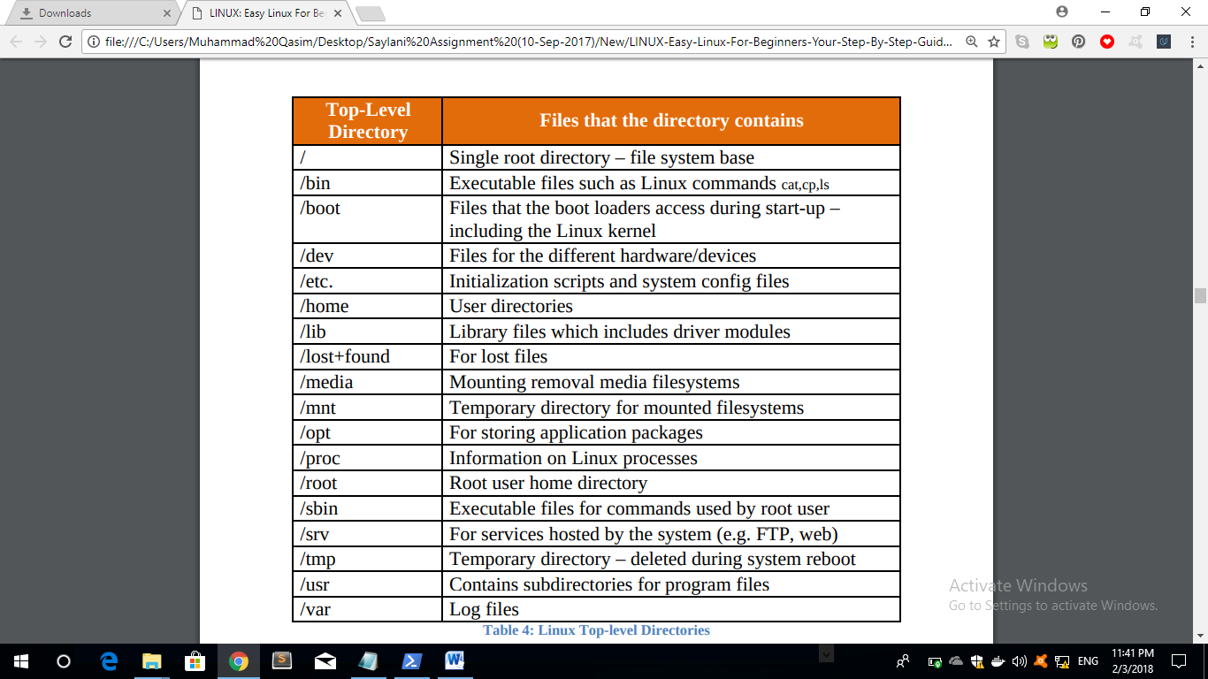 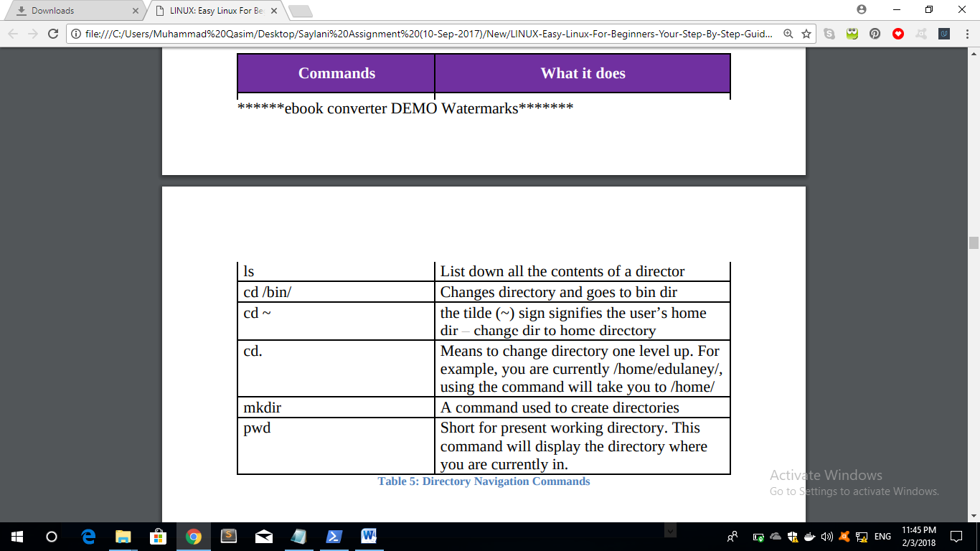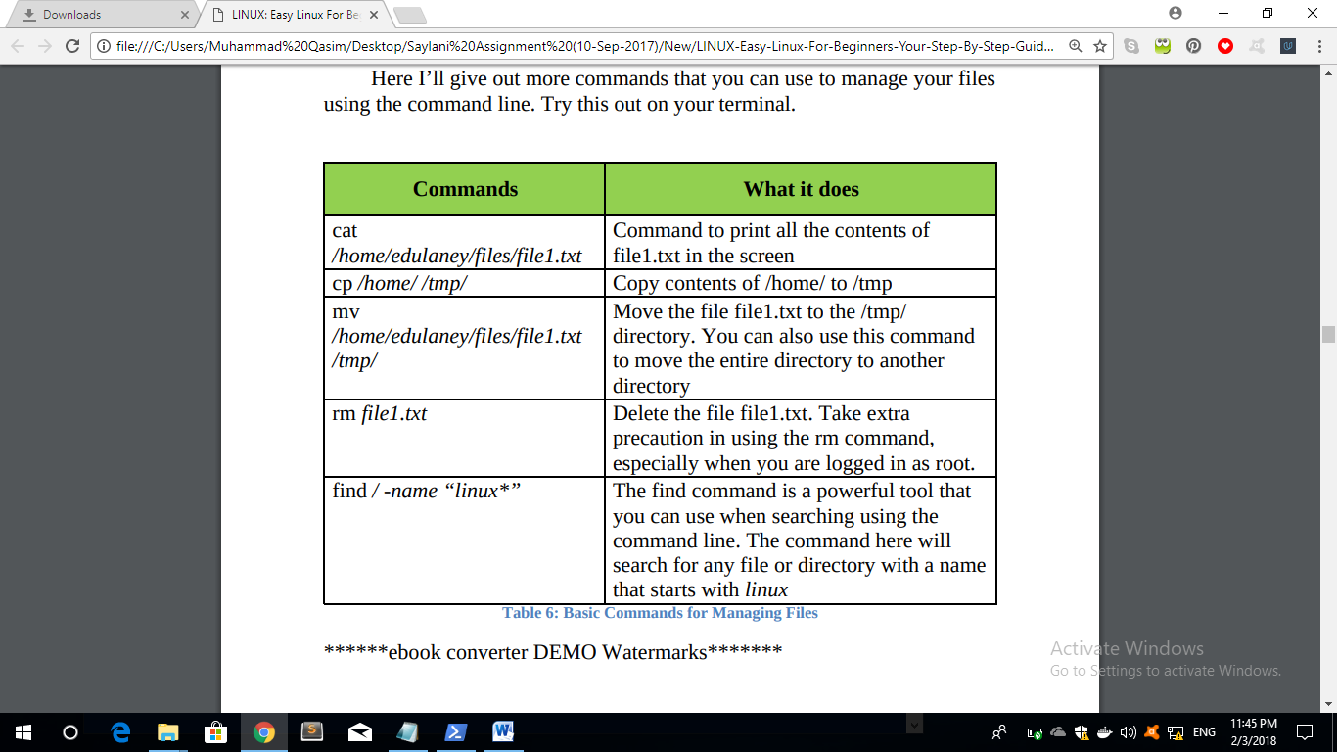Chapter Five: Post-Installation Activities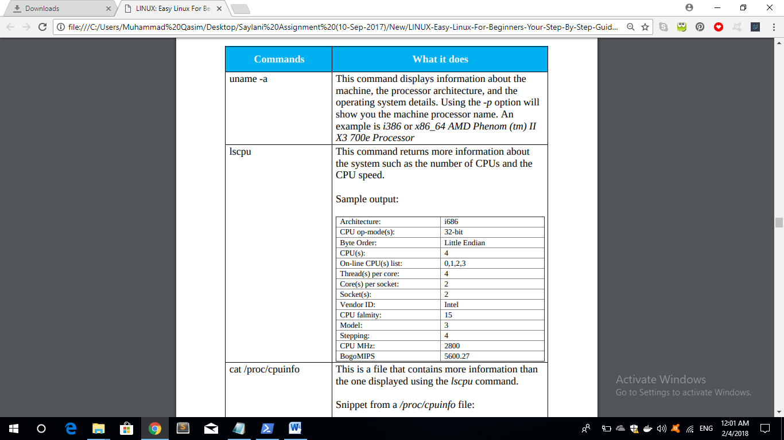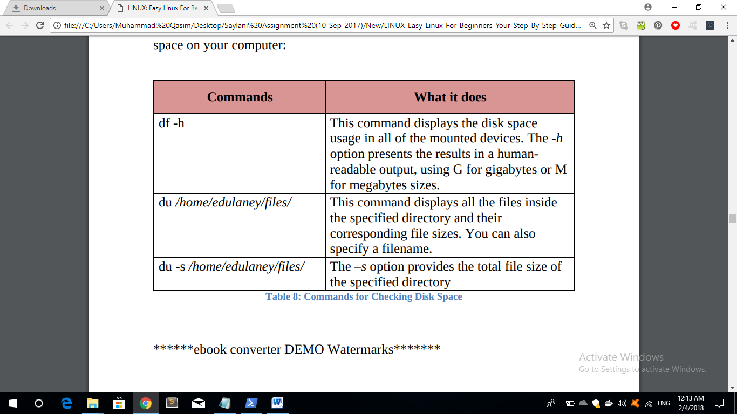Installing Additional Software Linux-compatible softwares come in .rpm for RPM (Fedore, SUSE) or .deb for Debian (Debian, Ubuntu, Xandros) packages. Even if the type of packages varies, both RPM and Debian packages can be installed in any type of Linux distribution. Popularly used distributions provide a GUI for installing additional applications. In this section, I will discuss the ways of installing software in Ubuntu and Fedora.

Debian-based distros use **APT** or the Advanced Packaging Tool

Shutteris the package name. Use the package name and run the **apt-get** install command again.