PRODUCT INSTRUCTION
PORTABLE HAND BLENDER | GROUP 4 | GLOBAL PRODUCTION ENGINEERING (GPE)
Revision | Application | Document status
1.0 | Academic prototype | Design instruction

This is a student prototype under development. Food-contact safety, water resistance, electrical protection and blade integrity have not yet been validated. Do not use the current prototype to prepare food or immerse the motor housing in liquid.

1 Product Overview
The Portable Hand Blender is a compact, rechargeable, handheld blending concept developed by GPE Group 4 to demonstrate product design, CAD-based development, prototyping, assembly and functional testing. A push button commands a DC motor, which transmits rotation through a drive coupling to a removable blade shaft assembly within a protective bell.

1.1 Main Features
Feature | Design intent
Portable power | Rechargeable battery; no power cable required during operation.
One-button control | Momentary push button to request motor operation.
Detachable front assembly | Blade shaft assembly and protective bell designed for removal; assembly fit pending verification.
Prototype-friendly structure | Four custom plastic parts made by FDM 3D printing; remaining parts purchased or outsourced.

1.2 Product Dimensions
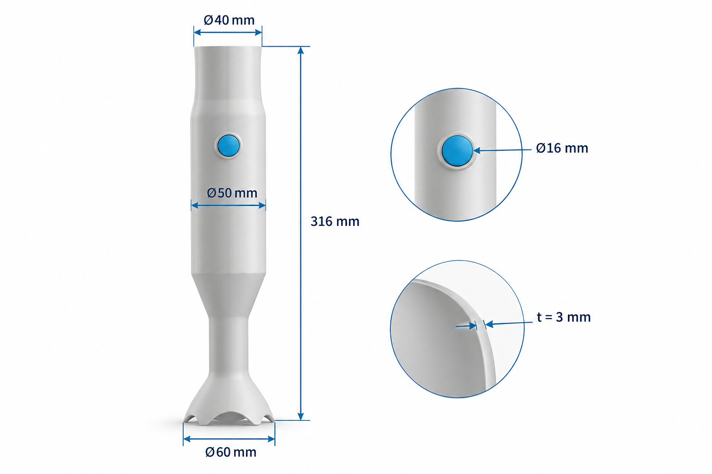
Figure 1. Concept dimensions (nominal): overall length 316 mm; body Ø50 mm; top Ø40 mm; guard Ø60 mm; button opening Ø16 mm; nominal housing wall 3 mm. Confirm against released CAD.

2 Product Components & Operation
Refer to the exploded-view drawing and the current Bill of Materials for component identification.
No. | Component | Function
01 | Upper Housing | Grip / upper enclosure
02 | Push Button | Momentary user command
03 | Lower Housing | Internal mounting and enclosure
04 | PCBA | Motor-drive electronics; full controller not finalized
05 | Rechargeable Battery Pack | Portable energy source
06 | DC Motor | Rotary drive
07 | Front End Cap | Front interface / positioning
08 | Drive Coupling | Motor-to-shaft torque transfer
09 | Blade Shaft Assembly | Shaft and blade as one purchased/custom assembly
10 | Blade Guard / Protective Bell | Detachable blade surround
11 | External Charger | Separate charging accessory

3 Before Use — Prototype Checklist
- Verify housing is closed, button is released and the system defaults to OFF when powered.
- Check that the protective bell is securely fitted; inspect blade retention, shaft alignment and coupling fit.
- Confirm battery polarity, battery protection and motor-driver electrical ratings before energizing.
- Keep hands and loose objects away from the blade; perform only supervised, guarded engineering tests.

4 Basic Operating Instructions
Step | User action | Expected response
1 | Place the prototype in a controlled test fixture or hold it securely only where approved by the test lead. | Blade is fully guarded and stationary.
2 | Connect the qualified battery only after the electrical inspection. | Unit remains OFF.
3 | Press and hold the push button briefly during a low-risk dry test. | Motor runs and rotates the blade shaft if control circuit has been validated.
4 | Release the button. | Motor command stops; wait for blade to come fully to rest.
5 | Disconnect battery before opening, adjusting or removing parts. | No unintended activation during handling.

Operating limits: allowable run time, current, speed, noise, temperature and mixing capability are TBD until prototype tests are recorded. Do not present the current unit as a validated kitchen appliance.

5 Battery Charging
The selected accessory is Adapter IC44009 5V, for a compatible single-cell nominal LiPo battery. In the current concept the charger is EXTERNAL; no built-in charging port is specified.
- Turn OFF and disconnect the battery from the product before charging.
- Check connector polarity, cell chemistry and charger instructions; do not connect mismatched or damaged batteries.
- Connect the 1S LiPo battery to the charger using its specified connector and power it from an appropriate USB source.
- Supervise charging on a nonflammable surface and follow the battery and charger manufacturer instructions.
- Disconnect the charger before reinstalling the battery; recheck polarity and cable routing.

6 Detachment, Cleaning & Storage
Disconnect the battery and wait for the blade to stop completely before any disassembly. Handle the blade assembly as a sharp component. Only detach the blade guard and blade shaft by the approved assembly procedure; do not pull on the motor shaft or force the coupling.
For the current 3D-printed PETG prototype, remove dust using a dry, lint-free cloth. Do not submerge, rinse, dishwasher-clean or expose the assembled motor/battery housing to liquids. Food-contact cleaning procedures must be defined only after qualified materials and ingress protection have been established. Store with battery disconnected in a dry location.

7 Basic Troubleshooting
Observation | First checks / corrective action
No motor rotation | Stop test; inspect battery charge, connector polarity, button and PCBA wiring.
Unexpected motor startup | Disconnect battery immediately; inspect switch logic and power-on behavior.
High vibration / abnormal noise | Stop test; inspect blade balance, shaft alignment and coupling retention.
Heat, smell, swollen battery or smoke | Isolate power if safe; stop use and follow battery emergency procedures.
Guard loose or blade rubbing | Stop test; inspect CAD fit, locking interface and clearances.

