PORTABLE HAND BLENDER | GPE GROUP 4 | DESIGN-ALIGNED REVISION
Document | Version | Issue date | Scope
MI-001 | 1.0 | 08 Nov 2026 | Prototype & Mass-production concept

1. Product Description
Our product is a portable hand blender, also called an immersion blender. It is a small kitchen device that helps users blend ingredients directly inside a cup, bowl or pot. Typical uses include making smoothies, soup, sauces, baby food and soft fruit mixtures.
In simple terms, the product works as follows: when the user presses the button, an electric motor inside the housing rotates a shaft. This rotation is transferred to the blade at the bottom of the blender. The blade then cuts and mixes the ingredients until the desired texture is reached.
The key design idea of our project is to separate the product into a reusable motor core and a detachable blending module. The motor housing is the long-life core of the product, while the shaft, seal, blade and guard are the parts that can be removed more easily for cleaning, repair or replacement. Compared with many conventional products, this makes the design more suitable for circular economy and open-source development.

  - Product Illustration

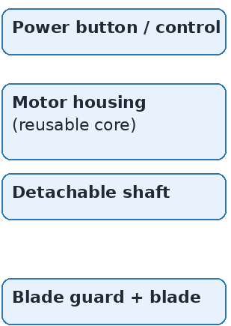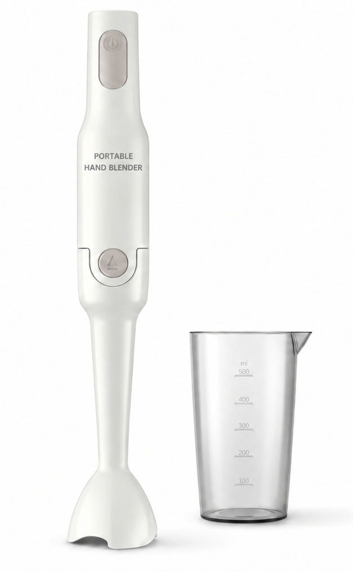
Figure 1. Preliminary product illustration with main modules.
Main purpose | Blend and mix soft food ingredients quickly and safely.
Core architecture | Reusable motor housing + detachable wet-side blending module.
Circular design focus | Repairability, replacement of wear parts, easier cleaning and long product life.
Open-source focus | The product will later be documented with CAD files, BOM, manufacturing files and repair information.
Current status | Preliminary concept for first submission; detailed dimensions and technical choices will be validated during the feasibility review.

1.2 Potential Upgrade Directions
A major advantage of this concept is that the same motor core can support more than one function. If the attachment interface is designed in a modular way, future teams or users can create new modules without redesigning the whole product. This is important for both circular design and open-source hardware, because it extends the useful life of the product and encourages community improvement.
Upgrade idea | What is added? | User benefit | Why it fits the project
Whisk attachment | A detachable whisk head replaces the blade module. | Supports mixing cream, eggs and light sauces. | Uses the same motor core and demonstrates modularity.
Mini chopper cup | A small cup or bowl module with its own blade arrangement. | Extends the product from blending to simple chopping tasks. | Shows how one platform can support multiple kitchen functions.
Improved control / safety module | A refined button layout, speed selection or simple interlock concept. | Safer and more convenient operation. | Improves usability without changing the main platform.

2. Functionality Analysis
The main function is to blend ingredients safely and portably. The function analysis separates the user-facing function from the internal subfunctions so that design choices can be evaluated independently and later mapped to components.
ID | Level | Function | Description | Priority
F0 | Main | Blend ingredients safely and portably | Convert food ingredients into the desired consistency during normal kitchen use. | Must
F1 | Sub | Be easy to hold and control | The handle and button layout should allow comfortable handheld operation. | Must
F2 | Sub | Operate safely during normal use | The user should be protected from direct contact with the blade and from accidental misuse. | Must
F3 | Sub | Reduce splashing and leakage | The blending head should minimize splashing and prevent liquid from entering the main housing. | Must
F4 | Sub | Be easy to clean after use | Food-contact parts should be easy to rinse or remove for cleaning. | Must
F5 | Sub | Allow replacement of wear parts | Parts such as blade, seal or coupling should be replaceable without replacing the whole device. | Must
F6 | Sub | Be easy to understand and reproduce | The design and instructions should be documented clearly for open-source sharing. | Must
F8 | Sub | Accept future functional modules | The same core platform should support future attachments such as a whisk or mini chopper. | Optional

Product Boundaries
- The baseline product is a portable hand blender for soft food preparation.
- A dedicated beaker is treated as an accessory rather than part of the core product.
- Functions such as ice crushing, heavy-duty food processing, app connectivity and advanced smart features are outside the scope of the first design.
- Future attachments are considered as upgrade options and are not required for the initial prototype.

3. Requirements List
The requirement list combines mandatory course constraints with preliminary technical targets for the product. The course constraints are fixed, while the technical values below are proposed targets to guide the next design steps.
ID | Category | Requirement | Target / value | Method / comment | Status
C-01 | Course scope | Product type | Portable hand blender / immersion blender | Must remain a table-top kitchen device | Fixed
C-02 | Course scope | Part count | 3-8 main parts (fixtures excluded) | System-level part count to be defined consistently | Open
C-03 | Course scope | Moving parts | At least 1 moving part | Rotating shaft/blade satisfies this | Met by concept
C-04 | Course scope | Wear parts | At least 1 replaceable wear part | Seal, blade or coupling can serve as wear part | Met by concept
C-05 | Course scope | Electronics + actuator | Required | Electric motor and control button required | Met by concept
C-06 | Course scope | Mechatronic coupling | Required | User control must actively drive the kinematic function | Met by concept
C-07 | Course scope | Manufacturing method | FabLab only | Filament 3D printing, milling, laser cutting, simple assembly | Open
C-08 | Course scope | Purchased parts | Maximum 2 purchased parts | Needs careful concept decision | Critical
C-09 | Course scope | Prototype cost | <= 200 EUR | Track in BOM | Target
C-10 | Course scope | Open repository | Public OSH repository + CERN-OHL-S | GitHub repository at design freeze | Planned
R-01 | Dimensions | Overall length | 330-380 mm | Target portable hand-blender size | Preliminary
R-02 | Dimensions | Maximum handle diameter | <= 50 mm | For one-hand grip comfort | Preliminary
R-03 | Dimensions | Blending shaft length | 160-200 mm | Allows blending inside common cups and pots | Preliminary
R-04 | Dimensions | Guard diameter | 55-65 mm | Must cover blade and reduce splashing | Preliminary
R-05 | Dimensions | Blade diameter | 35-45 mm | Target range for compact blending head | Preliminary
R-06 | Mass | Total product mass | <= 1.0 kg | Should remain comfortable for handheld use | Preliminary
R-07 | Electrical | Nominal supply voltage | 12 V DC | Chosen as a safer prototype voltage | Preliminary
R-08 | Electrical | Motor power | 80-120 W nominal | Enough for soft ingredients in concept scope | Preliminary
R-09 | Electrical | Speed range | 8,000-12,000 rpm (blade) | Exact value depends on motor/coupling choice | Preliminary
R-10 | Electrical | User control | 1 power button; optional 2-speed setting | At least on/off control required | Preliminary
R-11 | Performance | Ingredient scope | Soft fruit, cooked vegetables, sauces, soups | Not intended for hard ice crushing in baseline concept | Fixed concept
R-12 | Performance | Continuous run time | At least 2 min per cycle | Then allow cooling if needed | Preliminary
R-13 | Performance | Test portion volume | 300-500 mL typical | Matches included beaker / normal kitchen use | Preliminary
R-14 | Safety | User protection | Blade guarded during normal use | No exposed free-spinning blade during intended operation | Target
R-15 | Safety | Ingress protection (functional) | No liquid entry into motor housing during normal blending | Verify by water-use test | Target
R-16 | Safety | Housing temperature | Outer handle should remain comfortable to touch | Thermal check during feasibility stage | Open
R-17 | Usability | Cleaning time | Basic cleaning in <= 5 min | Food-contact parts easy to rinse | Target
R-18 | Maintainability | Wear-part replacement time | <= 10 min with simple tools | Target for blade/seal/coupling access | Target
R-19 | Maintainability | Disassembly method | Reversible fasteners / non-destructive joints | Avoid permanent adhesive joints where possible | Target
R-20 | Materials | Food-contact surfaces | Smooth, cleanable, non-toxic materials | Material choice to be finalized later | Open
R-21 | Documentation | Files to publish | CAD source, STEP, BOM, assembly, repair, build files | Required for OSH repository | Planned
R-22 | Upgradeability | Attachment interface | One standardized detachable interface | Needed for future add-on modules | Target

