MANUFACTURING INSTRUCTION
PORTABLE HAND BLENDER | GPE GROUP 4 | DESIGN-ALIGNED REVISION
Document | Version | Issue date | Scope
MI-001 | 1.0 | 08 Nov 2026 | Prototype & Mass-production concept

Prepared for Group 4’s Global Production Engineering (GPE) open-source prototype. Component IDs and nomenclature follow the supplied exploded assembly diagram (Figure 1). Manufacture using the released CAD/STEP/STL dimensions.

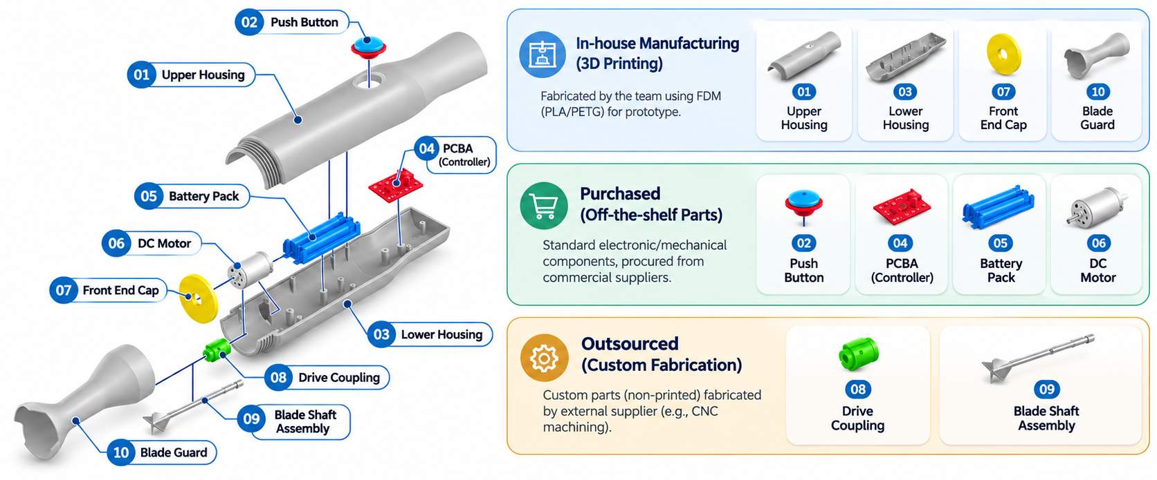
Figure 1. Component Sourcing & Manufacturing Plan for Prototype.

1 Component List
No. | Component (as illustrated) | Prototype Route | Design Baseline
01 | Upper Housing | 3D PRINT | Outer shell; CAD
02 | Push Button | BUY | Standalone button / integrated contact
03 | Lower Housing | 3D PRINT | Outer shell; CAD
04 | Printed Circuit Board Assembly (PCBA) | BUY | Provisional driver module, not a finished control PCBA
05 | Rechargeable Battery Pack | BUY | Protected 1S LiPo candidate; package fit TBD
06 | DC Motor | BUY | Test motor only; power & torque unverified
07 | Front End Cap | 3D PRINT | Custom CAD; motor interface
08 | Drive Coupling | OUTSOURCE | Custom CNC to both shaft interfaces
09 | Blade Shaft Assembly | OUTSOURCE | Complete metal shaft with blade — ONE assembly
10 | Blade Guard / Protective Bell | 3D PRINT | Removable; dry-fit print only

NOTE: Only 01, 03, 07, 10 are produced in-house for the prototype, so 09 already includes the blade and not add a separate blade purchase line.

2 Prototype Manufacturing
ID | Component | Qty | Route | Specification / selected item | Supplier | Price (USD)
01 | Upper Housing | 1 | MAKE | PETG; print to CAD | Team FDM | $4.20
02 | Push Button | 1 | BUY | Adafruit #1505; 16 mm momentary | Adafruit [R1] | $0.95
03 | Lower Housing | 1 | MAKE | PETG; print to CAD | Team FDM | Included*
04 | Circuit Board  (Included Wiring) | 1 | BUY | Pololu DRV8833 #2130 | Pololu [R2] | $10.95
05 | Rechargeable Battery Pack | 1 | BUY | Adafruit 3.7 V, 2500 mAh #328 | Adafruit [R3] | $14.95
06 | Motor | 1 | BUY | 12/24v 50W motor | Yongji [R4] | $10.00
07 | Front End Cap | 1 | MAKE | PETG; print to CAD | Team FDM | $0.60
08 | Drive Coupling | 1 | OUTSOURCE | Custom CNC; shaft fits per CAD | PCBWay RFQ [R6] | $7.00
09 | Blade Shaft Assembly | 1 | OUTSOURCE | Metal shaft + blade | Specialist / RFQ [R6] | $18.00
10 | Blade Guard / Protective Bell | 1 | MAKE | PETG; removable; print to CAD | Team FDM | $0.90
11 | Adapter | 1 | BUY | Adapter IC44009 5V | Thegioiic [R8] | $1.51
NOTE * Filament allowance only; existing team 3D printer and electricity excluded.

2.1 Purchased parts & outsourcing selection
The six items below are purchased or outsourced for the prototype. Prices marked † are internal estimates pending supplier quotations. For product pages and full URLs, see Section 4.
02 Push Button
Adafruit 16 mm momentary pushbutton #1505 | $0.95 — Supplier: Adafruit [R1]
Momentary push-to-activate button. Confirm mounting-hole diameter, button travel, electrical contact arrangement, and splash protection. Appearance/color may differ from the exploded view.
04 PCBA
Pololu DRV8833 motor driver carrier #2130 | $10.95 — Supplier: Pololu [R2]
Motor-driver module only, not a complete PCBA. Controller, charging and protection functions still require electrical design and integration.
05 Rechargeable Battery Pack
Adafruit 3.7 V / 2500 mAh LiPo battery #328 | $14.95 — Supplier: Adafruit [R3]
Candidate protected 1-cell LiPo. Check battery envelope, output current, charging method and safe enclosure retention before ordering.
06 DC Motor
Yongji 12/24v 50W motor | $10.00 — Supplier: Yongji [R4]
Test motor with 2 mm output shaft. Its operating voltage and load capability have not been validated with the proposed 1S LiPo; do not treat as a qualified blender motor.
07 Drive Coupling
Custom precision coupling — CNC quotation | $7.00† — Supplier: PCBWay (RFQ) [R6]
No verified ready-made SKU. Supply motor-shaft and blade-shaft dimensions, STEP file, retention interface, material and concentricity targets for quote.
08 Blade Shaft Assembly
Complete shaft-and-blade metal assembly — custom quotation | $18.00† — Supplier: PCBWay / specialist (RFQ) [R6]
One purchased assembly including the blade. Request a supplier able to turn the shaft AND manufacture/attach/balance the blade. PCBWay CNC is a quote route, not a verified complete-assembly supplier.
08 Adapter
IC44009 5V Adapter | $1.51† — Supplier: thegioiic [R8]
Adapter charging for small portable machine.

2.2 Manufacturing process for 3D-printed parts
Common FDM method: open released STEP/STL → check millimeter units and mesh → slice using PETG (initial test profile: 0.20 mm layer; 3 perimeters; 20–30% infill) → orient interfaces for minimum distortion → print → remove supports → deburr → check against CAD and purchased parts. Settings are initial trials, not design specifications.
Part | Practical fabrication & check | Print time*
01 + 03 Upper and lower housing | Slice as separate shells; keep motor/battery/PCBA mounting areas accessible. Trial-fit shell closure and push-button clearance. | 3–6 h
07 Front end cap | Print mating face accurately; remove support from opening; check fit to shell, motor nose and coupling passage. | 0.5–1 h
10 Blade guard / bell | Print removable guard; clean latch/contact surfaces; verify retention and blade envelope with motor disconnected. Dry demonstration only. | 0.8–1.5 h

Cost formula: printed material cost = slicer filament mass (including supports, g) × actual PETG USD/kg ÷ 1000. Replace time and price estimates with actual slicer results before publishing the final BOM.
NOTE FDM porous parts are NOT assumed food-safe or waterproof. Do not use this prototype for food processing, immersion in liquid or operation with the blade exposed.

3 MASS PRODUCTION recommendation
Planning scenario: 10,000 units/year. These process routes are recommendations, not current validated vendor quotes. Freeze housing CAD and electrical architecture, confirm food-contact/blade safety, then request supplier RFQs before tooling investment.

3.1 Proposed manufacturing strategy & sourcing
Component | Proposed manufacturing method | Supplier / outsourcing route
01 Upper Housing | Plastic injection molding | Contract injection molder / RFQ
02 Push Button | Purchase qualified sealed switch | OEM switch supplier / RFQ
03 Lower Housing | Plastic injection molding | Contract injection molder / RFQ
04 PCBA | Custom SMT PCB assembly + testing | Electronics manufacturing service (EMS) / RFQ
05 Rechargeable Battery Pack | Purchase protected, tested battery pack | Qualified battery-pack OEM / RFQ
06 DC Motor | Purchase appliance-rated DC motor | Motor OEM / RFQ
07 Front End Cap | Plastic injection molding | Contract injection molder / RFQ
08 Drive Coupling | Precision CNC turning / machining | PCBWay / Xometry (RFQ examples)
09 Blade Shaft Assembly | Stainless turning + blade forming/balancing | Specialist metal assembly supplier / RFQ
10 Blade Guard / Bell | Plastic injection molding | Contract injection molder / RFQ

NOTE † Unit targets are preliminary planning assumptions for 10,000 units/year, not supplier quotations. All suppliers above are proposed sourcing categories or RFQ routes, not appointed/qualified manufacturing partners. Example service links: [R6], [R7], [R8].

3.2 Manufacturing processes by part
Component(s) | Recommended process / acceptance focus
01, 03, 07, 10 | Injection molding: adjust CAD for draft, wall thickness, bosses, gating and shrinkage → T0 samples → verify mating features and removable guard. Specify resin and food-contact assessment as relevant.
02 Push Button | Source sealed OEM switch; verify electrical rating, stroke, lifetime, water ingress prevention and user actuation after shell installation.
04 PCBA | Electrical design + prototype validation → EMS SMT, solder inspection and 100% electrical/functional test; define charger interface or external charger policy.
05 Battery Pack | Qualified pack OEM with cells, protection and traceability; validate discharge current, charging, insulation and handling.
06 DC Motor | Motor OEM qualification: torque-speed/current curve, dimensions, shaft tolerance, heating, duty cycle and endurance.
08 Drive Coupling | Turn/machine to released motor and shaft fits; inspect coaxiality, secure retention and slip under load.
09 Blade Shaft Assembly | Turn stainless shaft, form/stamp blade, attach permanently to shaft; inspect finish, sharp edges, corrosion resistance, straightness and dynamic balance.

3.3 Estimated cost of goods sold (COGS)
Element | USD/unit | Definition
10 numbered components | 17.60 | Sum target costs (Base on BOM)
Assembly labor | 1.50 | Illustrative 6 min at $15/h loaded
Packaging | 0.65 | Allowance
Factory overhead & utility | 0.85 | Allowance
Inspection + yield allowance | 0.70 | Allowance
FACTORY COGS before tooling | 19.80 | No supplier quotes
Illustrative tooling amortization | 0.90 | $9,000 / 10,000 units, year one
COGS incl. one-year tooling | 22.21 | Scenario only

NOTE Tooling, unit cost and scrap must be re-quoted from final CAD. COGS excludes freight, import duties, certification and engineering. The pictured 10-part breakdown is a design structure, not the complete procurement BOM for wires, seals and safety electronics.

3.4 Release checks before buying tooling
Verify: (1) CAD-to-purchased-part clearance; (2) motor voltage vs selected battery, load torque and protection; (3) PCBA functionality and charging architecture; (4) safe coupling/shaft retention, blade balance and guarded operation; (5) sealing, food-contact and cleanability requirements; (6) complete BOM, supplier quotations, tolerance drawings and pilot test approval.

4 References
Product and supplier reference pages (full web addresses printed for PDF export). Prices were carried over from Rev 0.4 and must be rechecked before purchase.
R1 Adafruit pushbutton #1505
https://www.adafruit.com/product/1505
R2 Pololu DRV8833 carrier #2130
https://www.pololu.com/product/2130
R3 Adafruit LiPo battery #328
https://www.adafruit.com/product/328
R4 Efficient 12/24V 50W Wiper Motor
https://boyongwiper.en.made-in-china.com/product/ZJcUqlpyCfrd/China-Efficient-12-24V-50W-Wiper-Motor-for-Car-Front.html
R5 Optional charger #1304
https://www.adafruit.com/product/1304
R6 PCBWay CNC machining RFQ
https://www.pcbway.com/CNC
R7 Xometry alternative CNC RFQ
https://www.xometry.com/capabilities/cnc-machining-service/
R8 IC44009 5V Adapter
https://www.thegioiic.com/nguon-adapter-5v-2a-dau-type-c-dai-1m

