BILL OF MATERIALS (BOM)
PORTABLE HAND BLENDER | GPE GROUP 4 | PROTOTYPE BASELINE
Document | Revision | Date | Basis
BOM-001 | 1.0 | 03 Nov 2026 | BILL OF MATERIALS (BOM)
Purpose. This single-unit engineering BOM identifies the 10 numbered components in the team’s exploded view, their sourcing routes, quantities and preliminary costs. It supports prototype purchasing, cost tracking and future supplier substitutions.

1 Product Structure
Figure 1. Exploded-view component numbering is authoritative; design dimensions must come from released CAD/STEP/STL, not from this illustration.
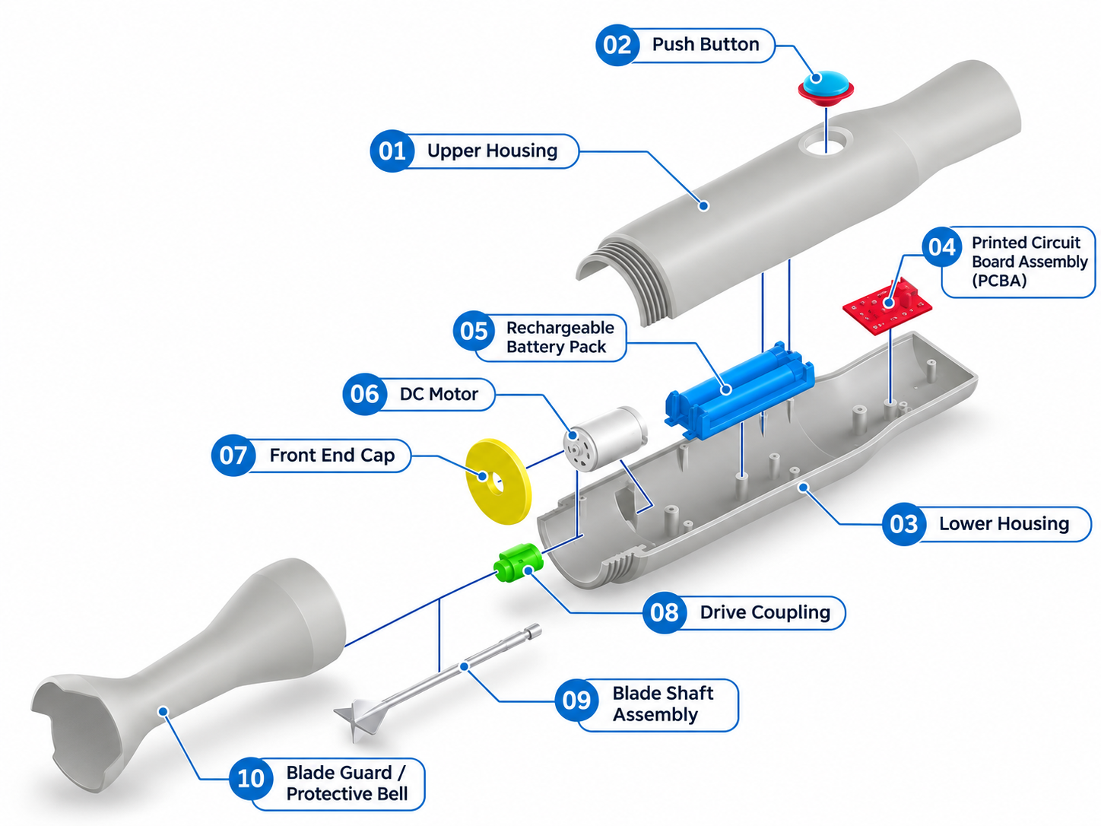
BOM rules: 01, 03, 07 and 10 are printed in-house; 02, 04, 05 and 06 are purchased; 08 and 09 are outsourced custom components. Part 09 includes both shaft and blade as ONE assembly. Auxiliary supplies are separately tracked and not assigned new diagram IDs.

2 Prototype BOM
Cost status: L = historical product-page price carried from MI Rev 0.5; A = internal allowance / not quoted. USD, one prototype, excluding shipping and tax.
ID | Component | Qty | Route | Specification / selected item | Supplier | Price (USD) | Status
01 | Upper Housing | 1 | MAKE | PETG; print to CAD | Team FDM | $4.20 | A
02 | Push Button | 1 | BUY | Adafruit #1505; 16 mm momentary | Adafruit [R1] | $0.95 | L
03 | Lower Housing | 1 | MAKE | PETG; print to CAD | Team FDM | Included* | A
04 | Circuit Board  (Included Wiring) | 1 | BUY | Pololu DRV8833 #2130 | Pololu [R2] | $10.95 | L
05 | Rechargeable Battery Pack | 1 | BUY | Adafruit 3.7 V, 2500 mAh #328 | Adafruit [R3] | $14.95 | L
06 | Motor | 1 | BUY | 12/24v 50W motor | Yongji [R4] | $10.00 | L
07 | Front End Cap | 1 | MAKE | PETG; print to CAD | Team FDM | $0.60 | A
08 | Drive Coupling | 1 | OUTSOURCE | Custom CNC; shaft fits per CAD | PCBWay RFQ [R6] | $7.00 | A
09 | Blade Shaft Assembly | 1 | OUTSOURCE | Metal shaft + blade | Specialist / RFQ [R6] | $18.00 | A
10 | Blade Guard / Protective Bell | 1 | MAKE | PETG; removable; print to CAD | Team FDM | $0.90 | A
11 | Adapter | 1 | BUY | Adapter IC44009 5V | Thegioiic [R8] | $1.51 | L
 | Total Direct Cost |  |  |  |  | $69.06
* 01 + 03 share a combined $4.20 filament allowance. The $4.20 is booked against 01 only to prevent double counting; actual split must be updated from slicer mass.
All other printed prices cover filament only; team printer, electricity and labor excluded.
The $69.06 prototype BOM Direct Cost is a planning estimate, not a validated purchase cost.

3 Procurement Quality Notes
ID / group | Mandatory pre-purchase check
02 Push Button | Confirm actual mount diameter, switch electrical contact and splash protection against upper-housing CAD.
04 PCBA | DRV8833 board is only a motor-driver candidate; controller, charging/protection integration and final PCBA remain open.
05 + 06 Battery / Motor | Verify battery discharge current, motor voltage, torque, heat and protection under real blender load.
08 Coupling | Send both mating shaft diameters, STEP model, tolerance and retention method to CNC supplier for RFQ.
09 Blade Shaft Assembly | Obtain one complete food-contact suitable metal shaft-and-blade assembly; qualify retention, balance and finish.
01/03/07/10 Printed parts | Confirm printed size, fit and guard retention. FDM PETG parts are not assumed watertight or food-safe.

4 Mass-production BOM
Scenario: 10,000 units/year; these are target piece prices, not supplier quotations. See Manufacturing Instruction Rev 0.5 for processing assumptions and COGS.
ID | Component | Recommended route | Target USD/unit
01 | Upper Housing | Injection molding | 1.25
02 | Push Button | Qualified sealed OEM switch | 0.35
03 | Lower Housing | Injection molding | 1.25
04 | PCBA | Custom EMS/SMT assembly | 2.10
05 | Rechargeable Battery Pack | Qualified battery pack OEM | 4.00
06 | DC Motor | Appliance-rated motor OEM | 3.20
07 | Front End Cap | Injection molding | 0.40
08 | Drive Coupling | Precision CNC machining | 0.55
09 | Blade Shaft Assembly | Specialist metal forming / assembly | 1.95
10 | Blade Guard / Protective Bell | Injection molding | 1.05
11 | Adapter | Qualified adapter OEM | 1.5
 | 11-COMPONENT TARGET TOTAL | Excludes auxiliary components / final assembly | $17.60
Factory COGS target: $17.60/unit before tooling, or $20.00/unit with illustrative first-year tooling amortization. This is a business planning scenario, not a purchase-ready production BOM; final electronics, sealing and safety items may add cost.

5 Supplier References
R1 Adafruit pushbutton #1505
https://www.adafruit.com/product/1505
R2 Pololu DRV8833 carrier #2130
https://www.pololu.com/product/2130
R3 Adafruit LiPo battery #328
https://www.adafruit.com/product/328
R4 Efficient 12/24V 50W Wiper Motor
https://boyongwiper.en.made-in-china.com/product/ZJcUqlpyCfrd/China-Efficient-12-24V-50W-Wiper-Motor-for-Car-Front.html
R5 Optional charger #1304
https://www.adafruit.com/product/1304
R6 PCBWay CNC machining RFQ
https://www.pcbway.com/CNC
R7 Xometry alternative CNC RFQ
https://www.xometry.com/capabilities/cnc-machining-service/
R8 IC44009 5V Adapter
https://www.thegioiic.com/nguon-adapter-5v-2a-dau-type-c-dai-1m
Internal baseline: Assembly Diagram.png (Group 4); Manufacturing Instruction Rev 0.5. Update the item name, supplier, cost, reference and interface validation together whenever the selected component changes.

