GROUP 4 / GPE2025 PROJECT / OPEN-SOURCE DOCUMENTATION

Assembly Guide
PORTABLE HAND BLENDER
Revision: 1.0 | Language: English

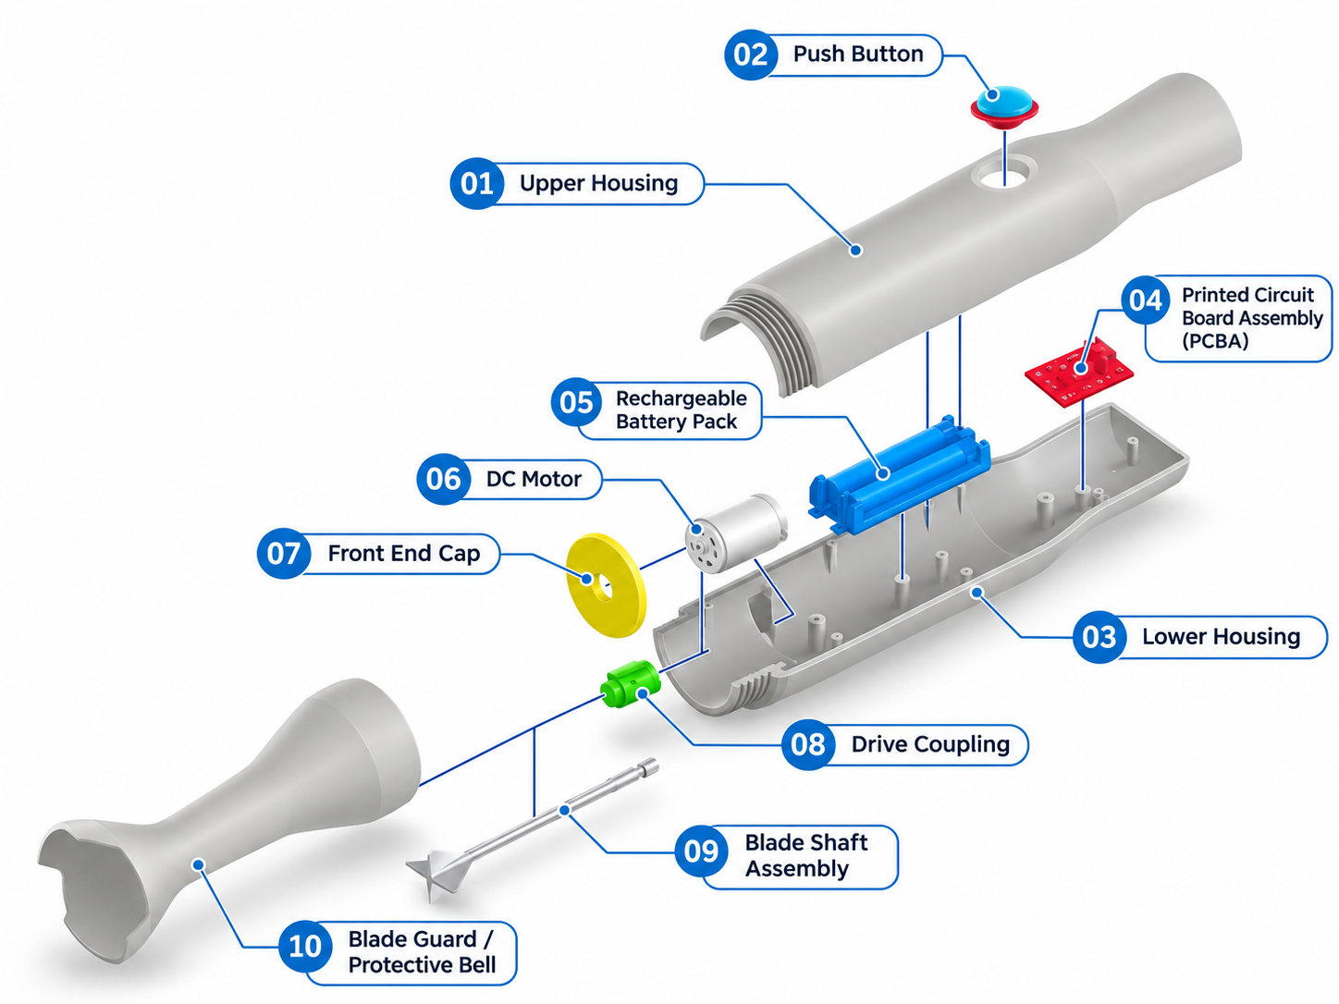
Figure 1. Exploded assembly view with component identification (01–10).

1. Product Overview
The Portable Hand Blender is a compact, battery-powered handheld appliance designed for light blending and mixing tasks. Its main body houses the rechargeable battery pack, DC motor, printed circuit board assembly (PCBA), and drive mechanism. The blade shaft assembly and blade guard are designed to be detachable for cleaning and replacement; the two housing halves form a fixed body assembly during normal use.
Document scope: component identification, intended assembly arrangement, pre-assembly checks, a proposed prototype assembly procedure, and final inspection. This is a draft based on the supplied CAD exploded view; no dimensions, electrical ratings, tolerances, or attachment validation have been provided.

2. Components List
Item | Component name | CAD color | Function
01 | Upper Housing | Grey | Upper fixed shell; houses the separated push button.
02 | Push Button | Blue / Red | Separate user-operated actuator for the electrical switch.
03 | Lower Housing | Grey | Lower fixed shell; supports internal parts.
04 | Printed Circuit Board Assembly (PCBA) | Red | Controls electrical operation.
05 | Rechargeable Battery Pack | Blue | Provides electrical power.
06 | DC Motor | White | Generates rotary motion.
07 | Front End Cap | Yellow | Closes front of housing; interface to verify.
08 | Drive Coupling | Green | Transfers torque to detachable blade shaft.
09 | Blade Shaft Assembly | Silver | Detachable shaft and blending blade.
10 | Blade Guard / Protective Bell | Grey | Detachable guard surrounding the blade.
Note: The ten rows identify visible components/assemblies, not a complete production BOM. Add separate items for any screws, wires, connectors, seals, bearings, switches, charging socket, or fasteners used in the final design.

3. Component Details
Component / Group | Assembly status | Specification / design detail
Upper + Lower Housing  (01, 03) | Fixed to body | Two-part main body; joining method, material, dimensions and fasteners: TBD.
Push Button (02) | Fixed to body | Actuator material, travel, switch interface, retaining geometry, return action and moisture ingress protection: TBD. Button must actuate reliably without sticking.
PCBA (04) | Internal / fixed | Board size, electronic schematic, button-switch interface, charging and mounting points: TBD.
Battery Pack (05) | Internal / fixed | Cell chemistry, nominal voltage, capacity, battery protection and connector: TBD.
DC Motor (06) | Internal / fixed | Rated voltage, speed, torque, shaft diameter and mount: TBD.
Front End Cap (07) | Fixed to body | Housing closure; retention and sealing responsibilities: TBD.
Drive Coupling (08) | Internal / fixed | Coupling geometry, locking method, concentricity and material: TBD.
Blade Shaft Assembly (09) | DETACHABLE | Shaft/blade materials, dimensions, retention and drive interface: TBD. Must detach without opening the body.
Blade Guard (10) | DETACHABLE | Guard material, blade clearance and locking/release method: TBD. Must detach without opening the body.
Design requirement: Both Item 09 and Item 10 are intended to detach from the body; the housing assembly (Items 01 and 03) remains fixed. The exact locking and sealing arrangements have not yet been shown or validated.

4. Before Assembly
- Confirm the latest CAD revision, part numbers, and orientation of each component.
- Inspect all parts for cracks, burrs, sharp edges, deformation, or visible damage.
- Verify the motor–coupling–shaft interface, shaft alignment, retaining features, and free rotation.
- Confirm the detachable interfaces for the blade shaft (09) and guard (10), including the locking and release method.
- Confirm the proposed shaft support, bearing/bushing, and liquid sealing design before use near liquids.
- Inspect the separate Push Button (02), its retaining features and the aligned switch interface on the PCBA; verify smooth movement without applying power.
- Check the battery voltage, polarity, protection, charging connections, and approved electrical schematic.
- Keep the battery electrically disconnected during mechanical assembly and wiring work.
- Prepare appropriate PPE, a clean workbench, and a safe method of handling sharp blades.

Tools and Materials
As applicable to the validated design: small screwdrivers, non-marring tools, vernier caliper, multimeter, specified connectors/fasteners and approved insulating materials. Tightening torques, adhesives, and sealants must follow finalized drawings; no values are assumed here.

5. Proposed Assembly Procedure
This order is a proposed prototype sequence, not a verified production work instruction. The final assembly sequence must be confirmed against the CAD assembly, mounting access and prototype test results.

Step 01 | Prepare the lower housing (03)
Place the Lower Housing open side up. Verify mounting features for motor, battery, and PCBA.
Check: Mounting features and mating edges are intact.

Step 02 | Install the DC motor (06)
Orient the motor output shaft toward the front/blending end and locate the motor in its mounting area. Secure using the finalized retention features.
Check: Motor is stable and output shaft is unobstructed.

Step 03 | Fit the front end cap and drive coupling (07, 08)
Fit the Front End Cap and Drive Coupling in the order allowed by the actual mounting design. Verify clearance and the designed interface for the detachable blade assembly.
Check: The coupling seats correctly and rotates freely without contacting the cap.

Step 04 | Install the battery pack (05)
Locate and secure the Battery Pack in its dedicated cavity while leaving electrical connections isolated until the approved wiring step.
Check: Battery is retained and cannot contact the drive train.

Step 05 | Install the PCBA (04) and wiring
Mount the PCBA and connect the motor, battery, push-button switch, and charging elements only according to the finalized electrical schematic. Route and insulate cables appropriately.
Check: Correct polarity and secure, insulated connections; no pinched leads.

Step 06 | Install the separate push button (02)
Place the Push Button into the opening in the Upper Housing (01), following the approved retention design. Align it with the switch actuator on the PCBA (04). Keep the battery disconnected during fitting.
Check: The button moves smoothly, returns as designed, cannot fall out and reliably actuates the switch without binding.

Step 07 | Close the fixed body (01 + 03)
Arrange wires away from rotating parts. Align the Upper Housing and Lower Housing and fasten using the approved joining method. The housing is intended to remain fixed during routine use.
Check: Body halves are fully seated, with no gaps, loose parts, or trapped wiring.

Step 08 | Attach the detachable blade shaft (09)
With power disconnected, insert and engage the Blade Shaft Assembly with the designed Drive Coupling interface. Install shaft support and liquid sealing elements as specified in the validated design.
Check: Blade shaft is retained, coaxial and removable by the intended release method.

Step 09 | Attach the detachable blade guard (10)
Position the Protective Bell around the blade and engage its designed detachable attachment. Check clearance throughout manual rotation before power-on.
Check: Guard locks securely, releases as designed and does not touch the blade.

Step 10 | Complete inspection and controlled testing
Complete Section 6 before powering on. Any functional test must use a documented method that controls exposed blade, electrical, and liquid hazards.
Check: All applicable checks pass and are recorded.

6. Final Inspection Checklist
Check | Acceptance criterion | Pass / Fail
Push button | Button retained; moves & returns freely; controls switch as intended. | □ / □
Body assembly | Housing halves secure; no damage, gaps or trapped wires. | □ / □
Detachable blade shaft | Fits, locks and releases without opening housing. | □ / □
Detachable blade guard | Fits, locks and releases; no blade interference. | □ / □
Drive alignment | Shaft rotates freely; coupling has no binding. | □ / □
Sealing | Liquid barrier and shaft support verified by design/test. | □ / □
Electrical | Polarity, insulation, battery protection and charging checked. | □ / □
Function | Controlled functional test completed to approved procedure. | □ / □

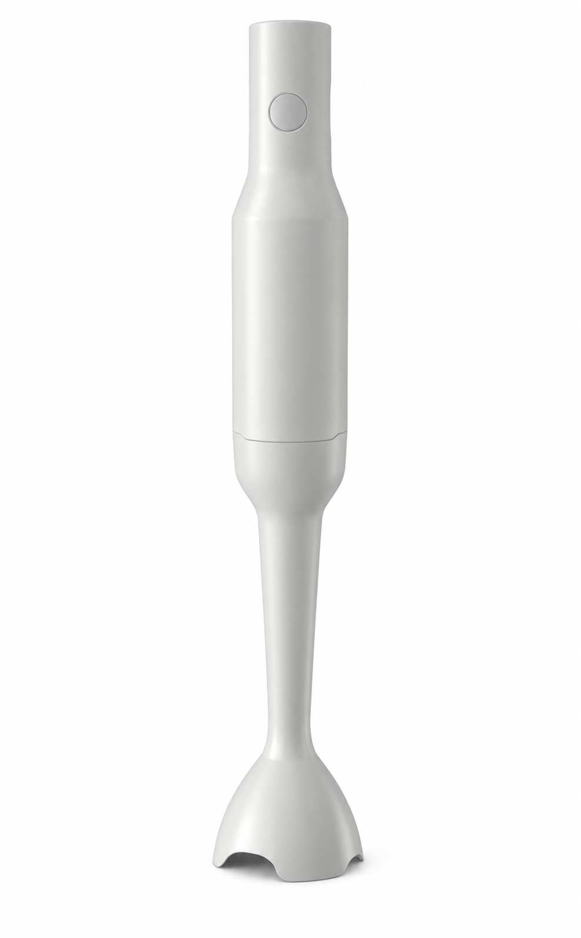
Figure 2. Portable Hand Blender – Assembled Product View

Inspector: ____________________ Date: ____________________ Prototype / Revision: ____________________

