ELECTRONICS DOCUMENTATION
Portable Hand Blender • GPE Group 4 • Prototype
This document covers the four electrical components in the team’s exploded assembly diagram (02, 04, 05, 06). It defines a simple on/off motor bench-test circuit using the current shortlist; it is not a validated blade-driving electrical design.

1 Components and electrical specifications
ID / Ref. | Selected component | Electrical role / specification
02 / SW1 | Adafruit #1505, 16 mm momentary N.O. button | Closes AIN1 to BATT+ when pressed
04 / U1 | Pololu #2130 DRV8833 motor-driver carrier | VIN 2.7–10.8 V; 1.2 A continuous / motor channel
05 / BAT1 | Adafruit #328 protected 1S LiPo 2500 mAh | 3.7 V nominal; 4.2 V fully charged
06 / M1 | 12/24v 50W motor | 50W rated; 12–24 V specified operating range

2 Circuit schematic
Standard electrical symbols are used for the rechargeable battery, normally-open push button, motor and ground. U1 is represented as a driver-module symbol with its actual external pin names. No custom PCB or microcontroller is implied.
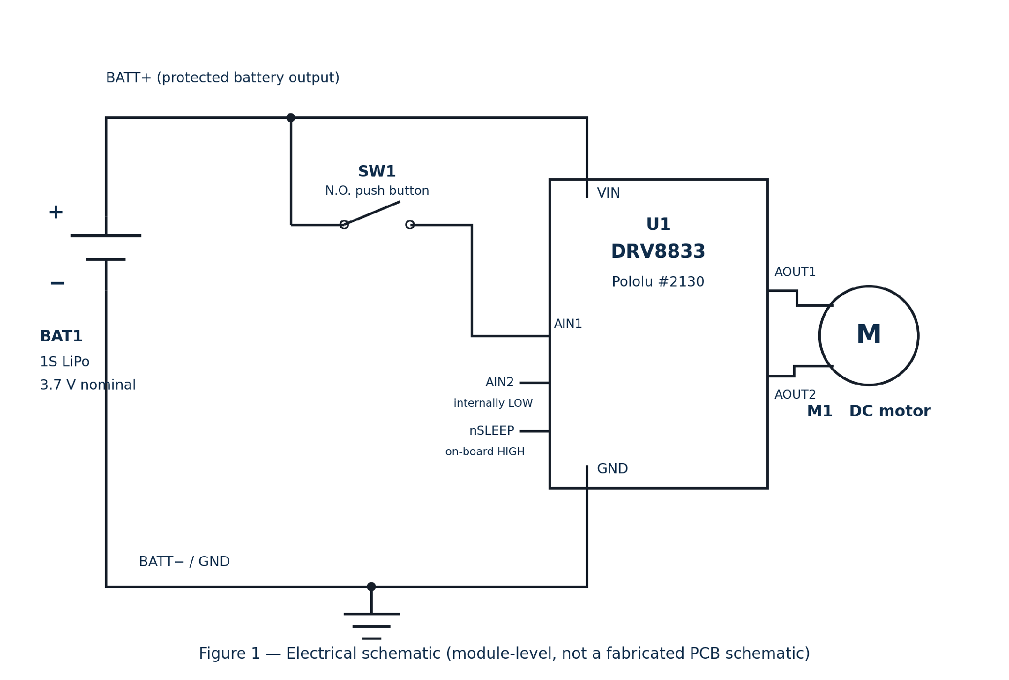

3 Wiring and operation
Net | Connection / function
BATT+ | BAT1 positive → U1 VIN and one side of SW1
GND | BAT1 negative → U1 GND (common return)
RUN | Other side of SW1 → U1 AIN1
MOTOR | U1 AOUT1 / AOUT2 → M1 terminals
Defaults | AIN2 internally LOW; nSLEEP pulled HIGH on Pololu #2130; unused channel B disconnected
Released: AIN1=LOW and AIN2=LOW → motor coasts/stops. Pressed: AIN1=HIGH, AIN2=LOW → channel A drives forward. Releasing the button returns the input LOW through its internal pulldown. Reverse motor leads if rotational direction is wrong, with power disconnected.

4 Verification and design limitations
Before applying power, use a multimeter to confirm battery polarity, no VIN-to-GND short, and switch continuity. Test with the blade and drive coupling REMOVED; record battery voltage and motor current. Charge the removed battery using a dedicated compatible 1S LiPo CC/CV charger; the driver board is not a charger.
Important: The selected motor is not specified for the 1S LiPo operating voltage. The driver carrier also lacks a complete product safety/control design. Final release requires motor–battery matching, current protection, water isolation and electrical/mechanical verification.

