* 3e).Digital voltmeters (DVMs) are the devices that measure an unknown input a.c. or d.c voltage by converting the voltage to a digital value and then they display the value of voltage being measured directly as discrete numerals in the decimal number system.  
  Numerical readout of digital voltmeters is advantageous since they eliminate observational errors committed by operators. The errors on account of parallax and approximations are entirely eliminated. The use of digital voltmeters increases the speed with which readings can be taken. Also, the output of digital voltmeters can be fed to memory devices for storage and future computations.

The block diagram of digital voltmeters is shown in the figure below.

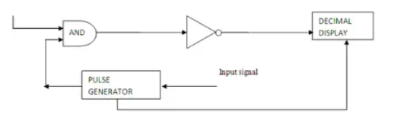

Explanation of various blocks

i) Input signal

It is basically the signal i.e. voltage to be measured.

ii) AND gate

It gives high output only when both the inputs are high. When a train pulse is fed to it along with rectangular pulse, it provides us an output having train pulses with duration as same as the rectangular pulse from the pulse generator.

iii) Decimal Display

It counts the numbers of impulses and hence the duration and display the value of voltage on LED or LCD display after calibrating it.

iv) Pulse generator

Actually it is a voltage source. It uses digital, analog or both techniques to generate a rectangular pulse. The width and frequency of the rectangular pulse is controlled by the digital circuitry inside the generator while amplitude and rise and fall time is controlled by analog circuitry.

f)Signal Generators is an electronic device that is capable of producing repeating or non-repeating waveforms. The waveform can be of different shapes and amplitude. Signal generators are mostly used in testing, troubleshooting, designing and repairing electronic devices.

Block Diagram of Signal Generator 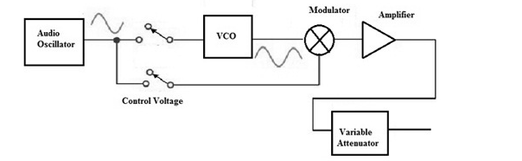

Explanation of various blocks

i)Amplifier

The amplifier amplifies the signal produced by the oscillator to a level suitable for the intended application.

ii)Audio Oscillator

The oscillator is the heart of the signal generator, and it generates a continuous waveform at a specific frequency. It can be a sine wave, square wave, triangle wave, or other waveform.

iii)Modulator

This component is used to add variations to the waveform, such as amplitude modulation (AM) or frequency modulation (FM). This allows the signal generator to simulate real-world signals, such as speech or music.

iv)Control Voltage

control voltage is used to control the frequency or other aspects of the signal being generated. The control voltage allows the signal generator to be synchronized with or controlled by other equipment, such as a microcontroller, a computer, or another signal generator.

v)Variable Attenuator

A variable attenuator is a component in a signal generator that allows the user to adjust the amplitude, or level, of the generated signal. The attenuator reduces the amplitude of the signal by a specified amount, which is expressed in decibels (dB).