**Lab#3:**

**Objective**: To learn RMI basics: Generate the stubs and skeletons and run client and server.

**Task#1:** Create RMI program in which server performs basic arithmetic operations.

**Interface:**

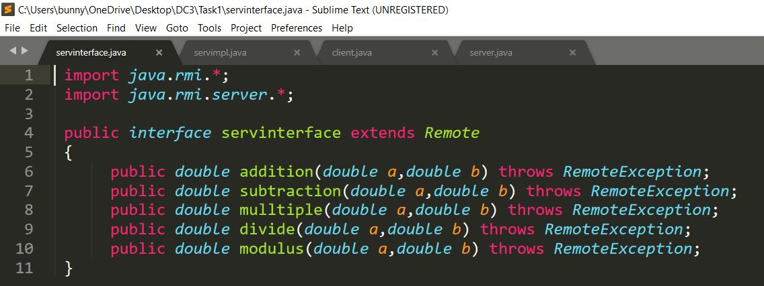

**Server Implementation:**

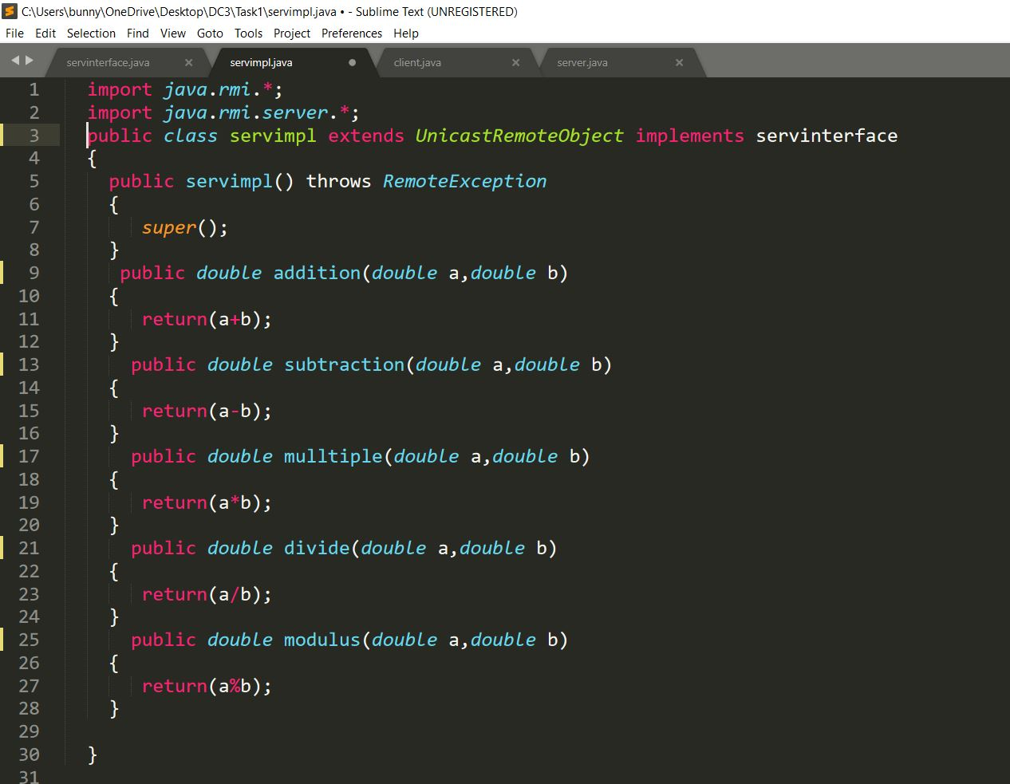

**Server:**

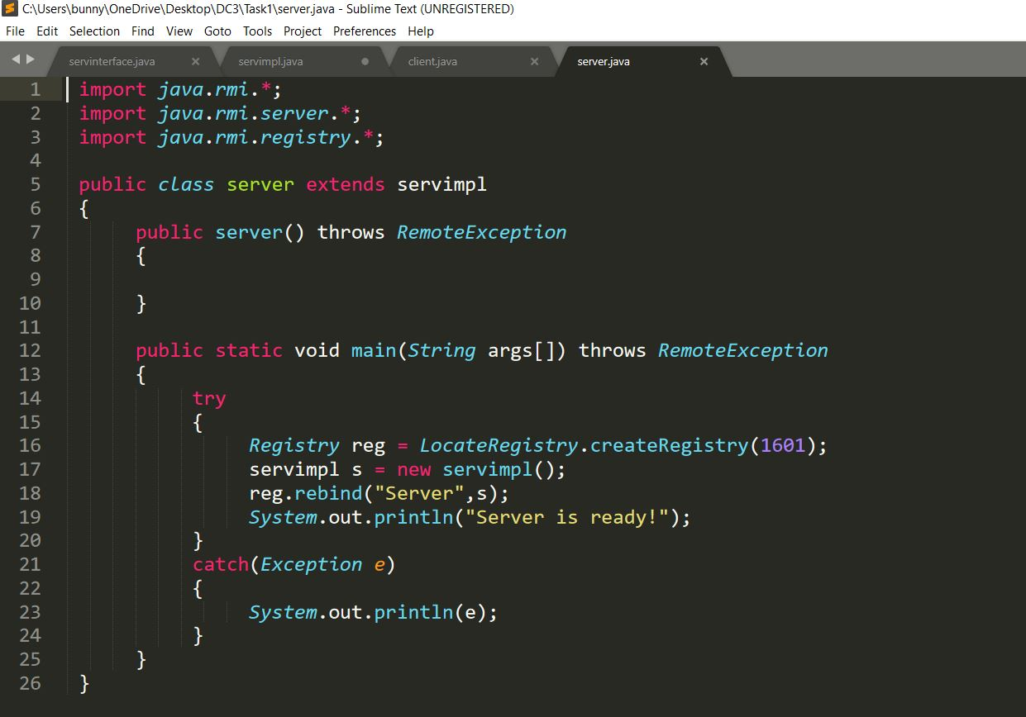

**Client:**

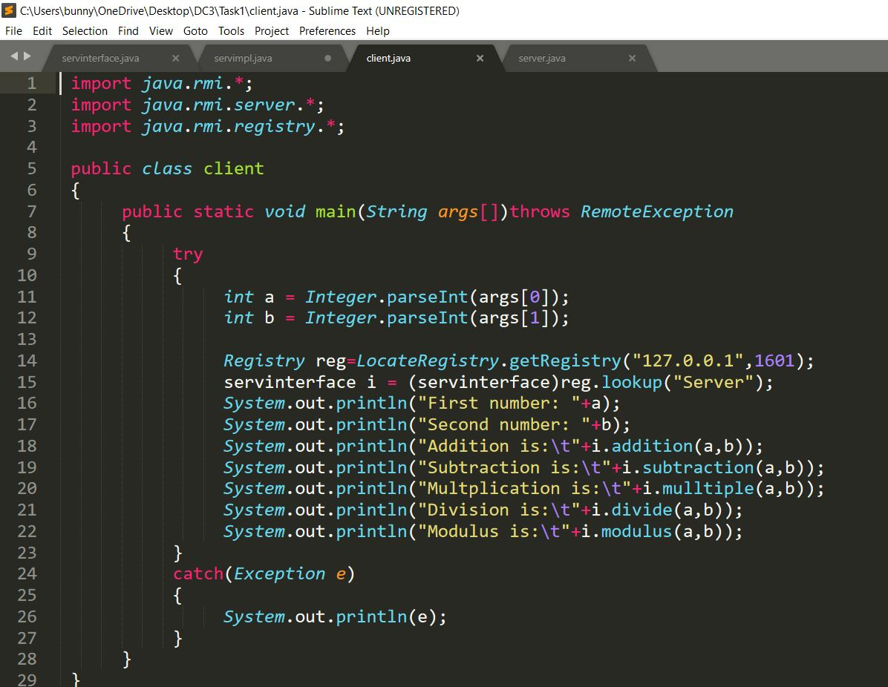

**Output:**

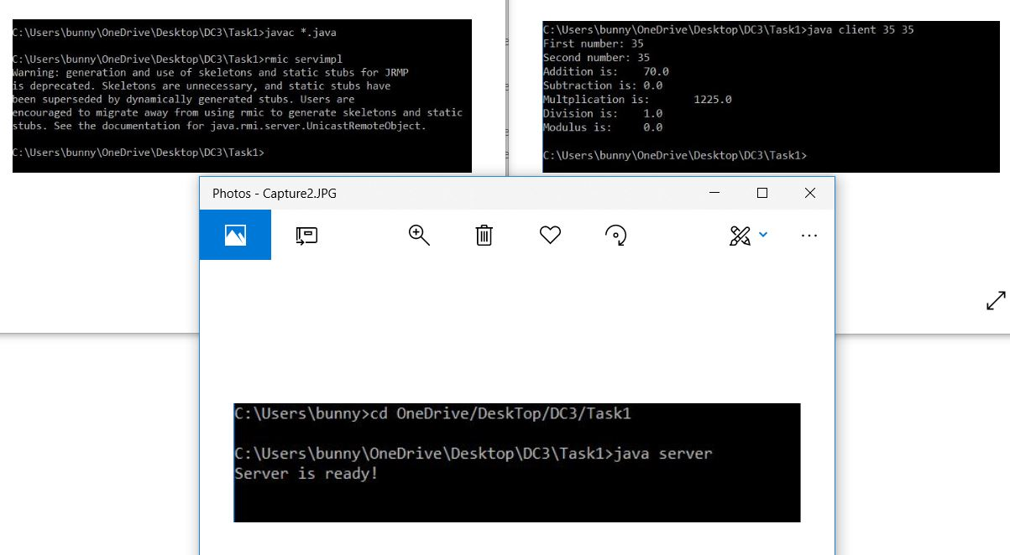

**Task#2:** Create RMI program in which server sorts the numbers in ascending order.

**Interface:**

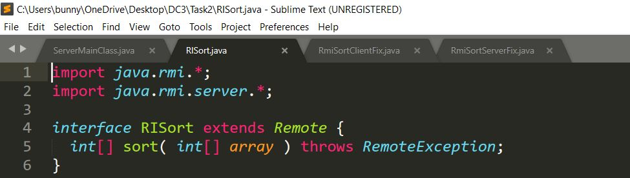

**Client:**

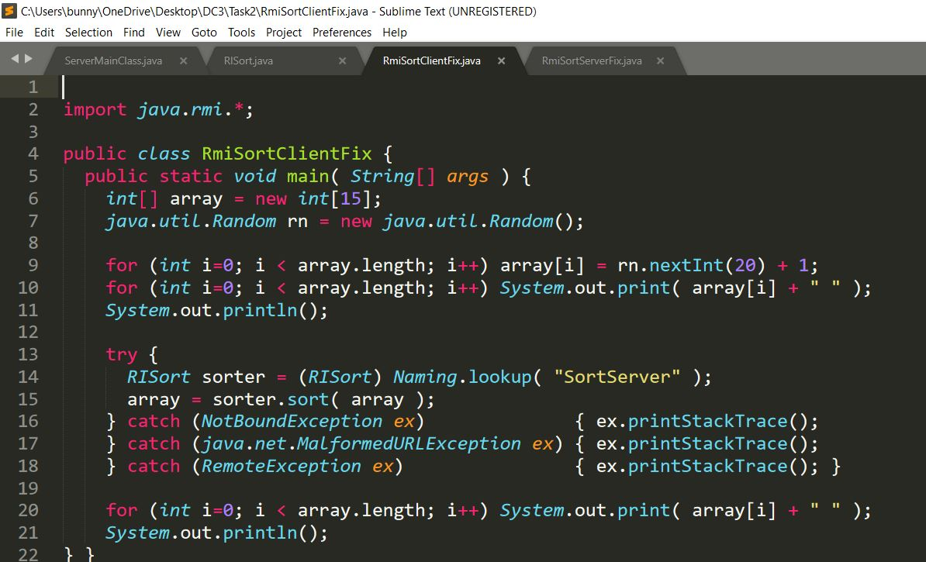

**Server:**

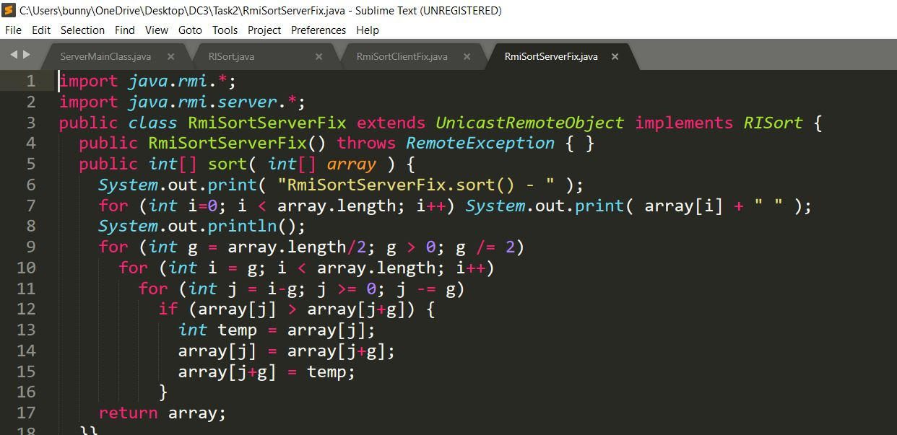

**Server Main:**

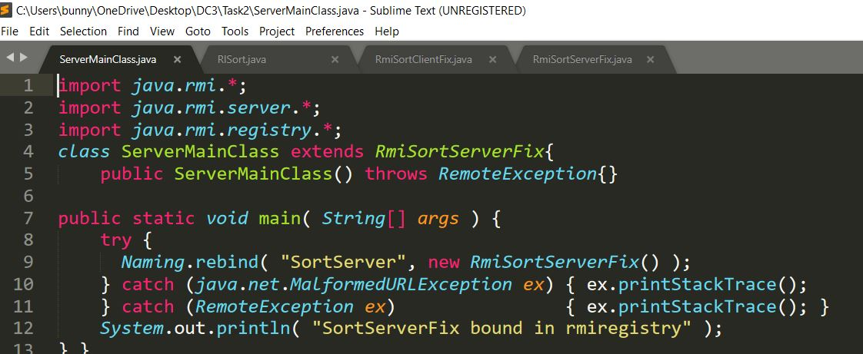

**Output:**

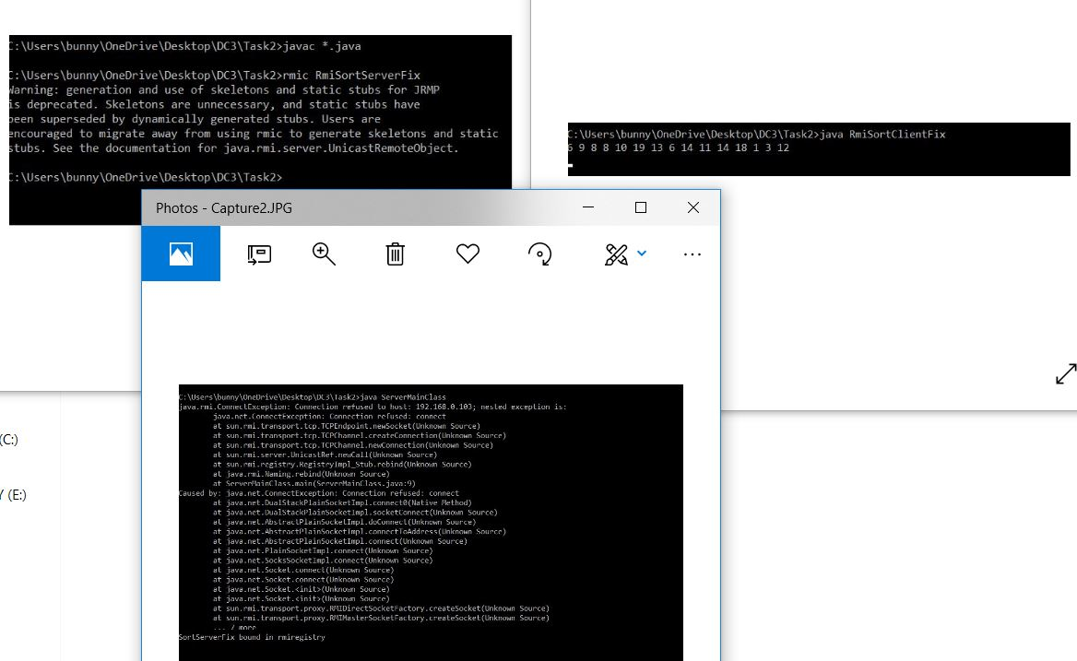

**Task#3:** Write an RMI program to implement the Map/Reduce concept of Hadoop on the server program. In other words the client program asks user to provide multiple sentences and send to server, server sends back the word counts.

**Interface:**

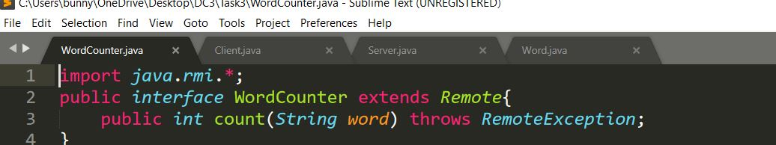

**WordCounter:**

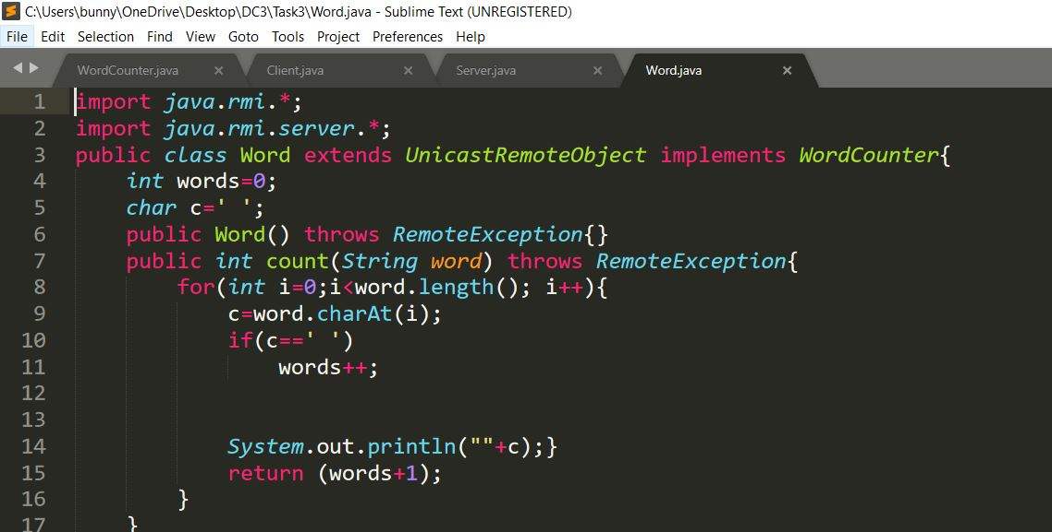

**Server:**

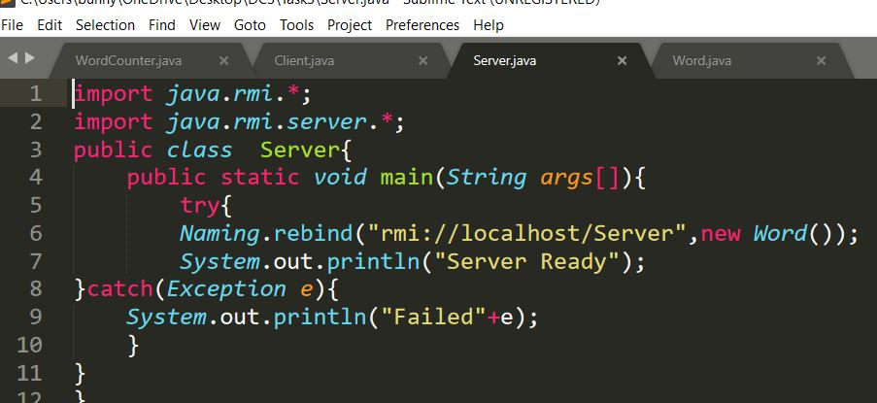

**Client:**

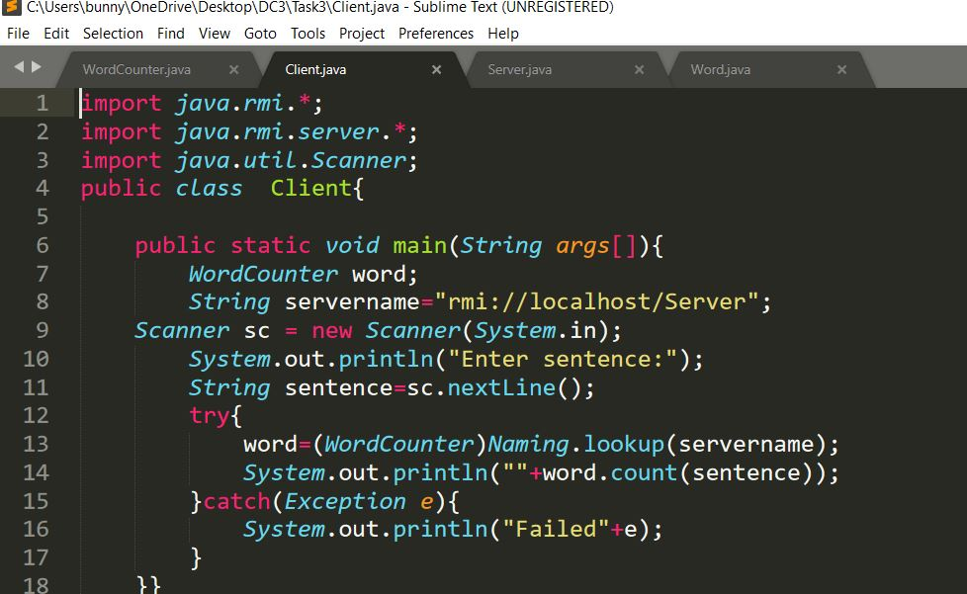

**Output:**

