**‘Lab#4’**

**´Objectives´:**  To Learn Report Generation in OLTP Systems.

**‘Customer Table’**

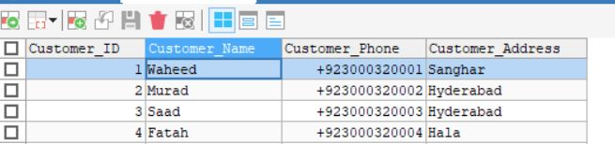

**‘Expenditure’**

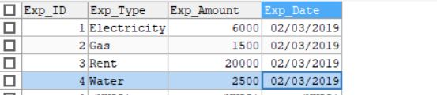

**‘Product Table’**

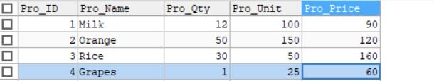

**‘Order Table’**

**SELECT * FROM ORDER;**

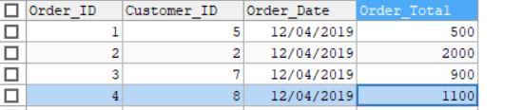

**‘Stored procedure contains following queries’:**

1. Total sales in a month (Use only order table).
2. Profit/loss in a month (Use product (to account for purchasing costs), expenditure as well as order tables).
3. Highest selling product of the month (By highest sold quantity)
4. Lowest selling product of the month (By lowest sold quantity)

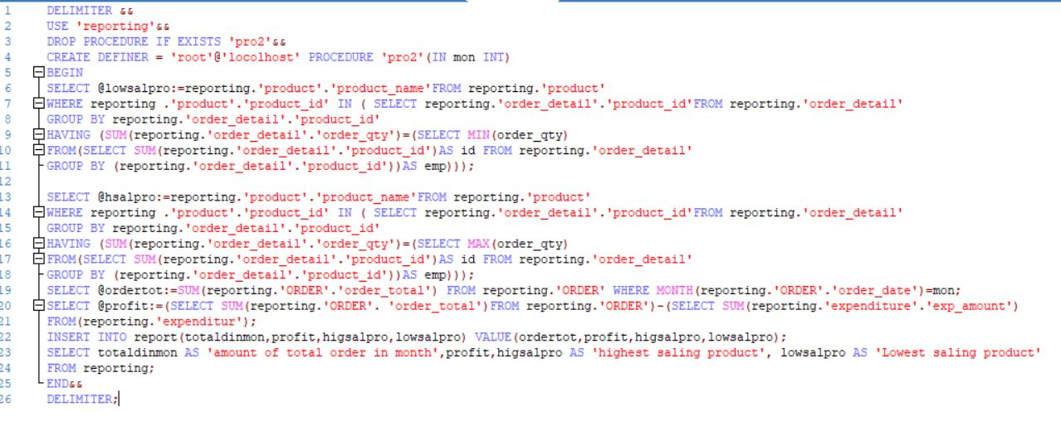

**‘Call’**

