**LAB#2:**

**Objective: To Become Familiar with OLTP System implementation.**

1. **Facility Table**

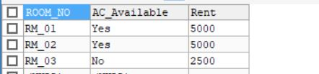

1. **Patient Table**

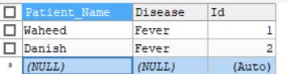

1. **Physician Table**

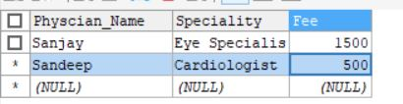

1. **Ward Table**

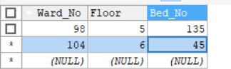

1. **Order Table**

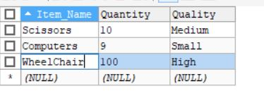

1. **Supply_Item Table**

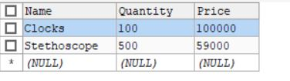

1. **Drugs Table**

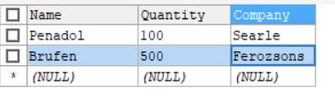

1. **Medical_Item Table**

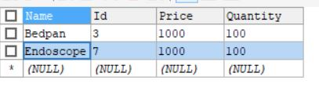

1. **Staff Table**

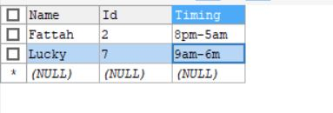

1. **Vendor Table**

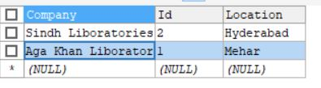

1. **Diagnose Table**

