**Lab#05**

Topic: To become familiar with DW Design.

Objective: To learn conceptual & logical DW Design.

1. Draw M/ERDs for the following scenarios represented by ERDs and business rules to ease your task.
2. Scenario 1: Advertising



**Business Rules**

1. Advertisements are placed by Agencies.

2. Advertisements are placed by Channels, such as TV or Print.

3. Advertisements can be part of a Marketing Campaign.

4. Invoices are produced and result in Payments.

5. Advertisements result in Responses.

6. Responses can be analysed by Demographics.

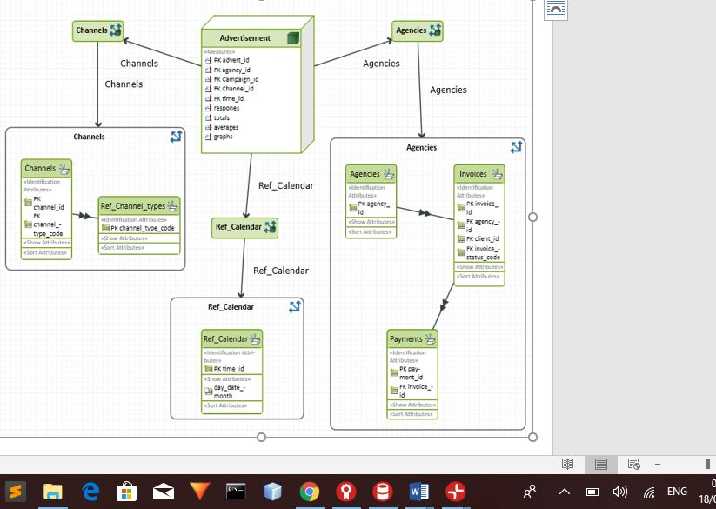

1. Scenario 2: Amusement Parks



**Business Rules**

1. Rides are available.

2. Customers use Credit or Debit Cards to buy Tickets to Ride.

3. Staff operate the Rides.

4. Staff also work on Maintenance Schedules for the Rides.

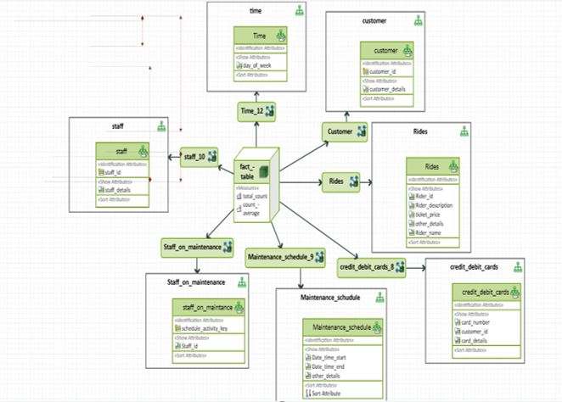

1. Scenario 3: Clown registry

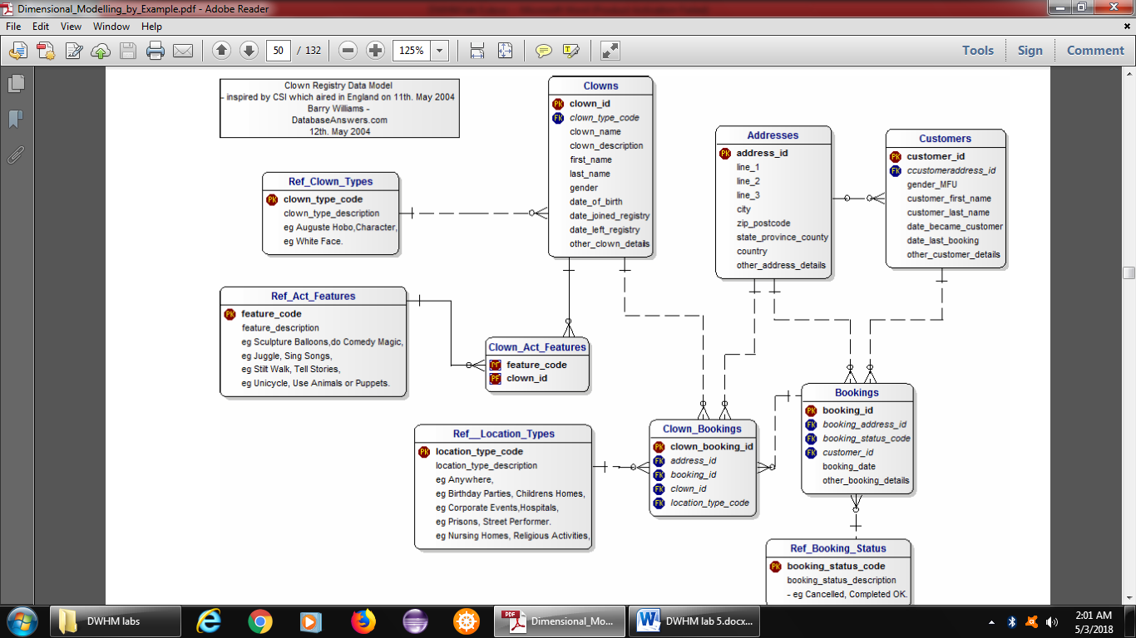

**Business Rules**

1. People registered as Clowns are stored in the Clowns Table.

2. A Clown can have Acts with specific Features.

3. Clowns accept Bookings to perform at specific Locations for specific Customers.

