**DEPARTMENT OF INFORMATION TECHNOLOGY**

**Academic Year: 2023 - 24**

**COURSE CODE: DJS22ITL302 CLASS: S. Y. B. Tech. Sem III**

**COURSE NAME: DBMS LAB SAP ID: 60003220045**

**Name: ANISH SHARMA**

**EXPERIMENT NO. 4**

**Implement the SQL statements for the following questions :**

1. Display movie no, title, type ,cust_id, issue date and return date using INNER JOIN, LEFT OUTER JOIN, RIGHT OUTER JOIN and FULL OUTER JOIN in the descending order of movie no.

SELECT MOVIE.Movie_no, MOVIE.Title, MOVIE.Type, Invoice.Cust_id, Invoice.Issue_date, Invoice.Return_date

FROM MOVIE

INNER JOIN Invoice ON MOVIE.Movie_no = Invoice.Movie_no

ORDER BY MOVIE.Movie_no DESC;

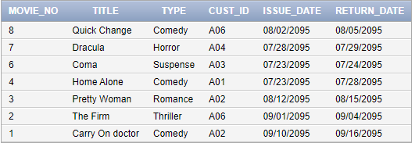

SELECT MOVIE.Movie_no, MOVIE.Title, MOVIE.Type, Invoice.Cust_id, Invoice.Issue_date, Invoice.Return_date

FROM MOVIE

LEFT JOIN Invoice ON MOVIE.Movie_no = Invoice.Movie_no

ORDER BY MOVIE.Movie_no DESC;

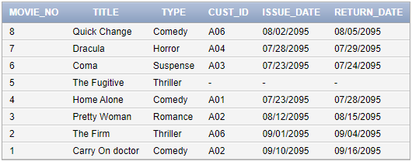

SELECT MOVIE.Movie_no, MOVIE.Title, MOVIE.Type, Invoice.Cust_id, Invoice.Issue_date, Invoice.Return_date

FROM MOVIE

RIGHT JOIN Invoice ON MOVIE.Movie_no = Invoice.Movie_no

ORDER BY MOVIE.Movie_no DESC;

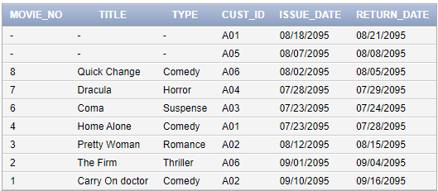

SELECT MOVIE.Movie_no, MOVIE.Title, MOVIE.Type, Invoice.Cust_id, Invoice.Issue_date, Invoice.Return_date

FROM MOVIE

FULL JOIN Invoice ON MOVIE.Movie_no = Invoice.Movie_no

ORDER BY MOVIE.Movie_no DESC;

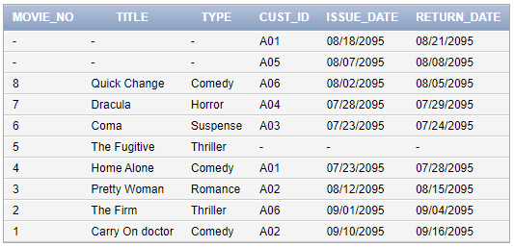

1. Find the lname,fname who have been issued moves

SELECT CM.Lname, CM.Fname

FROM Customer_MASTER CM

INNER JOIN Invoice I ON CM.Cust_id = I.Cust_id;

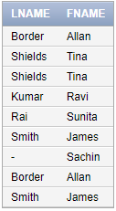

1. Find out the title and type of movies that have been issued to Tina.

SELECT M.Title, M.Type

FROM MOVIE M

INNER JOIN Invoice I ON M.Movie_no = I.Movie_no

INNER JOIN Customer_MASTER C ON I.Cust_id = C.Cust_id

WHERE C.Fname = 'Tina';

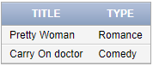

1. Display the first names and last names of the customers who have issued movies after 23rd July 95.

SELECT CM.Fname, CM.Lname

FROM Customer_MASTER CM

INNER JOIN Invoice I ON CM.Cust_id = I.Cust_id

WHERE I.Issue_date > TO_DATE('1995-07-23', 'YYYY-MM-DD');

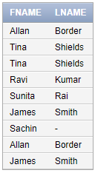

1. Find the customer name and area with invoice number ‘I10’.

SELECT CM.Lname || ', ' || CM.Fname AS Customer_Name, CM.Area

FROM Customer_MASTER CM

JOIN Invoice I ON CM.Cust_id = I.Cust_id

WHERE I.Inv_no = 'I10';



1. Find the names and movie numbers of all the customers who have been issued a movie.

SELECT CM.Lname || ', ' || CM.Fname AS Customer_Name, I.Movie_no

FROM Customer_MASTER CM

INNER JOIN Invoice I ON CM.Cust_id = I.Cust_id;

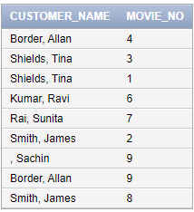

1. Find out which customers have been issued movie number 9.

SELECT CM.Lname || ', ' || CM.Fname AS Customer_Name

FROM Customer_MASTER CM

INNER JOIN Invoice I ON CM.Cust_id = I.Cust_id

WHERE I.Movie_no = 9;

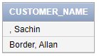

1. Find the name of the movie issued to Tina and Allan.

SELECT CM.Fname, CM.Lname, M.Title

FROM Customer_MASTER CM

INNER JOIN Invoice I ON CM.Cust_id = I.Cust_id

INNER JOIN MOVIE M ON I.Movie_no = M.Movie_no

WHERE CM.Fname IN ('Tina', 'Allan');

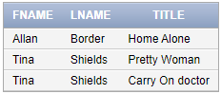

1. For the above query create a view.

CREATE VIEW MoviesIssuedToTinaAndAllan AS

SELECT CM.Fname, CM.Lname, M.Title

FROM Customer_MASTER CM

INNER JOIN Invoice I ON CM.Cust_id = I.Cust_id

INNER JOIN MOVIE M ON I.Movie_no = M.Movie_no

WHERE CM.Fname IN ('Tina', 'Allan');

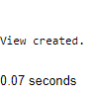

SELECT * FROM MoviesIssuedToTinaAndAllan;

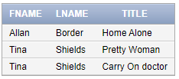

1. Modify the above view to add the price of the movie.

CREATE OR REPLACE VIEW MoviesIssuedToTinaAndAllan AS

SELECT CM.Fname, CM.Lname, M.Title, M.Price

FROM Customer_MASTER CM

INNER JOIN Invoice I ON CM.Cust_id = I.Cust_id

INNER JOIN MOVIE M ON I.Movie_no = M.Movie_no

WHERE CM.Fname IN ('Tina', 'Allan');

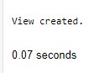

SELECT * FROM MoviesIssuedToTinaAndAllan;

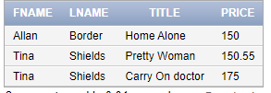

1. Drop the view.

DROP VIEW MoviesIssuedToTinaAndAllan;

