**SAP ID: 600032200045**

**Roll no. I011 CLASS: IT1**

**NAME: ANISH SHARMA BATCH: I1-1**

**S.Y. BTech (IT)**

**SUB: DBMS LAB**

**Experiment No: 5**

**Study of Basic SQL commands**

**------------------------------------------------EXERCISE--------------------------------------------**  **Implement the SQL statements for the following questions**

1.Find the lname, fname who have been issued movies.

**Ans:** select lname,fname from CUST where cust_id IN (select cust_id from invoice);

**OUTPUT**:

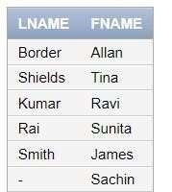

2.Find out the movie number which has been issued to Allan.

**Ans**: select movie_no from invoice where cust_id =(select cust_id from cust where fname like 'Allan');

**OUTPUT:**

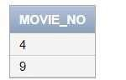

3.Display all the movie title whose price is same as the price of movie ‘The Firm’

Ans: select title from movie where price=(select price from movie where title like 'The Firm');

**OUTPUT**:

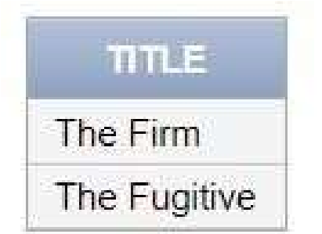

4.Find the customer name and area with invoice number ‘I10’.

**Ans**: select fname,lname,area from cust where cust_id IN (select cust_id from invoice where inv_no='I10');

**OUTPUT**:

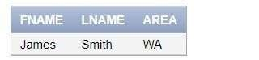

5.Find the names and movie numbers of all the customers who have been issued a movie.

**Ans**: select movie_no, (select title from movie where I.movie_no=movie_no) as title,

(select fname||' '||lname from cust where I.cust_id=cust_id) as

name from invoice I;

**OUTPUT**:

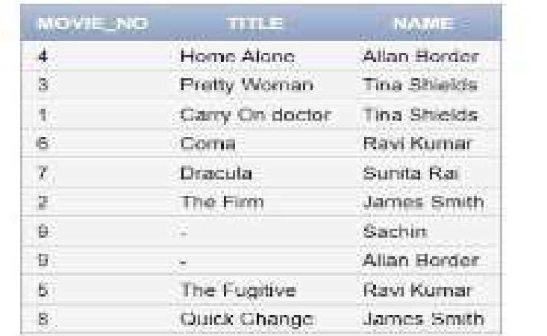

6.Find out which customers have been issued movie number 9.

**Ans**: select * from cust where cust_id IN(select cust_id from invoice where movie_no=9);

**OUTPUT**:

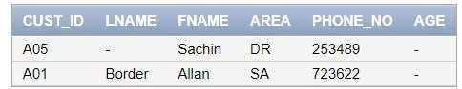

7.Find the name of the movie issued to Tina and Allan.

**Ans**: select title

from movie where movie_no IN (select movie_no from invoice

where cust_id IN (select cust_id from cust

where fname IN ('Tina','Allan')));

**OUTPUT**:

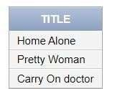

8.List the movie number, moviename issued to all the customers.

**Ans**: select movie_no,title from movie where movie_no IN (select movie_no

from invoice

where cust_id IN (select cust_id from cust ));

**OUTPUT**:

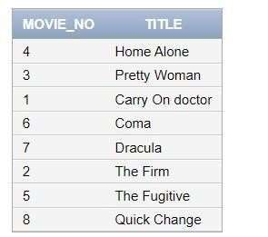

9.Find the customer names and phone numbers who have been issued movies before 01-aug-95.

**Ans**: select fname,lname,phone_no from cust where cust_id IN (select cust_id from invoice where issue_date<

'08-01-95');

**OUTPUT**:

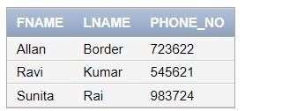

10.Find the type and movie number of movie issued to cust_id ‘A01’ and

‘A02’.

**Ans**: select type,movie_no from movie where movie_no IN (select movie_no from invoice where cust_id in ('A01','A02'));

**OUTPUT**:

