# Name : Anish Sharma SAP ID : 60003220045 Roll No : I011

Practical Questions:

1. Create a table with a name Sales_Order having columns order_no as primary key,

Order date should not be a null value, client_no, order_status, salesman_no.

CREATE TABLE Sales_Order (

order_no INT PRIMARY KEY,

order_date DATE NOT NULL,

client_no INT,

order_status VARCHAR(50),

salesman_no INT

);

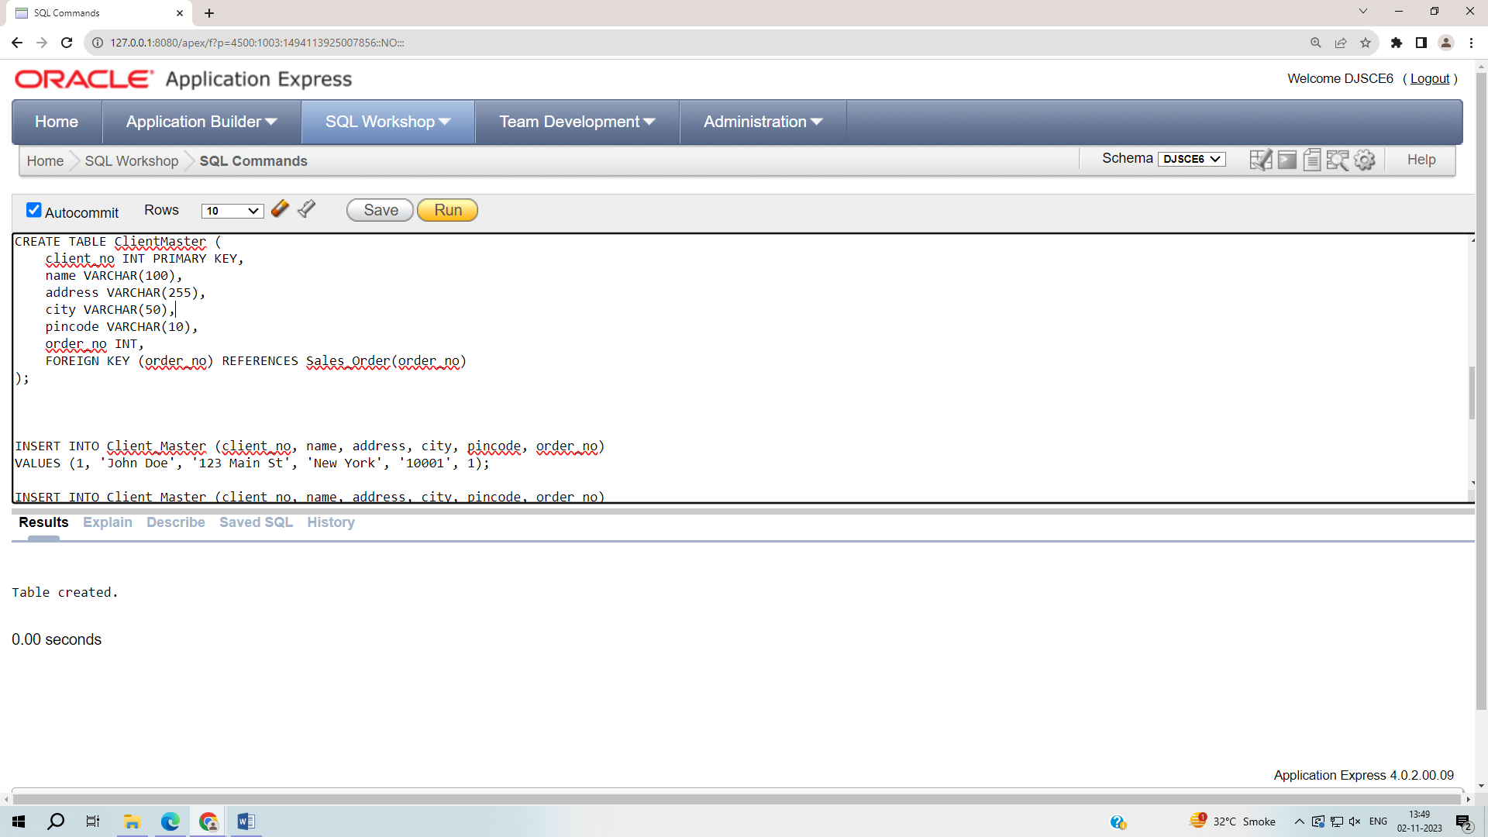

2. Insert the records in the table in such a way that few records should show constraint

violation for the columns order_no & order_date.

Order number

INSERT INTO Sales_Order (order_no, order_date, client_no, order_status, salesman_no)

VALUES (1, TO_DATE('2023-11-03', 'YYYY-MM-DD'), 1003, 'Delivered', 2003);

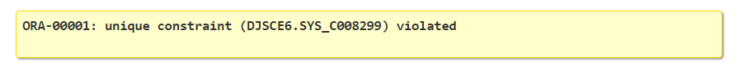

Order Date:

INSERT INTO Sales_Order (order_no, client_no, order_status, salesman_no)

VALUES (4, 1004, 'Pending', 2004);

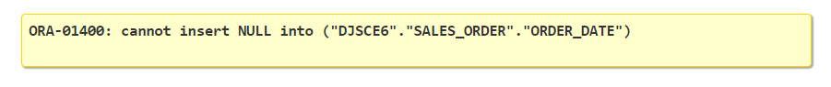

3. Display all the records of the Sales_Order table.

select * from Sales_order;

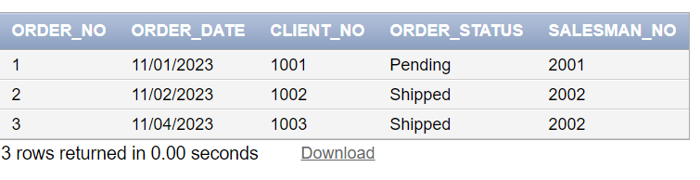

4. Add the constraint to the Sales_Order table that client_no column should not have

duplicate values & also it should allow null values to be inserted.

ALTER TABLE Sales_Order

ADD CONSTRAINT unique_client_no UNIQUE (client_no);



5. Display all the records of the Sales_Order table.

6. Create a table with a name Client_Master having columns client_no as a primary key,

name, address, city, pincode, order_no as foreign key referencing Sales_Order

order_no.



7. Insert the records in the Client_Master table in such a way that few records should

show constraint violation for the column order_no.

INSERT INTO Client_Master (client_no, name, address, city, pincode, order_no)

VALUES (4, 'Sue Davis', '101 Elm Blvd', 'Houston', '77004', 4);



8. Display all the records of the Client_Master table.

select * from Client_Master;

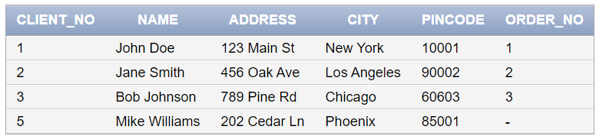

9. Delete a record from the Client_Master table whose client_no is 1

DELETE FROM Client_Master

WHERE client_no = 1;

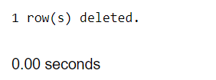

10. Delete a record from the Sales_Order table whose order_no is 2.

DELETE FROM Sales_order

WHERE order_no = 2;



11. Update any one value of the order_no column to a new value of Sales_Order table.

UPDATE Sales_Order

SET order_no = 5

WHERE order_no = 1;

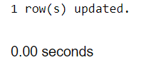

12. Create a table with name Client_Master1 having columns client_no as primary key,

name, city & balance. Names starting with ‘a’, city should be either Mumabi or Delhi

& balance should be greater than 1000.

CREATE TABLE Client_Master1 (

client_no INT PRIMARY KEY,

name VARCHAR(100),

city VARCHAR(50),

balance DECIMAL(10,2),

CONSTRAINT check_name_city

CHECK (SUBSTR(name, 1, 1) = 'a' AND (city IN ('Mumbai', 'Delhi')) AND balance > 1000)

);

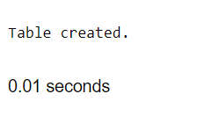

13. Insert the records in the table.

INSERT INTO Client_Master1 (client_no, name, city, balance)

VALUES (1, 'alice', 'Mumbai', 1500.00);

INSERT INTO Client_Master1 (client_no, name, city, balance)

VALUES (2, 'alex', 'Delhi', 2000.00);

INSERT INTO Client_Master1 (client_no, name, city, balance)

VALUES (4, 'Amy', 'Delhi', 2500.00);

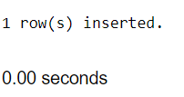

14. Display all the records of the table

Select * from Client_Master1;

