**COURSE CODE:** DJS22ITL302 **DATE:08/10/2023**

**COURSE NAME:** Data Structure Laboratory **CLASS: I1-Batch1**

**NAME:** Anish Ashok Sharma **CLASS: I1- 60003220045**

**Experiment No. 1**

**CO/LO: CO1**

**Aim:** Implement stack and queues using arrays

#### **Theory**: A stack is a data structure that follows the Last-In, First-Out (LIFO) principle. This means that the last element added to the stack is the first one to be removed.

A queue is a data structure that follows the First-In, First-Out (FIFO) principle. This means that the first element added to the queue is the first one to be removed.

**Program:**

**Queues:**

#include <stdio.h>

int queue[5];

int n=5;

int rear,front;

rear=-1;

front=-1;

void insert(int x){

if(rear==n-1)

printf("Overflow\n");

else if(front==-1 && rear==-1){

front=rear=0;

queue[rear]=x;

}

else{

rear++;

queue[rear]=x;

}

}

void delete(){

if(rear==-1 && front==-1){

printf("Underflow\n");

}

else if(front==rear){

printf("\nDelete element:%d",queue[front]);

rear=-1;

front=-1;

}

else{

printf("\nDelete element:%d\n",queue[front++]);;

}

}

void display(){

int i;

printf("\nPrinting queue:\n");

for(i=front;i<=rear;i++){

printf("%d ",queue[i]);

}

printf("\n");

}

int main()

{

int choice=1;

while(choice){

printf("1-insert\n2-delete\n3-display\n0-exit\n");

int check;

scanf("%d",&check);

if(check==0)

break;

else if(check==1){

printf("\nEnter element:\n");

int x;

scanf("%d",&x);

insert(x);

}

else if(check==2){

delete();

}

else if(check==3){

display();

}

}

return 0;

}

**Output screenshots:**

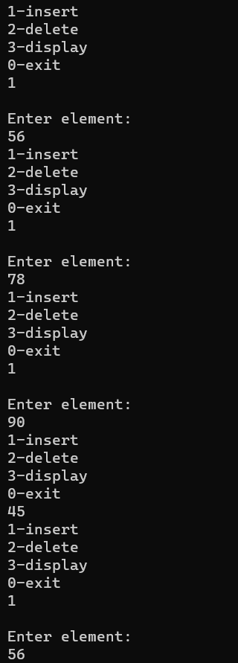

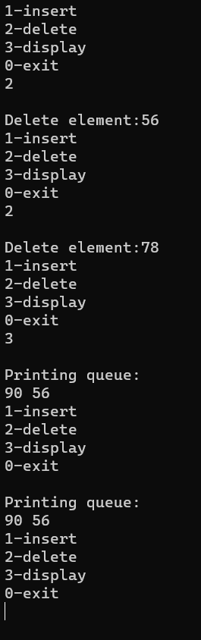

#### **Stack:**

#include <stdio.h>

#include <conio.h>

int arr[4];

int n = 4;

int top = -1;

void push(int x)

{

if (top == n - 1)

{

printf("Overflow\n");

}

else

{

top++;

arr[top] = x;

}

}

void pop()

{

if (top == -1)

{

printf("Underflow\n");

}

else

{

printf("\nPop element:%d", arr[top]);

top--;

}

}

void peek()

{

printf("\nPeak element:%d", arr[top]);

}

void main()

{

int choice = 1;

printf("Implementation of stack\n");

// Push

while (choice)

{

printf("\nEnter 1-push\n2-pop\n3-peek,\n0-exit\n");

scanf("%d", &choice);

if (choice == 0)

break;

else if (choice == 1)

{

// int check;

// printf("\nDo want to push a element in stack?\n1 for yes 0 for no\n");

// scanf("%d",&check);

// if(check==0){

// break;

// }

printf("\nEnter a element: ");

int x;

scanf("%d", &x);

push(x);

}

else if (choice == 2)

{

pop();

}

else if (choice == 3)

{

peek();

}

else

{

printf("\nEnter valid number");

}

}

// pop

// while(1){

// printf("\nDo you want to pop the element?\n1 for yes no for 0\n");

// int check;

// scanf("\n%d",&check);

// if(check==0)

// break;

// pop();

// }

// peak

// printf("\nDo you want to check peak element?\n1for yes no for 0");

// int check;

// scanf("%d",&check);

// if(check==1){

// peek();

// }else{

// printf("\nThank you");

// }

}

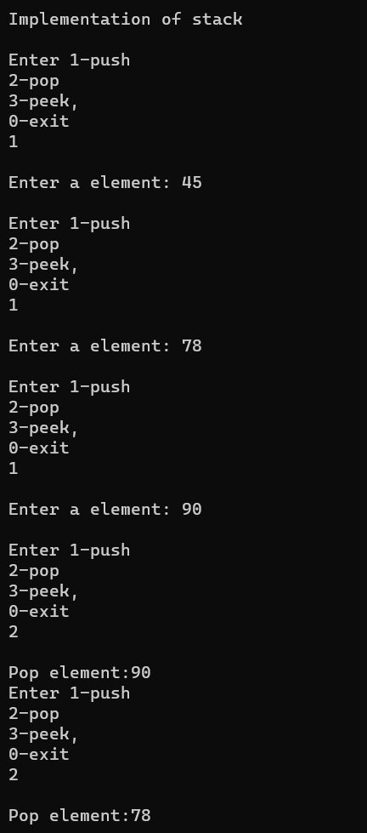

#### **Conclusion:**

In conclusion, you can implement a stack and a queue using arrays by employing specific operations to mimic their respective Last-In, First-Out (LIFO) and First-In, First-Out (FIFO) behaviors.

**REFERENCES:**

No references