**COURSE CODE:** DJS22ITL302 **DATE:5/10/2023**

**COURSE NAME:** Data Structure Laboratory **CLASS: I1-Batch1**

**NAME:** Anish Sharma

**Experiment No. 3**

**CO/LO: CO1**

**Aim: Implement Infix to postfix conversion and evaluation**

#### **Theory:**

#### **Infix - An infix operation is any operation of the format x op y format, such as x + y.**

#### **Postfix - An operation or expression can also be expressed as x y op, i.e. x y +, which is equivalent to writing x + y in infix. All we're trying to perform relocating the operator to the operand's right.**

**Program:**

**#include <limits.h>**

**#include <stdio.h>**

**#include <stdlib.h>**

**#define MAX 20**

**char stk[20];**

**int top = -1;**

**int isEmpty()**

**{**

**return top == -1;**

**}**

**int isFull()**

**{**

**return top == MAX - 1;**

**}**

**char peek()**

**{**

**return stk[top];**

**}**

**char pop()**

**{**

**if(isEmpty())**

**return -1;**

**char ch = stk[top];**

**top--;**

**return(ch);**

**}**

**void push(char oper)**

**{**

**if(isFull())**

**printf("Stack Full!!!!");**

**else{**

**top++;**

**stk[top] = oper;**

**}**

**}**

**int checkIfOperand(char ch)**

**{**

**return (ch >= 'a' && ch <= 'z') || (ch >= 'A' && ch <= 'Z');**

**}**

**int precedence(char ch)**

**{**

**switch (ch)**

**{**

**case '+':**

**case '-':**

**return 1;**

**case '*':**

**case '/':**

**return 2;**

**case '^':**

**return 3;**

**}**

**return -1;**

**}**

**int covertInfixToPostfix(char* expression)**

**{**

**int i, j;**

**for (i = 0, j = -1; expression[i]; ++i)**

**{**

**if (checkIfOperand(expression[i]))**

**expression[++j] = expression[i];**

**else if (expression[i] == '(')**

**push(expression[i]);**

**else if (expression[i] == ')')**

**{**

**while (!isEmpty() && peek() != '(')**

**expression[++j] = pop();**

**if (!isEmpty() && peek() != '(')**

**return -1;**

**else**

**pop();**

**}**

**else**

**{**

**while (!isEmpty() && precedence(expression[i]) <= precedence(peek()))**

**expression[++j] = pop();**

**push(expression[i]);**

**}**

**}**

**while (!isEmpty())**

**expression[++j] = pop();**

**expression[++j] = '\0';**

**printf( "%s", expression);**

**}**

**int main()**

**{**

**char expression[] = "((x+(y*z))-w)";**

**covertInfixToPostfix(expression);**

**return 0;**

**}**

**Output screenshots:**

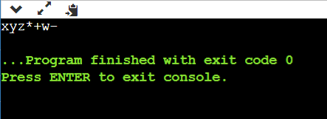

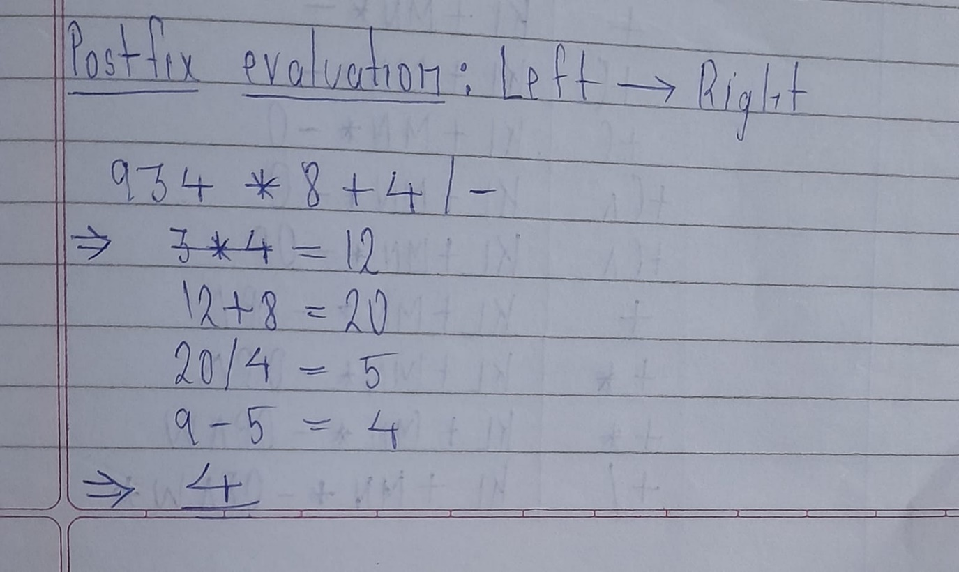

#### **Conclusion:**

With help of this code I learn how to convert infix to postfix and evaluation of postfix to infix.

**REFERENCES:**

Tutorialpoints