**DEPARTMENT OF INFORMATION TECHNOLOGY**

**Academic Year: 2023 - 24**

**COURSE CODE: DJS22ITL302 CLASS: S. Y. B. Tech. Sem III (I1-1)**

**COURSE NAME: Data Structures Lab SAP ID : 60003220045**

**Name: Anish Sharma DATE:** 04-12-2023

# EXPERIMENT NO. 9

**CO/LO:** Solve the problem using sorting techniques.

**Objective:** Write a program to implement different quadratic sorting algorithms with various parameters. Analyze the performance of all the algorithms.

# Code

#include <stdio.h>

#include <stdlib.h>

#include <time.h>

// Function prototypes

void quick_sort(int arr[], int low, int high, int *swaps, int *comparisons); void merge_sort(int arr[], int low, int high, int *swaps, int *comparisons); void selection_sort(int arr[], int n, int *swaps, int *comparisons); void radix_sort(int arr[], int n, int *moves);

// Helper functions void print_array(int arr[], int n); void swap(int *a, int *b);

int main() { srand(time(NULL));

int n;

printf("Enter the number of elements: "); scanf("%d", &n);

int arr[n];

printf("Enter the elements:\n"); for (int i = 0; i < n; i++) { scanf("%d", &arr[i]);

}

printf("\nOriginal array: "); print_array(arr, n);

int choice; printf("\nSelect sorting algorithm:\n1. Quick Sort\n2. Merge Sort\n3. Selection Sort\n4. Radix Sort\n"); scanf("%d", &choice);

int swaps = 0, comparisons = 0, moves = 0; clock_t start_time, end_time;

start_time = clock(); switch (choice) { case 1: quick_sort(arr, 0, n - 1, &swaps, &comparisons); break; case 2: merge_sort(arr, 0, n - 1, &swaps, &comparisons); break; case 3: selection_sort(arr, n, &swaps, &comparisons); break; case 4: radix_sort(arr, n, &moves); break; default: printf("Invalid choice\n"); return 1;

}

end_time = clock();

printf("\nSorted array: "); print_array(arr, n);

printf("\nPerformance Analysis:\n"); printf("Number of swaps: %d\n", swaps);

printf("Number of comparisons: %d\n", comparisons); printf("Number of shifts/movements: %d\n", moves);

printf("Total time taken to sort: %lf seconds\n", ((double)(end_time -

start_time)) / CLOCKS_PER_SEC);

return 0;

}

void quick_sort(int arr[], int low, int high, int *swaps, int *comparisons) { if (low < high) { int pivot = arr[high]; int i = low - 1;

for (int j = low; j < high; j++) { (*comparisons)++;

if (arr[j] <= pivot) { i++;

// Swap arr[i] and arr[j] int temp = arr[i]; arr[i] = arr[j]; arr[j] = temp;

(*swaps)++;

}

}

// Swap arr[i+1] and arr[high] (pivot) int temp = arr[i + 1]; arr[i + 1] = arr[high]; arr[high] = temp;

(*swaps)++;

int partition_index = i + 1;

// Recursively sort the sub-arrays

quick_sort(arr, low, partition_index - 1, swaps, comparisons); quick_sort(arr, partition_index + 1, high, swaps, comparisons);

} } void merge(int arr[], int low, int mid, int high, int *swaps, int *comparisons) { int n1 = mid - low + 1;

int n2 = high - mid;

int left[n1], right[n2];

for (int i = 0; i < n1; i++) left[i] = arr[low + i];

for (int j = 0; j < n2; j++) right[j] = arr[mid + 1 + j];

int i = 0, j = 0, k = low; while (i < n1 && j < n2) { (*comparisons)++;

if (left[i] <= right[j]) { arr[k] = left[i]; i++;

} else { arr[k] = right[j]; j++;

}

k++;

(*swaps)++;

}

while (i < n1) { arr[k] = left[i]; i++; k++;

(*swaps)++;

}

while (j < n2) { arr[k] = right[j]; j++; k++;

(*swaps)++;

}

}

void merge_sort(int arr[], int low, int high, int *swaps, int *comparisons) { if (low < high) { int mid = low + (high - low) / 2;

merge_sort(arr, low, mid, swaps, comparisons); merge_sort(arr, mid + 1, high, swaps, comparisons); merge(arr, low, mid, high, swaps, comparisons);

}

}

void selection_sort(int arr[], int n, int *swaps, int *comparisons) { for (int i = 0; i < n - 1; i++) { int min_index = i;

for (int j = i + 1; j < n; j++) { (*comparisons)++; if (arr[j] < arr[min_index]) min_index = j;

}

int temp = arr[min_index]; arr[min_index] = arr[i]; arr[i] = temp;

(*swaps)++;

}

}

void counting_sort(int arr[], int n, int exp, int *moves) { int output[n]; int count[10] = {0};

for (int i = 0; i < n; i++)

count[(arr[i] / exp) % 10]++;

for (int i = 1; i < 10; i++)

count[i] += count[i - 1];

for (int i = n - 1; i >= 0; i--) { output[count[(arr[i] / exp) % 10] - 1] = arr[i]; count[(arr[i] / exp) % 10]--;

(*moves)++;

}

for (int i = 0; i < n; i++)

arr[i] = output[i];

}

void radix_sort(int arr[], int n, int *moves) {

int max = 0; for (int i = 0; i < n; i++) {

if (arr[i] > max) max = arr[i];

}

for (int exp = 1; max / exp > 0; exp *= 10)

counting_sort(arr, n, exp, moves);

}

void generate_data(int arr[], int n, int order) {

switch (order) {

case 1: // In-order

for (int i = 0; i < n; i++) {

arr[i] = i + 1;

}

break;

case 2: // Reverse-order for (int i = 0; i < n; i++) { arr[i] = n - i;

}

break;

case 3: // Random

for (int i = 0; i < n; i++) {

arr[i] = rand() % n + 1;

}

break;

case 4: // Almost order for (int i = 0; i < n; i++) { arr[i] = i + 1;

}

// Shuffle a few elements to make it almost ordered for (int i = 0; i < n / 10; i++) {

int pos1 = rand() % n; int pos2 = rand() % n; int temp = arr[pos1]; arr[pos1] = arr[pos2]; arr[pos2] = temp;

}

break;

default: printf("Invalid data order\n"); exit(1);

}

}

void print_array(int arr[], int n) { for (int i = 0; i < n; i++) { printf("%d ", arr[i]);

}

printf("\n");

}

void swap(int *a, int *b) { int temp = *a; *a = *b;

*b = temp;

}

**OUTPUT :**

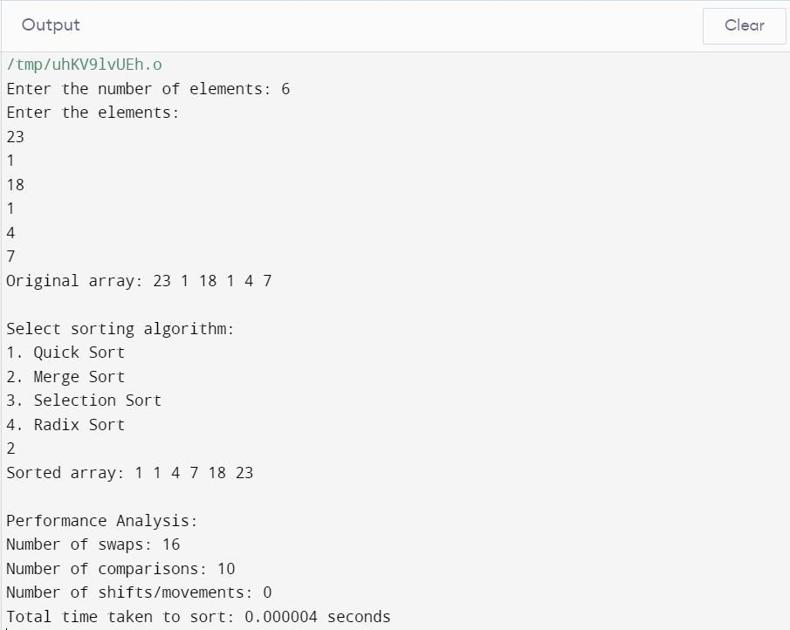

**Conclusion:**

This C code implements a program for sorting an array using four different sorting algorithms: Quick Sort, Merge Sort, Selection Sort, and Radix Sort. The program allows the user to input the number of elements in the array and the elements themselves. It then provides the option to choose one of the sorting algorithms for sorting the array. Thus implemented sort successfully.

**Website References:**

- Geeksforgeeks

-Javatpoint

-programiz