

Academic Year: 2023-24 Sem: III

Sub: Operating Systems Laboratory SAP ID: 60003220045

Name: Anish Sharma

**EXPERIMENT NO. 02**

**Code: Q1**

#include <stdio.h>

void calculateWaitingTime(int processes[], int n, int burst_time[], int waiting_time[]) { waiting_time[0] = 0; // Waiting time for the first process is 0

for (int i = 1; i < n; i++) {

waiting_time[i] = burst_time[i-1] + waiting_time[i-1]; }

}

void calculateTurnaroundTime(int processes[], int n, int burst_time[], int waiting_time[], int turnaround_time[]) {

for (int i = 0; i < n; i++) {

turnaround_time[i] = burst_time[i] + waiting_time[i]; }

}

void displayGanttChart(int processes[], int n, int burst_time[]) { printf("\nGantt Chart:\n");

for (int i = 0; i < n; i++) { printf("| P%d ", processes[i]);

} printf("|\n");

int current_time = 0;

for (int i = 0; i < n; i++) { printf("%d\t", current_time); current_time += burst_time[i];

}

printf("%d\n", current_time); }

void calculateAverageWaitingTime(int processes[], int n, int burst_time[], int waiting_time[]) {

float total_waiting_time = 0;

**A.Y.:** 2023-24

for (int i = 0; i < n; i++) { total_waiting_time += waiting_time[i];

}

float avg_waiting_time = total_waiting_time / n; printf("Average Waiting Time: %.2f\n", avg_waiting_time);

}

int main() { int n;

printf("Enter the number of processes: "); scanf("%d", &n);

int processes[n], burst_time[n], waiting_time[n], turnaround_time[n];

for (int i = 0; i < n; i++) {

printf("Enter burst time for process P%d: ", i+1); scanf("%d", &burst_time[i]);

processes[i] = i + 1; }

calculateWaitingTime(processes, n, burst_time, waiting_time); calculateTurnaroundTime(processes, n, burst_time, waiting_time, turnaround_time);

printf("\nProcess\tBurst Time\tWaiting Time\tTurnaround Time\n"); for (int i = 0; i < n; i++) {

printf("%d\t%d\t\t%d\t\t%d\n", processes[i], burst_time[i], waiting_time[i], turnaround_time[i]);

}

displayGanttChart(processes, n, burst_time);

calculateAverageWaitingTime(processes, n, burst_time, waiting_time);

return 0; }

**Q2**

#include <stdio.h>

struct Process {

**A.Y.:** 2023-24 int id;

int arrival_time; int burst_time; int priority;

int waiting_time;

int turnaround_time; };

void sjf_with_priority(struct Process processes[], int n) { int total_waiting_time = 0;

int total_turnaround_time = 0;

for (int i = 0; i < n; i++) {

for (int j = i + 1; j < n; j++) {

if (processes[i].arrival_time > processes[j].arrival_time || (processes[i].arrival_time == processes[j].arrival_time &&

(processes[i].priority > processes[j].priority ||

(processes[i].priority == processes[j].priority && processes[i].burst_time > processes[j].burst_time)))) {

struct Process temp = processes[i]; processes[i] = processes[j]; processes[j] = temp;

} }

}

int current_time = 0;

for (int i = 0; i < n; i++) {

if (processes[i].arrival_time > current_time) { current_time = processes[i].arrival_time;

}

processes[i].waiting_time = current_time - processes[i].arrival_time; processes[i].turnaround_time = processes[i].waiting_time + processes[i].burst_time;

total_waiting_time += processes[i].waiting_time; total_turnaround_time += processes[i].turnaround_time;

current_time += processes[i].burst_time; }

printf("\nGantt Chart:\n"); printf("0");

for (int i = 0; i < n; i++) {

**A.Y.:** 2023-24

printf("->P%d->%d", processes[i].id, current_time); }

printf("\n\nTABLE\n"); printf("Process AT BT WT TAT\n"); for (int i = 0; i < n; i++) {

printf("P%d\t%d\t%d\t%d\t%d\n", processes[i].id, processes[i].arrival_time, processes[i].burst_time, processes[i].waiting_time, processes[i].turnaround_time);

}

double avg_waiting_time = (double)total_waiting_time / n; double avg_turnaround_time = (double)total_turnaround_time / n;

printf("\nAverage Turnaround Time: %.6lf\n", avg_turnaround_time); printf("Average Waiting Time: %.6lf\n", avg_waiting_time);

}

int main() { int n;

printf("Enter the number of processes: "); scanf("%d", &n);

struct Process processes[n];

for (int i = 0; i < n; i++) { processes[i].id = i + 1;

printf("Enter the arrival time for process P%d: ", i + 1); scanf("%d", &processes[i].arrival_time);

printf("Enter the burst time for process P%d: ", i + 1); scanf("%d", &processes[i].burst_time);

printf("Enter the priority for process P%d: ", i + 1); scanf("%d", &processes[i].priority);

}

sjf_with_priority(processes, n);

return 0; }

**Q3**

#include <stdio.h>

void priorityScheduling(int processes[], int n, int burst_time[], int priority[], int arrival_time[]) {

**A.Y.:** 2023-24

int waiting_time[n], turnaround_time[n];

for(int i = 0; i < n-1; i++) { for(int j = 0; j < n-i-1; j++) {

if(arrival_time[j] > arrival_time[j+1]) { int temp = arrival_time[j]; arrival_time[j] = arrival_time[j+1]; arrival_time[j+1] = temp;

temp = priority[j]; priority[j] = priority[j+1]; priority[j+1] = temp;

temp = burst_time[j]; burst_time[j] = burst_time[j+1]; burst_time[j+1] = temp;

temp = processes[j]; processes[j] = processes[j+1]; processes[j+1] = temp;

} }

}

waiting_time[0] = 0;

int current_time = arrival_time[0];

for(int i = 1; i < n; i++) {

waiting_time[i] = burst_time[i-1] + waiting_time[i-1]; current_time += burst_time[i-1];

}

for(int i = 0; i < n; i++) {

turnaround_time[i] = burst_time[i] + waiting_time[i]; }

printf("\nGantt Chart:\n"); for(int i = 0; i < n; i++) {

printf("| P%d ", processes[i]); }

printf("|\n");

current_time = arrival_time[0]; for(int i = 0; i < n; i++) {

**A.Y.:** 2023-24

printf("%d\t", current_time); current_time += burst_time[i];

}

printf("%d\n", current_time);

printf("\nProcess\tArrival Time\tBurst Time\tPriority\tWaiting Time\tTurnaround Time\n");

for(int i = 0; i < n; i++) {

printf("%d\t%d\t\t%d\t\t%d\t\t%d\t\t%d\n", processes[i], arrival_time[i], burst_time[i], priority[i], waiting_time[i], turnaround_time[i]);

}

float avg_waiting_time = 0, avg_turnaround_time = 0; for(int i = 0; i < n; i++) {

avg_waiting_time += waiting_time[i]; avg_turnaround_time += turnaround_time[i];

}

avg_waiting_time /= n; avg_turnaround_time /= n;

printf("\nAverage Waiting Time: %.2f\n", avg_waiting_time); printf("Average Turnaround Time: %.2f\n", avg_turnaround_time);

}

int main() { int n;

printf("Enter the number of processes: "); scanf("%d", &n);

int processes[n], burst_time[n], priority[n], arrival_time[n]; for(int i = 0; i < n; i++) {

printf("Enter arrival time for process P%d: ", i+1); scanf("%d", &arrival_time[i]);

printf("Enter burst time for process P%d: ", i+1); scanf("%d", &burst_time[i]);

printf("Enter priority for process P%d: ", i+1); scanf("%d", &priority[i]);

processes[i] = i+1; }

priorityScheduling(processes, n, burst_time, priority, arrival_time);

return 0;

**A.Y.:** 2023-24 }

**OUTPUT: Q1**

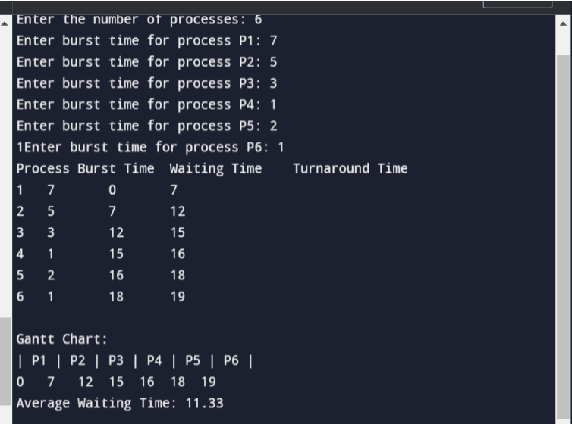

**Q2**

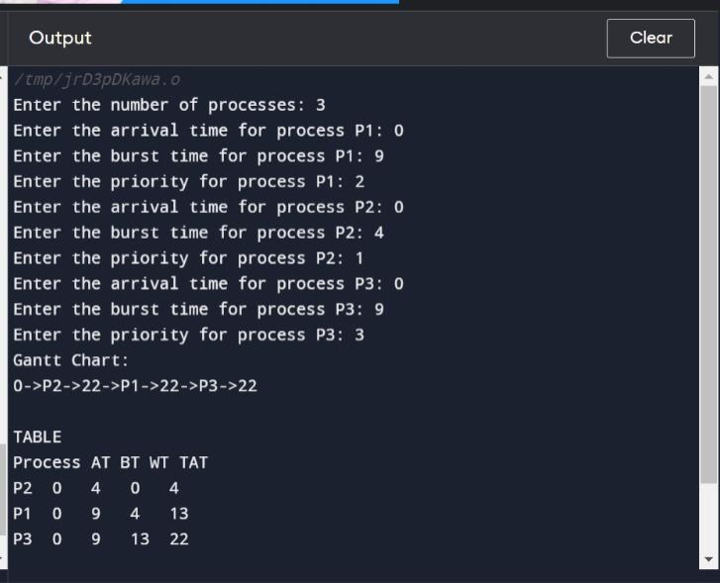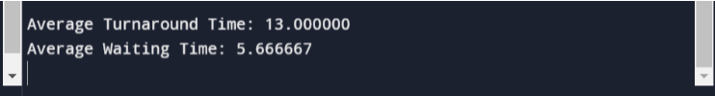

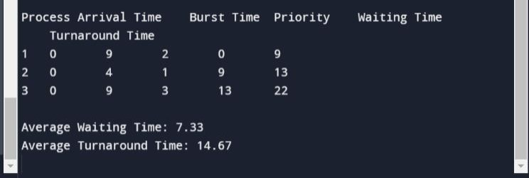

**A.Y.:** 2023-24

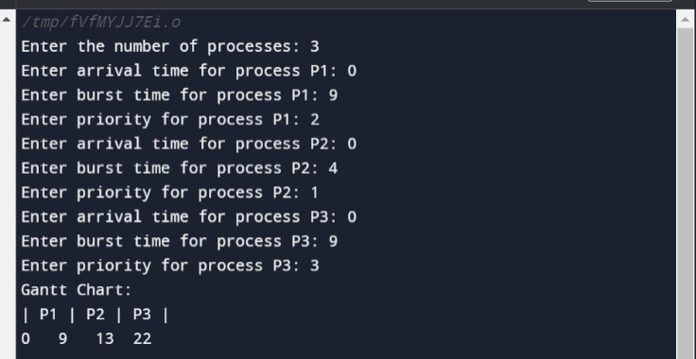Q3.