

Academic Year: 2023-24 Sem: III

Sub: Operating Systems Laboratory SAP ID: 60003220045

Name: Anish Sharma

**EXPERIMENT NO. 03**

Source Code:

#include <stdio.h>

#include <stdlib.h>

int mutex = 1;

int full = 0;

int empty = 10, x = 0; void producer()

{

--mutex; ++full;

--empty; x++;

printf("\nProducer produces" "item %d",

x); ++mutex;

}

void consumer() {

--mutex; --full; ++empty;

printf("\nConsumer consumes " "item %d",x);

x--;

++mutex;

}

int main() {

int n, i;

printf("\n1. Press 1 for Producer" "\n2. Press 2 for Consumer" "\n3. Press 3 for Exit");

#pragma omp critical

for (i = 1; i > 0; i++) {

printf("\nEnter your choice:");

scanf("%d", &n);

switch (n) {

case 1:

if ((mutex == 1)&& (empty != 0)) {

producer();

}

else {

printf("Buffer is full!");

}

break;

case 2:

if ((mutex == 1)&& (full != 0))

{

consumer();

}

else {

printf("Buffer is empty!");

}

break;

case 3:

exit(0);

break;

} }

}

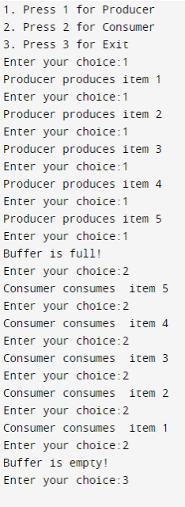**Output:**